Comparative genome analyses reveal distinct structure in the saltwater crocodile MHC

PLOS ONE

Weerachai Jaratlerdsiri¹, Janine Deakin^{2,3}, Ricardo Godinez M.^{4,14}, Xueyan Shan⁵, Daniel G. Peterson⁶, Sylvain Marthey⁷, Eric Lyons⁸, Fiona M. McCarthy⁹, Sally R. Isberg^{1,10}, Damien P. Higgins¹, Amanda Y. Chong¹, John St John¹¹, Travis C. Glenn¹², David A. Ray^{5,6,13}, Jaime Gongora^{1,*}

¹ Faculty of Veterinary Science, University of Sydney, Sydney, New South Wales 2006, Australia

² Evolution Ecology and Genetics, Research School of Biology, Australian National University, Canberra, Australian Capital Territory 2601, Australia

³ Institute for Applied Ecology, University of Canberra, Canberra, Australian Capital Territory 2601, Australia

⁴ Department of Organismic and Evolutionary Biology, Harvard University, Cambridge, Massachusetts 02138, United States of America

⁵ Department of Biochemistry, Molecular Biology, Entomology and Plant Pathology, Mississippi State University, Mississippi State, Mississippi 39762, United States of America

⁶ Institute for Genomics, Biocomputing and Biotechnology (IGBB), Mississippi State University, Mississippi State, Mississippi 39762, United States of America

⁷ Animal Genetics and Integrative Biology, INRA, UMR 1313 Jouy-en-Josas 78352, France

⁸ School of Plant Science, University of Arizona, Tucson, Arizona 85721, United States of America

⁹ School of Animal and Comparative Biomedical Sciences, University of Arizona, Tucson, Arizona 85721, United States of America

¹⁰ Center for Crocodile Research, P.O. Box 329, Noonamah, Northern Territory 0837, Australia

¹¹ Department of Biomolecular Engineering, University of California, Santa Cruz, California 95064, United States of America

¹² Department of Environmental Health Science, University of Georgia, Athens, Georgia 30602, United States of America

¹³ Current Address: Department of Biological Sciences, Texas Tech University, Lubbock, Texas 79409, United States of America

¹⁴ Department of Genetics, Harvard Medical School, 77 Louis Pasteur Ave., Boston, Massachusetts 02115, United States of America

* Corresponding author: Phone: +61-2 9036 9348. Fax: +61-2 9351 3957. E-mail: jaime.gongora@sydney.edu.au

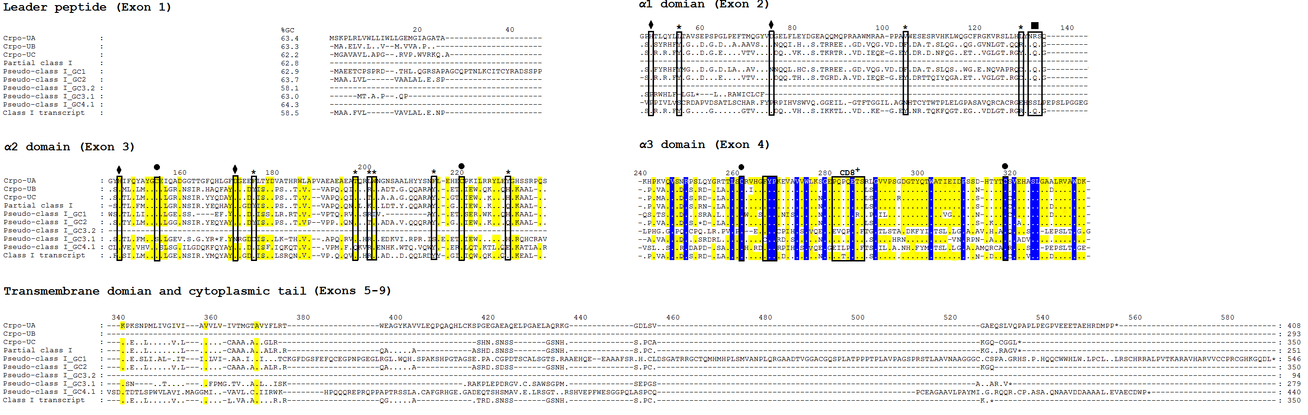

Figure S4. Amino acid alignment of saltwater crocodile MHC class I genes/pseudogenes identified in the current study and a MHC class I transcript from the American alligator. Variable positions are relative to sequence variants on the top stretching from leader peptide to cytoplasmic domain. Dots represent identical amino acids to the top variant; asterisks represent stop codons; and numbers above the alignments represent the order of amino acid positions. Sites in boxes indicate amino acid positions that are conserved or have expected functions. These amino acid positions also contain the following additional labels: asterisks, conserved peptide-binding residues of antigen N and C termini, as described in Kaufman et al. [69]; diamonds, salt bridge-forming residues; circles, disulfide bridge-forming cysteines; squares: N-glycosylation site; CD8⁺, the expected CD8⁺ binding site. Background colours in the alignments indicate degrees of amino acid identity: 100% in blue; 65-100% in yellow; and below 65% in white

