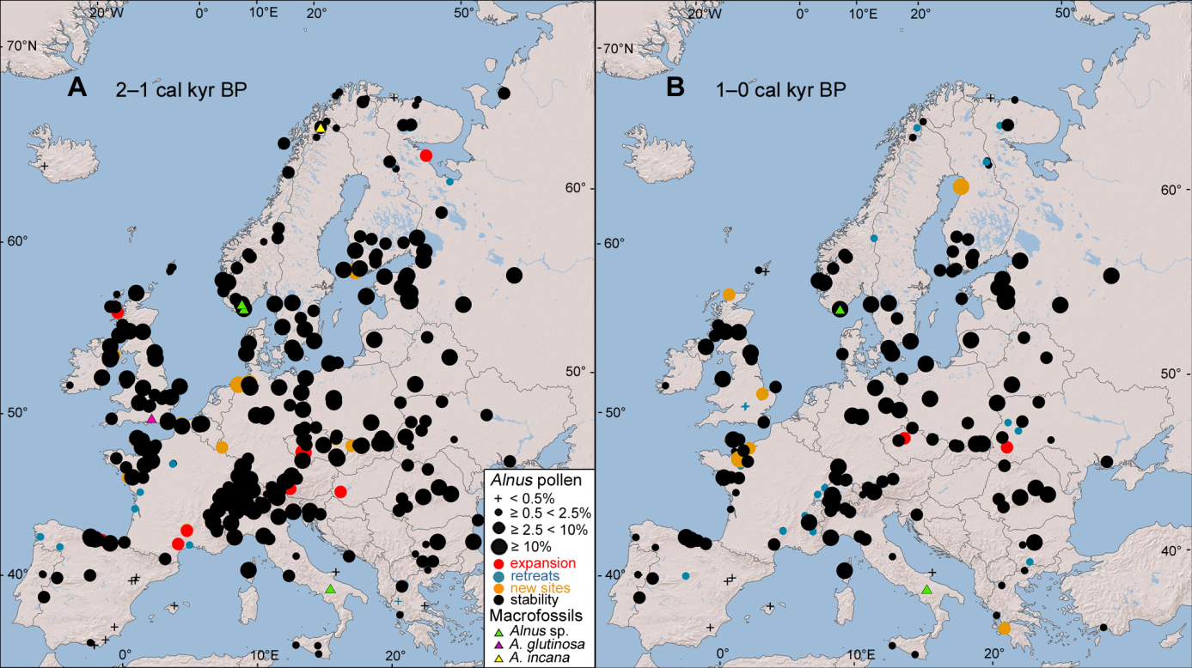
Figure S2. Holocene distribution (2–0 cal. kyr BP) of Alnus pollen sites. According to four classes of percentage of Alnus pollen and macrofossil remains; for details see Appendix S3 Figure S1.

