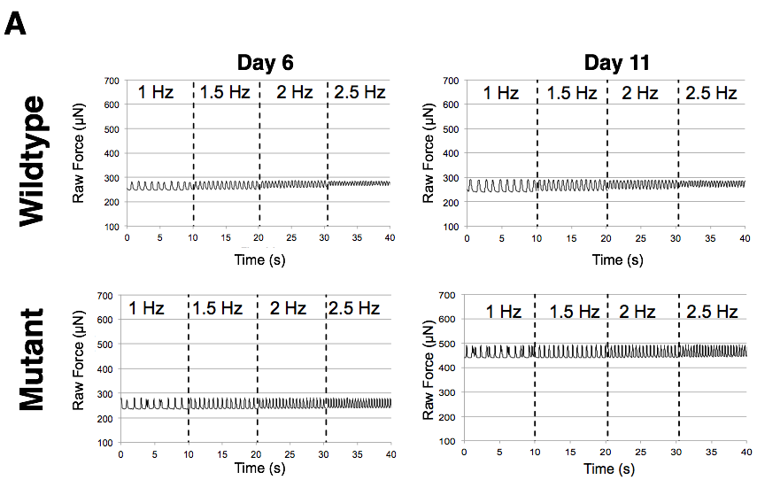

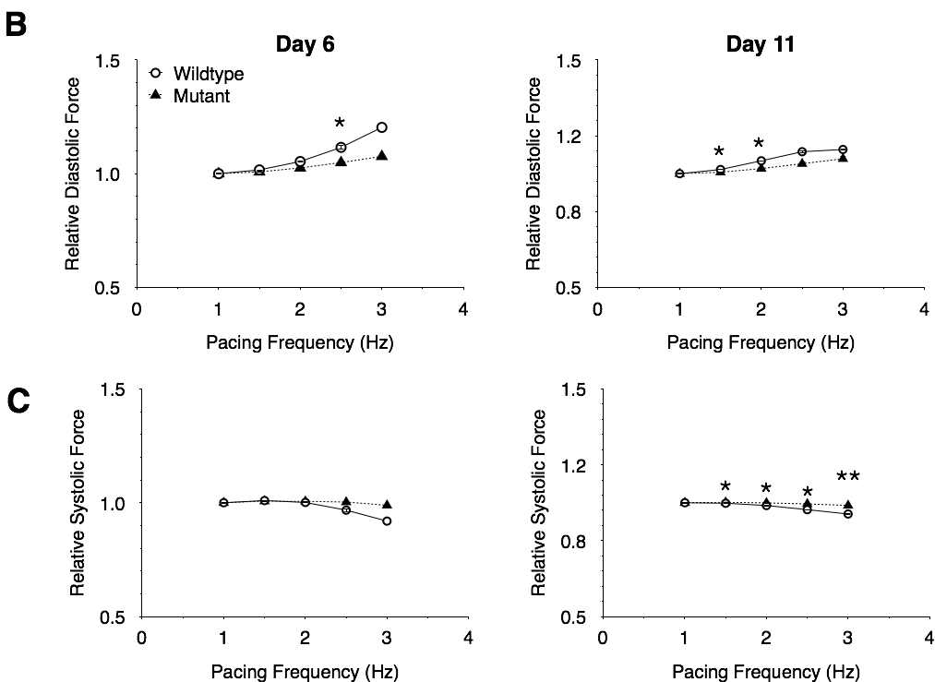
S2 Fig. Wild- type tissue diastolic force changes more with frequency than mutant tissues at both day 6 and day 11 of pacing. (A) Representative twitch tracing for wild type (top) and mutant (bottom) at both day 6 (left) and day 11 (right) of pacing from 1-2.5 Hz; (B) Force-frequency relationship of hiPSC-hECT diastolic force relative to the diastolic force at 1 Hz at both day 6 (left) and day 11 (right); (C) Force-frequency relationship of hiPSC-hECT systolic force relative to the starting systolic force at 1 Hz at both day 6 (left) and day 11 (right). At both day 6 and day 11 the change in diastolic force versus frequency for the mutant is much less than that of the wild type. Error bars represent standard error. * p < 0.05, ** p < 0.01 between mutant and wild type relative forces.

