Figure S-4. Pearson correlation coefficient (r²) of within group sample comparisons by RMA normalized probe set intensities from microarray analysis.

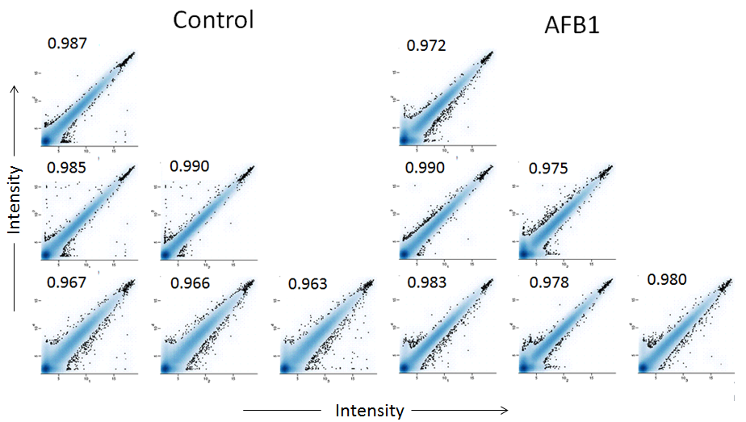

Comparison of gene expression between replicate liver samples of control and Aflatoxin B1 (AFB1) treated rats (n=4/group) was performed after microarray (Agilent probes) analysis. Normalized probe set intensities were log2 transformed and plotted against probe intensities of other animals within the group. The large correlation coefficients show high degree of reproducibility of data when individual animals were compared within each group.

