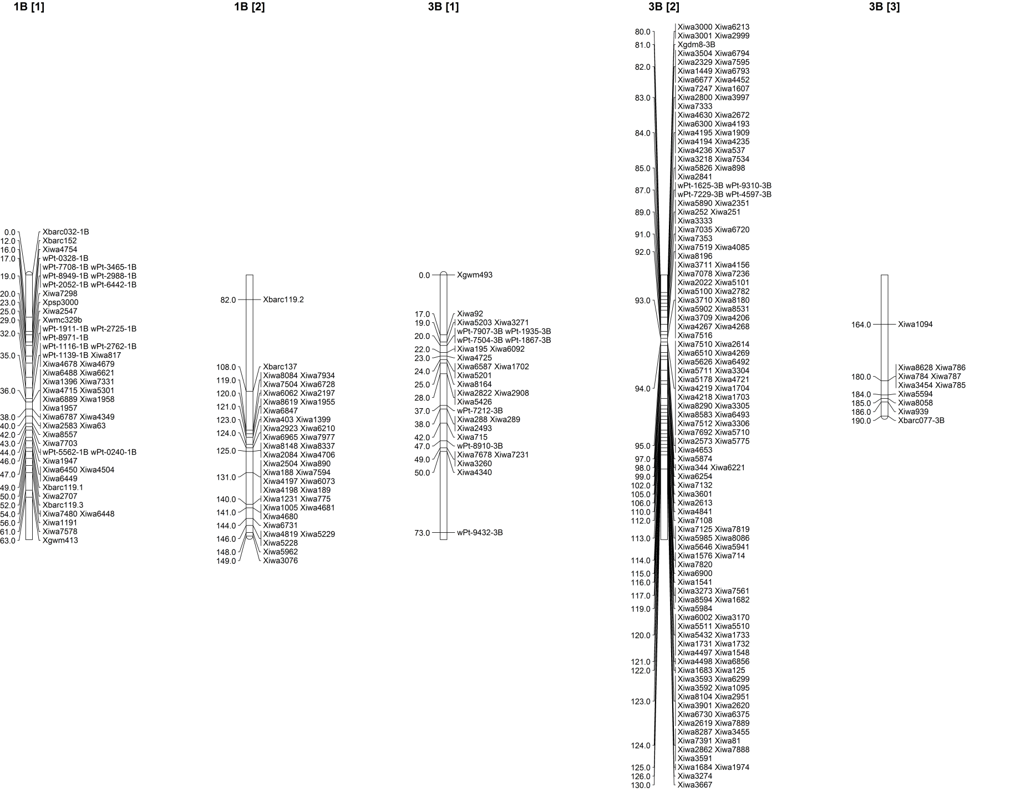
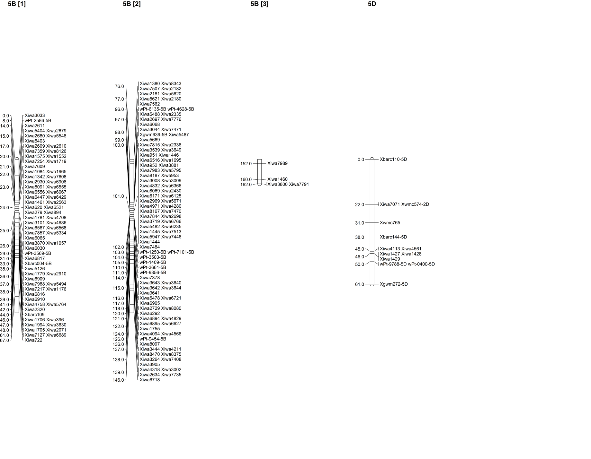
Figure S2 Full linkage maps of the four wheat chromosomes 1B, 3B, 5B, and 5D, which were associated with stripe rust infection type and disease severity values using QTL analysis in the Brundage by Coda recombinant inbred line population.

