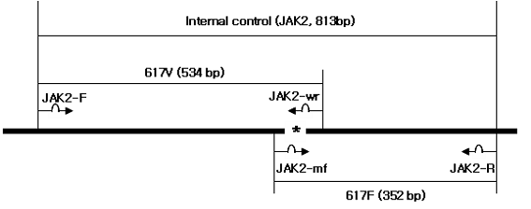
Figure S5. Scheme of the allele-specific DPO primers for the detection of JAK2 V617F mutation. Internal control (813 bp) of PCR was used JAK2-F primer and JAK2-R primer. JAK2-F primer and JAK2-wr primer was used for detection of JAK2 wild type (617V, 534 bp). JAK2-R primer and JAK2-mf primer was used for detection of JAK2 mutant type (617F, 352 bp).

