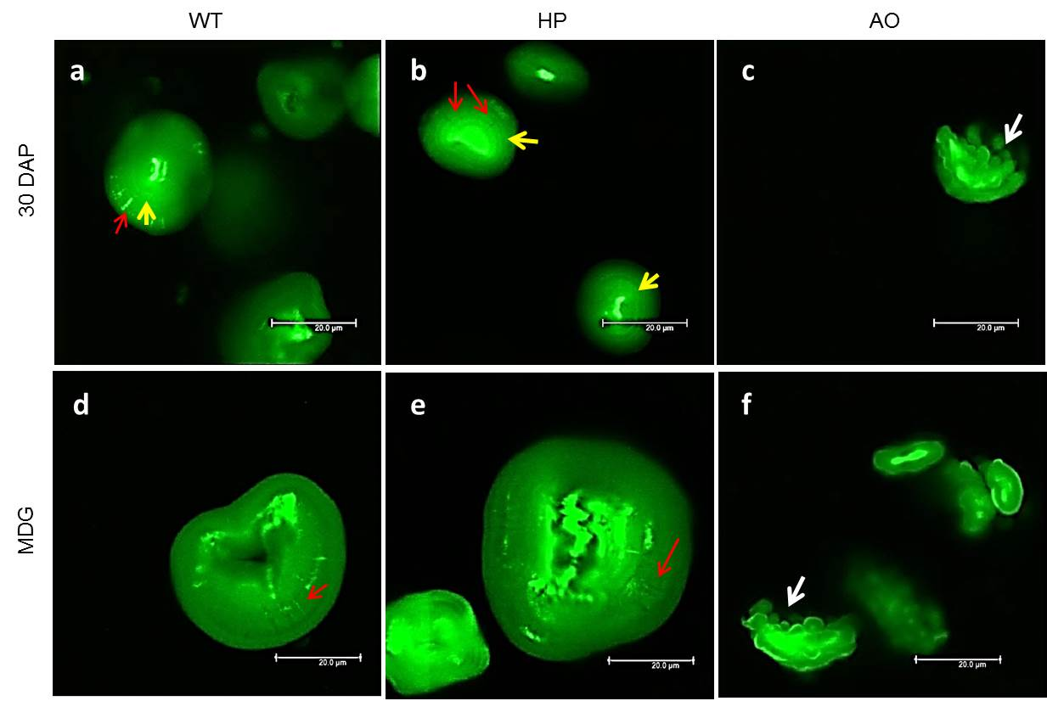

S5 Fig. Confocal laser scanning micrographs showing inner structural details of purified starch granules stained with APTS. Images are from different developmental stages (10, 20, 30 DAP and MDG) at higher magnification of WT (a,d), HP (b,e) and AO (c,f). Arrows indicate locations of growth rings (yellow), bright and dark channels (red), and typical protrusions on AO (white) of starch granules. Scale bar indicates 20 µm.

