Supplemental Information
1. Use of mouse anti-ZIKV serum
The ZIKV PE243 isolate was initially analysed by indirect immunofluorescence assay (IFA). Vero E6 cells were infected with ZIKV at an MOI of 1 and fixed 24 h p.i. with 8% formaldehyde, followed by immunostaining with anti-ZIKV mouse antibodies diluted 1:100 in 2% FBS in PBS. Detection of bound primary antibodies was achieved using an anti-mouse secondary antibody conjugated to AlexaFluor® 488 (ThermoFisher Scientific) diluted 1:250 in 2% FBS in PBS. Images were analysed using a Zeiss LSM 710 inverted confocal microscope. A ZIKV-specific signal was detected in virus-infected cells (Fig 1).
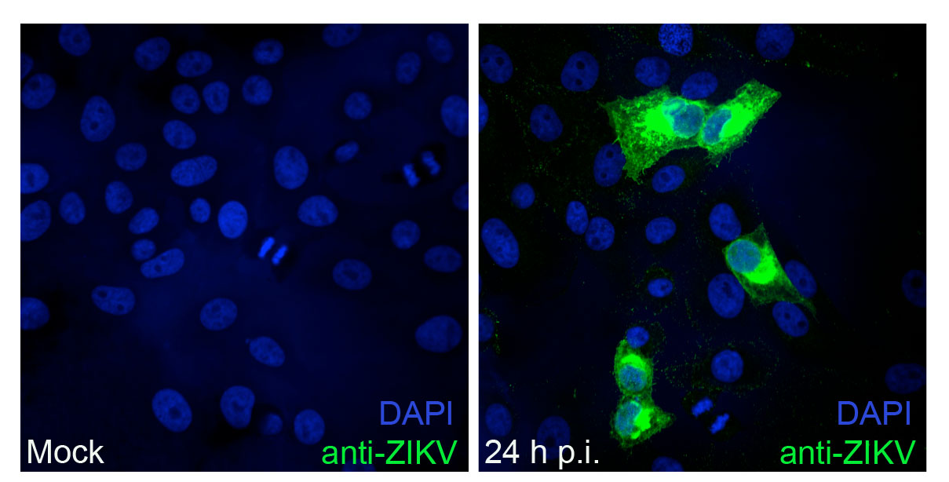
Fig 1. Detection of ZIKV by using mouse anti-ZIKV serum and IFA. Mock infected (left panel) or ZIKV infected (MOI 1, right panel) Vero E6 cells were fixed 24 h p.i. Immunofluorescence analysis was performed by using mouse anti-ZIKV serum.

2. Use of E antibodies
A panel of antibodies against ZIKV E protein was purchased from Aalto Bio Reagents (Ireland). The ZIKV PE243 isolate was further analysed by IFA and western blot analysis by using commercially available antibodies against the ZIKV E protein (Table 1). Western blot analysis of total cell lysate utilizing ZIKV_E_ Ab1 and ZIKV_E_ Ab3 antibodies, generated two bands; a higher molecular weight band observed between 48- 68 kDa corresponding in molecular weight to the predicted ZIKV E protein (54 kDa), and a lower molecular weight band between 38- 48 kDa (Fig 2). ZIKV_E_Ab2 gave only one band at the expected molecular weight for E. All antibodies gave a highly specific signal by IFA in ZIKV-infected cells. These antibodies therefore appear suitable for future studies of ZIKV.

Immunofluorescence and confocal imaging
Vero E6 cells were infected with ZIKV at an MOI of 1 and fixed 48 h p.i. with 8% formaldehyde, followed by immunostaining for ZIKV E with mouse IgG antibodies (Aalto Bio Reagents) diluted in 5% FBS in PBS as described in Table 1. Detection of bound primary antibodies was achieved using an anti-mouse secondary antibody conjugated to AlexaFluor® 488 (ThermoFisher Scientific) diluted 1:1,000 in 5% FBS in PBS. Images were analysed using a Zeiss LSM 710 inverted confocal microscope.

Western blotting
SDS-PAGE and western blots were performed using lysates from Vero E6 cells infected with ZIKV at an MOI of 3 that were harvested at 48 h p.i. Samples were run on a 4%-12% gradient Bis Tris gel (Life Technologies) and blotted to a nitrocellulose membrane (GE Healthcare). Protein expression was determined using ZIKV specific antibodies described in Table 1 (Aalto Bio Reagents) diluted in PBS with 5% dried milk and 0.1% Tween 20. Secondary detection was achieved using an anti-mouse antibody conjugated to HRP (Life Technologies) and visualised by enhanced chemiluminescence using Pierce ECL western blot substrate (Thermo Scientific) as per the manufacturer’s instructions.

Table 1. ZIKV primary antibodies for detection of ZIKV E protein by western blotting and immunofluorescence analysis.
Designated Name | Product code | Western blot  working ratio | Immunofluorescence  working ratio
ZIKV_E_Ab1 | AZ1176/0302156 | 1:10000 | 1:500
ZIKV_E_Ab2 | AZ1176/0402166 | 1:5000 | 1:400
ZIKV_E_Ab3 | AZ1176/0502176 | 1:10000 | 1:1000

Fig 2. Characterization of commercially available anti-ZIKV E protein monoclonal antibodies. ZIKV-infected (MOI 3) and mock-infected Vero E6 cells were lysed 48 h p.i and analyzed by western blot. Detection of ZIKV E was achieved using ZIKV_E_Ab1 (A) ZIKV_E_Ab2 (B) or ZIKV_E_Ab3 (C) (Table 1). (D) ZIKV infected (MOI 1, top panels) and mock infected (bottom panels) Vero E6 cells were fixed 48 h p.i. and immunofluorescence analysis performed using ZIKV_E_Ab1 (labelled E_1), ZIKV_E_Ab2 (labelled E_2) or ZIKV_E_Ab3 (labelled E_3) antibodies (labelled E_3) (see Table 1 for details).

