**S1 Figure**

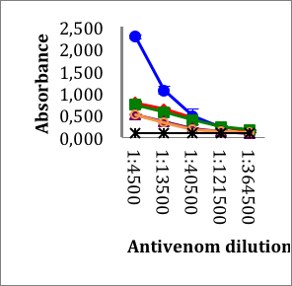

A

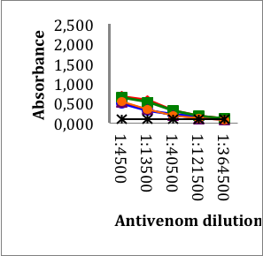

B

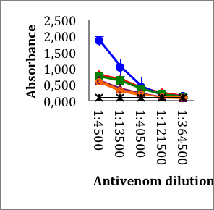

C

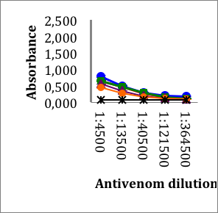

D

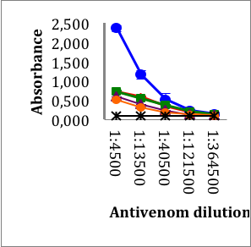

E

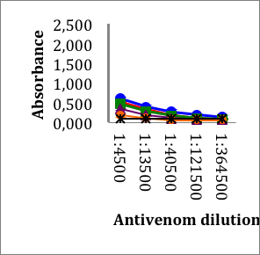

F

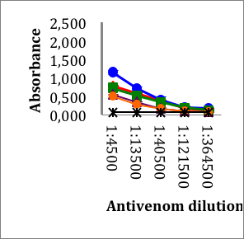

G

Titration curves for mono and polyspecific antivenoms against *Lachesis* venoms. Antivenoms were serially diluted by a factor of 3 (starting from a dilution of 1/500) and tested by ELISA against the following crude *Lachesis* venoms: *L. stenophrys* from Costa Rica (**A**), *L. melanocephala* from Costa Rica (**B**), *L. muta muta* from Colombia (**C**), Peru (**D**), the Brazil regions of Cascalheria (**E**), Tucurui (**F**), and *L. muta rhombeata* from Recife, Brazil (**G**). Antivenom acronyms, BCL, polyspecific anti-bothropic, anti-crotalic, anti-lachesic antivenom from Instituto Clodomiro Picado (Cr); BL, anti-bothropic and anti-lachesic antivenom from Instituto Vital Brazil, Niterói, Brazil; AL, monoespecific anti-lachesic antivenom; AB, monoespecific anti-bothropic antivenom; AC, monoespecific anti-crotalic antivenom. Each point represents the mean ± SD of three independent determinations.