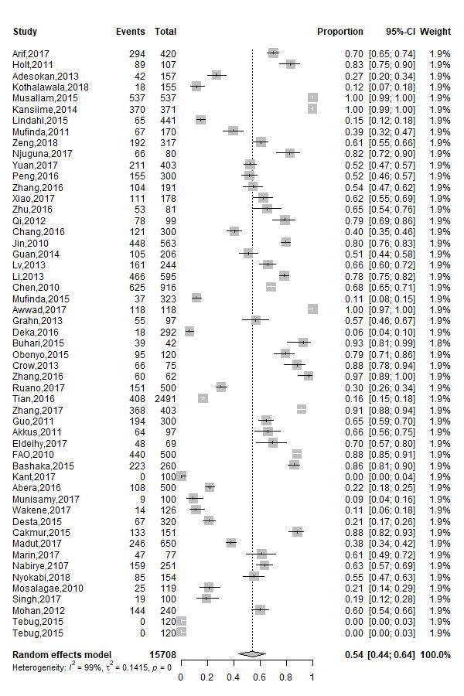
Figure 2A. Forest plots of brucellosis awareness
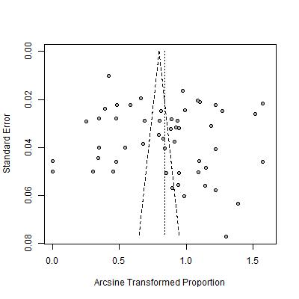
Figure 2B. Funnel plot of brucellosis awareness.

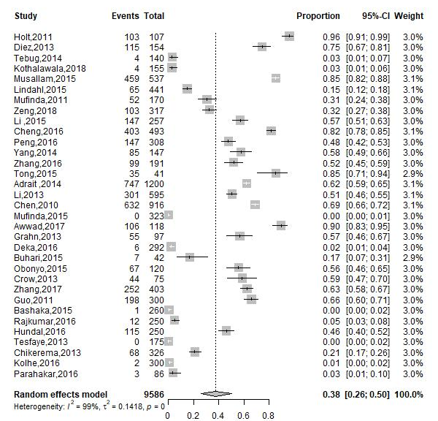
Figure 3A. Forest plots of brucellosis knowledge of its zoonotic nature.

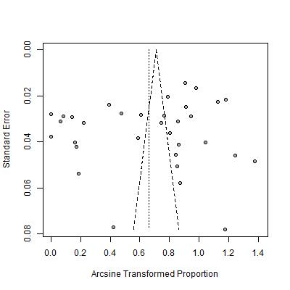
Figure 3B. Funnel plot of brucellosis knowledge of its zoonotic nature
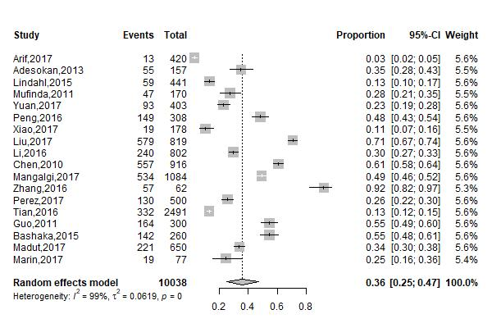

Figure 4A. Forest plots of brucellosis knowledge regarding the mode of transmission.

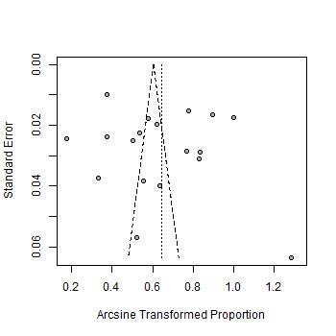
Figure 4B. Funnel plots of brucellosis knowledge regarding the mode of transmission.
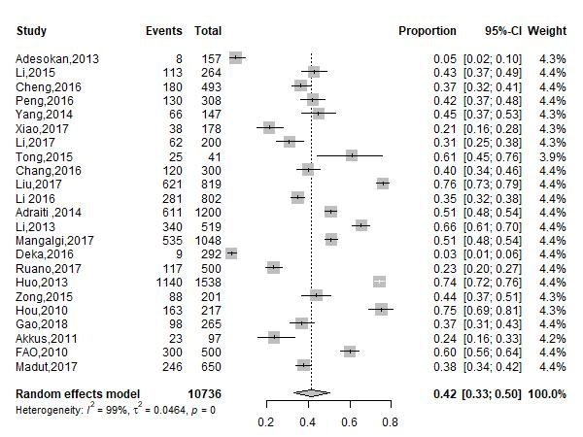 Figure 5A. Forest plots of knowledge regarding symptoms of human brucellosis

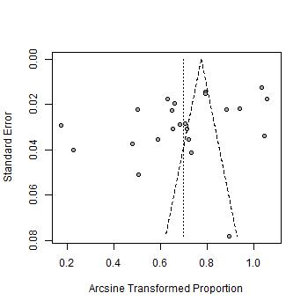

Figure 5B. Forest plots of knowledge regarding symptoms of human brucellosis
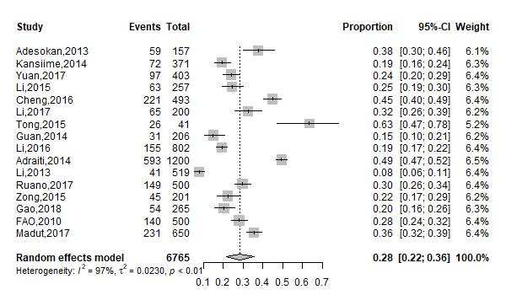 Figure 6A. Forest plots of knowledge regarding signs of animal brucellosis.

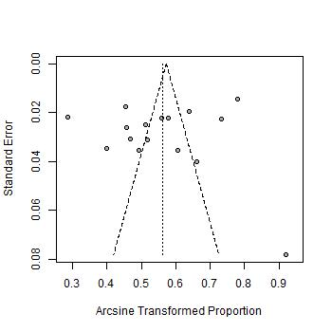
Figure 6B. Funnel plots of knowledge regarding signs of animal brucellosis.

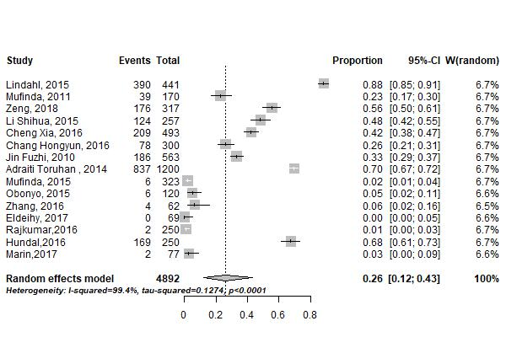
Figure 7A. Forest plots of knowledge regarding vaccination as a preventive measure.

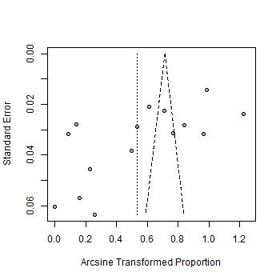
Figure 7B. Funnel plot of knowledge regarding vaccination as a preventive measure.

