S1 Appendix: Supplemental Figures A-H
Supplemental Figure A: Cost-effectiveness of lung cancer screening scenarios by screening starting age in the base-case analysis
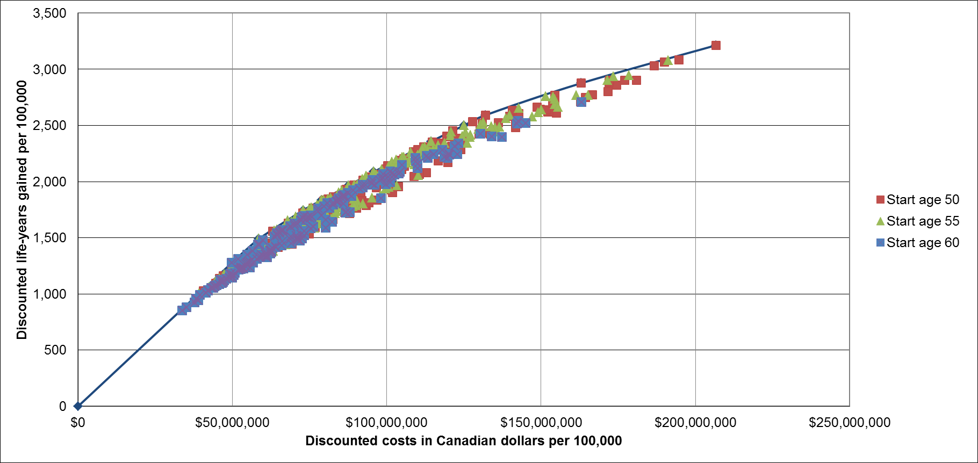

Supplemental Figure B: Cost-effectiveness of lung cancer screening scenarios by screening stopping age in the base-case analysis
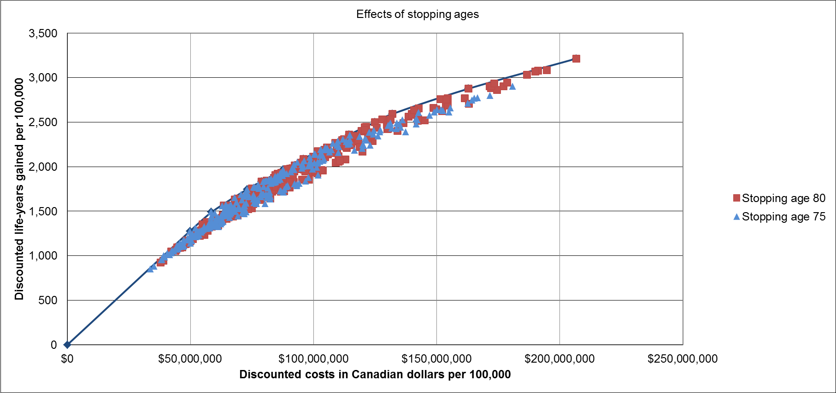

Supplemental Figure C: Cost-effectiveness of lung cancer screening scenarios by type of aggregated smoking criteria in the base-case analysis
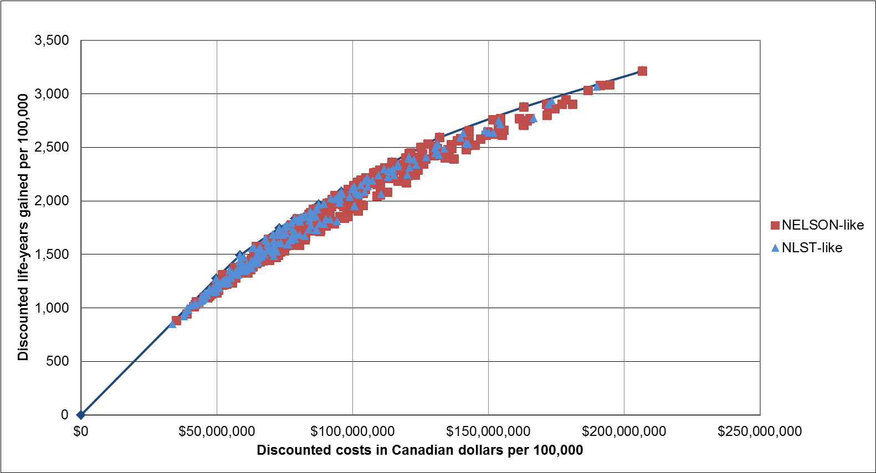

Supplemental Figure D: Cost-effectiveness of lung cancer screening scenarios by aggregated smoking criteria (efficient frontier and NLST-like scenarios only) in the base-case analysis
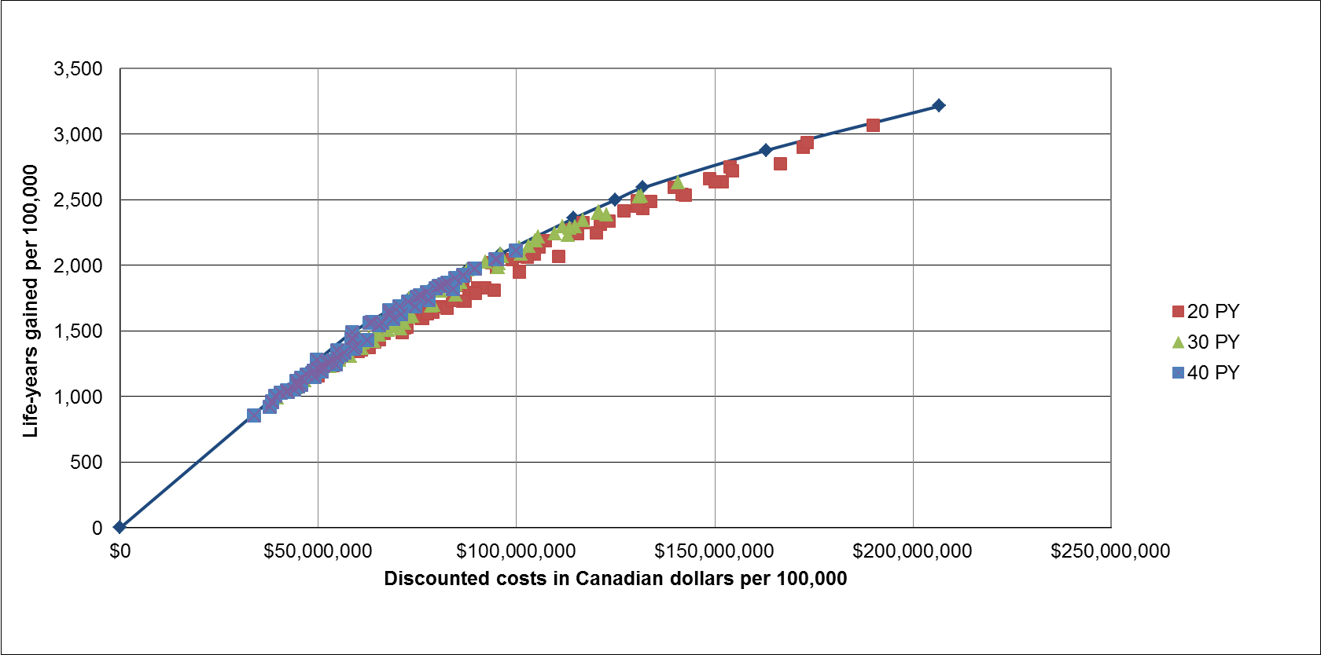
Figure notes: abbreviations: pack-years (PY)

Supplemental Figure E: Cost-effectiveness of lung cancer screening scenarios by aggregated smoking criteria (efficient frontier and NELSON-like scenarios only) in the base-case analysis
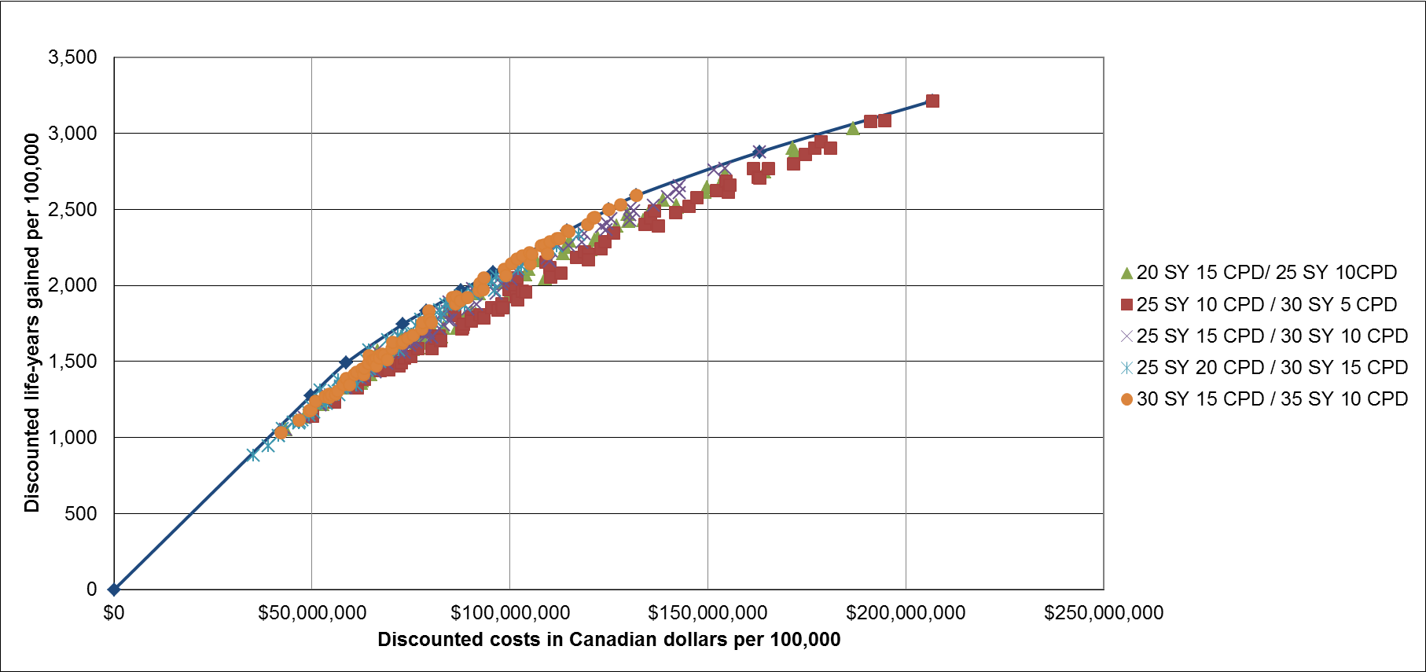
Figure notes: abbreviations: smoking duration in years (SY), cigarettes per day (CPD)

Supplemental Figure F: Cost-effectiveness of lung cancer screening scenarios by years since cessation in the base-case analysis
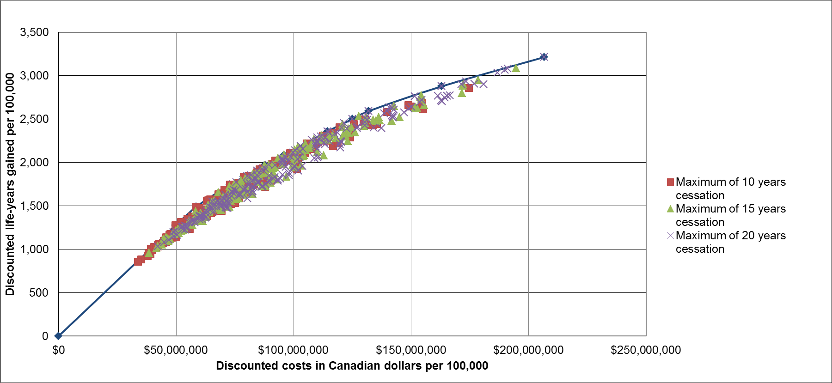

Supplemental Figure G: Cost-effectiveness of lung cancer screening scenarios: exclusion of individuals after reaching the maximum number of years since cessation compared with no exclusion in the base-case analysis
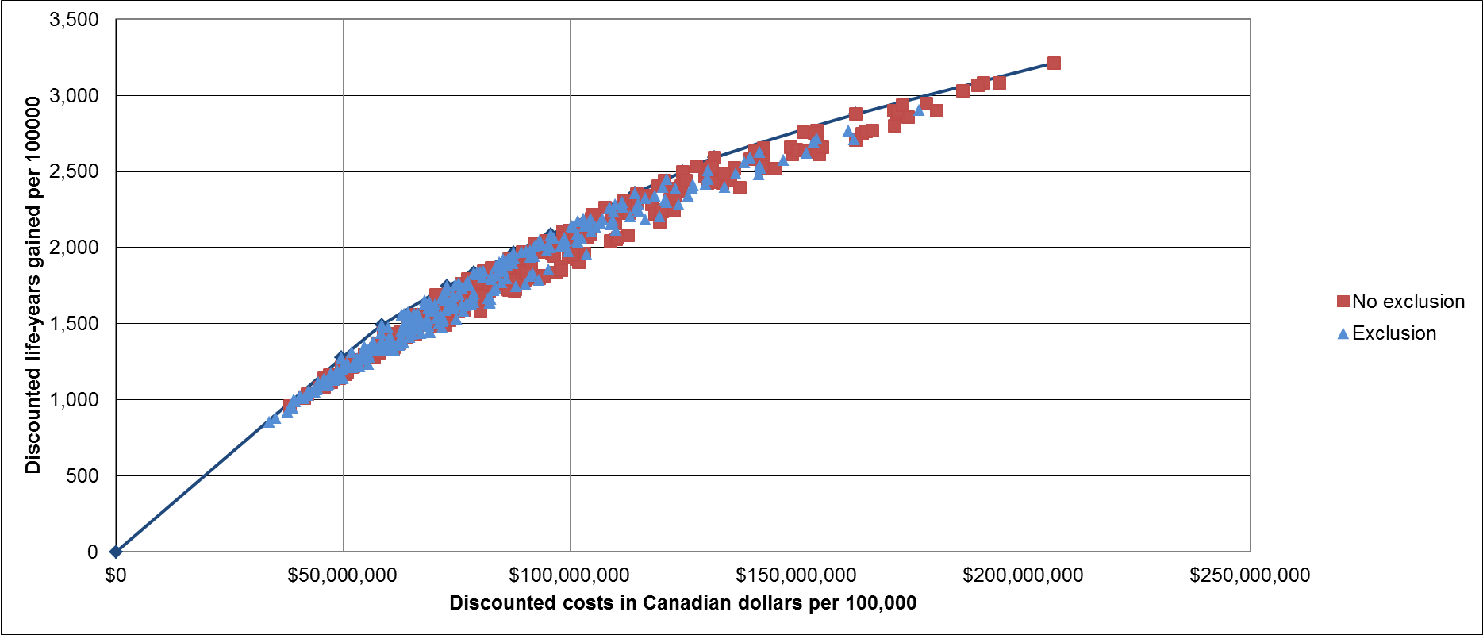

Supplemental Figure H: Cost-effectiveness of lung cancer screening scenarios by intervals between screenings in the base-case analysis
