Supplementary Figure 2 - Forest plot of association between maternal BMI and offspring BMI using multivariable linear regression in ALSPAC and Generation R
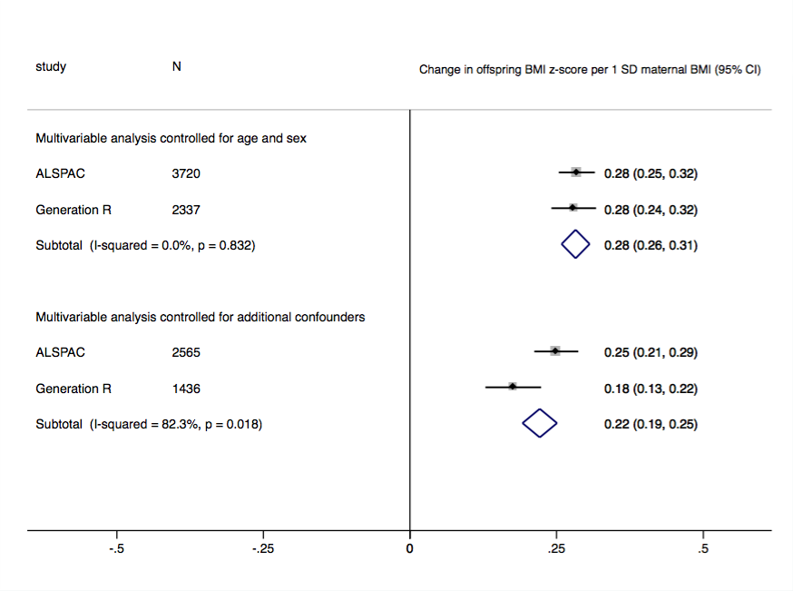
All models used age-standardised values of maternal BMI and age- and sex-standardised values of offspring BMI combined in a fixed effects meta-analysis. Multivariable analysis controlled for additional confounders adjusted for socio-economic position, parity, paternal BMI, maternal smoking during pregnancy. Additional adjustment for ethnicity was undertaking in Generation R by including the top 20 principal components obtained from PCA on offspring genome-wide data in the multivariable analyses.

