S4 Appendix: Calibration aspects of the evaluated lung cancer risk prediction models for 6-year lung cancer incidence and mortality

Figure A: Calibration plots for the Bach model for 6-year lung cancer incidence in all datasets

NLST CT arm NLST CXR arm

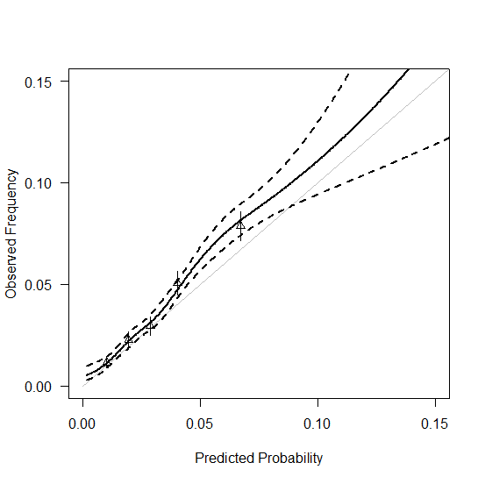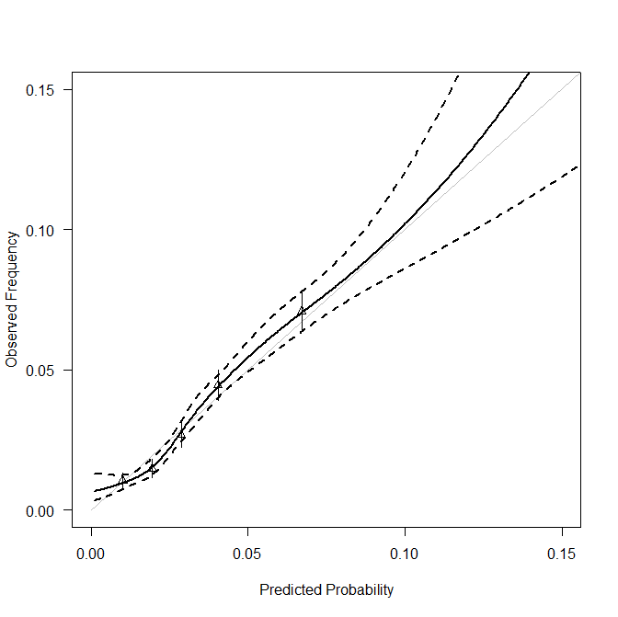

PLCO CXR arm PLCO Control arm
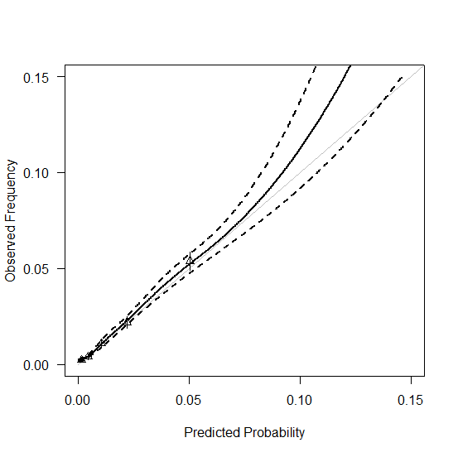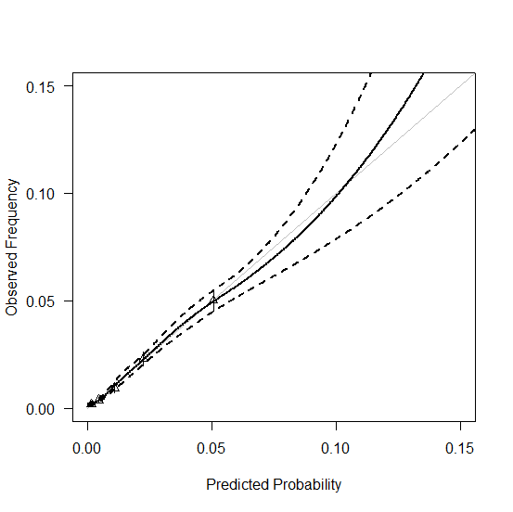

Figure B: Calibration plots for the Bach model for 6-year lung cancer mortality in all datasets

NLST CT arm NLST CXR arm

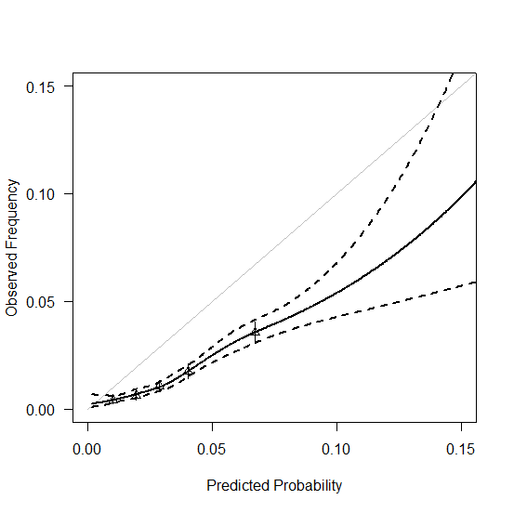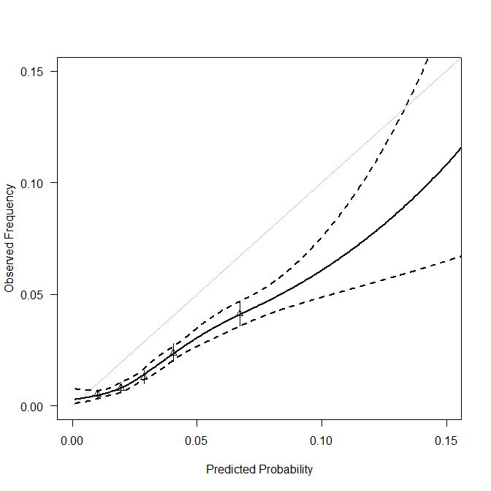

PLCO CXR arm PLCO Control arm

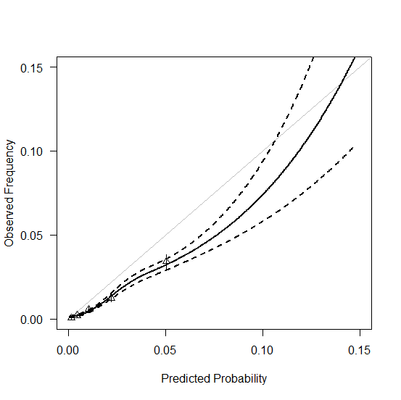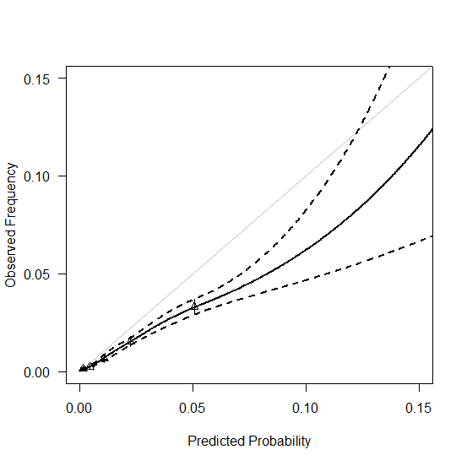

Figure C: Calibration plots for the LLP model for 6-year lung cancer incidence in all datasets

NLST CT arm NLST CXR arm

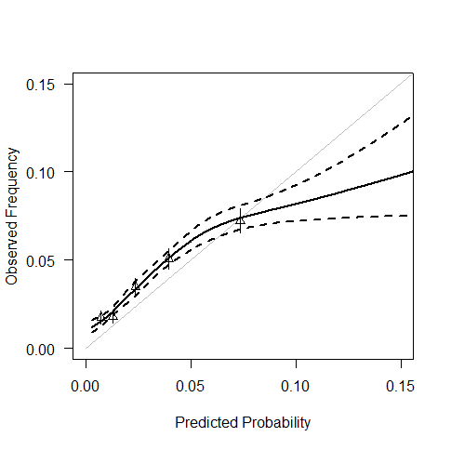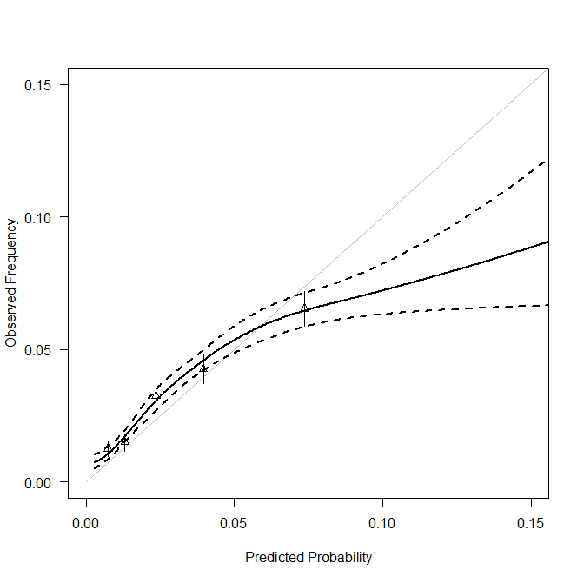

PLCO CXR arm PLCO Control arm

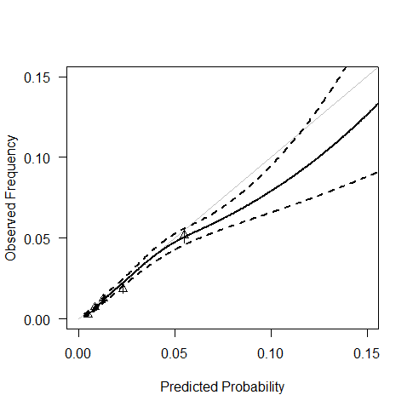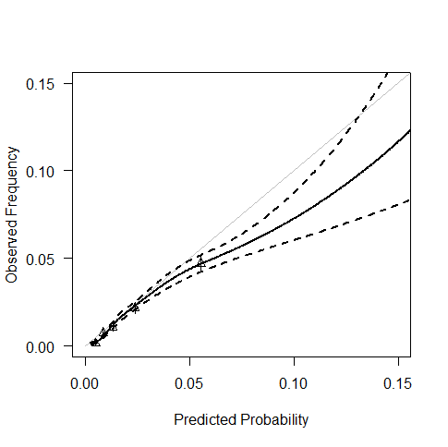

Figure D: Calibration plots for the LLP model for 6-year lung cancer mortality in all datasets

NLST CT arm NLST CXR arm
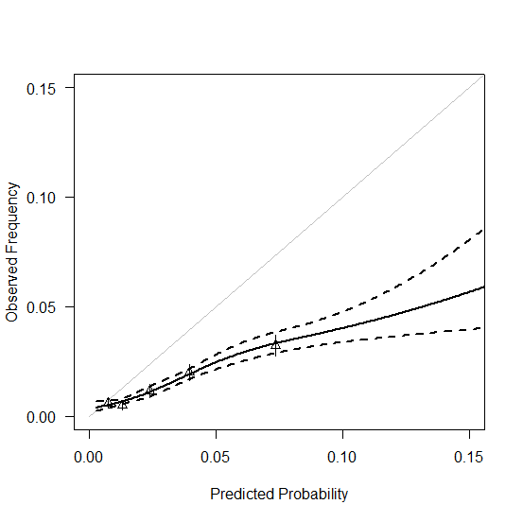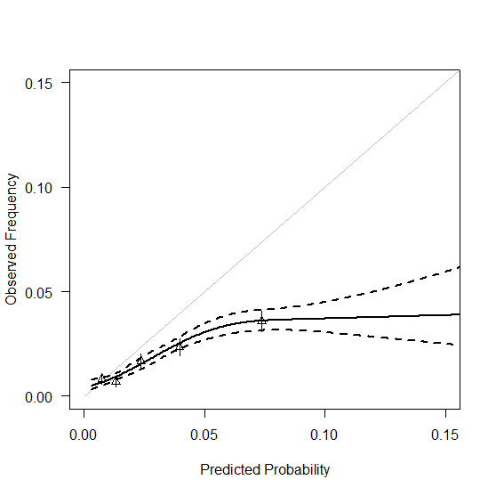

PLCO CXR arm PLCO Control arm
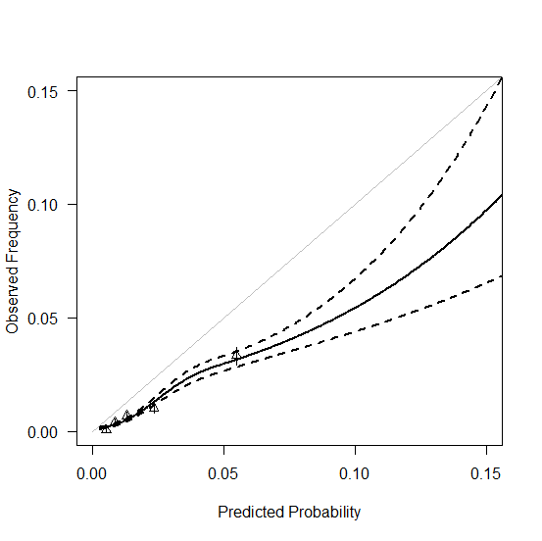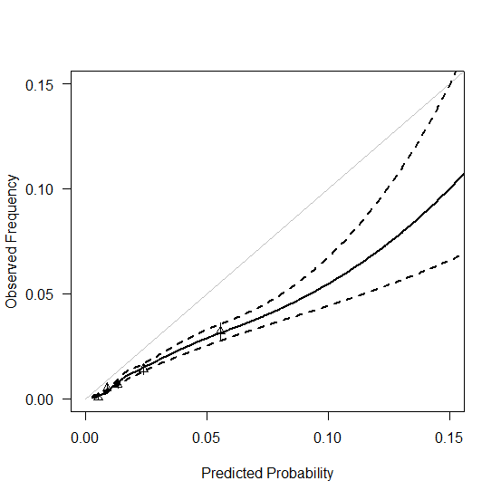

Figure E: Calibration plots for the simplified LLP model for 6-year lung cancer incidence in all datasets

NLST CT arm NLST CXR arm

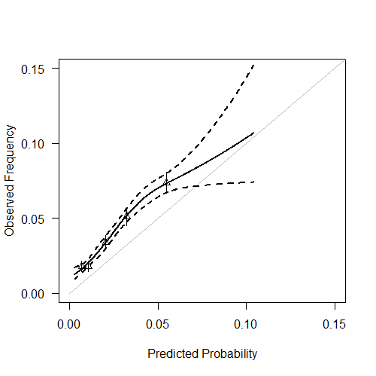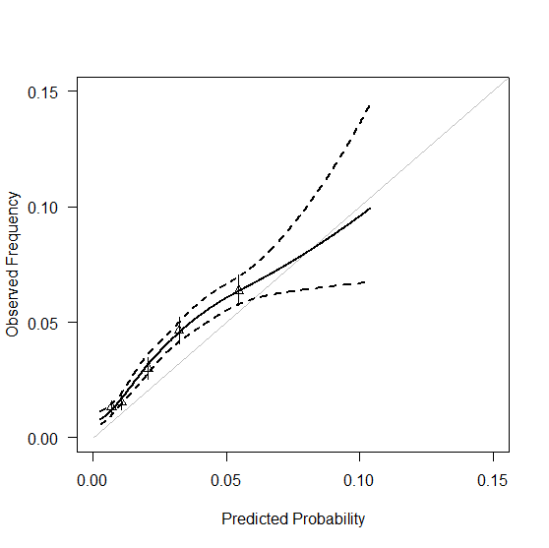

PLCO CXR arm PLCO Control arm

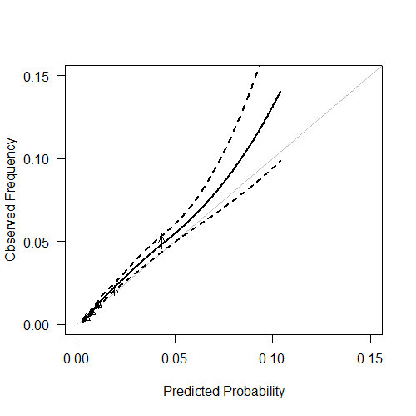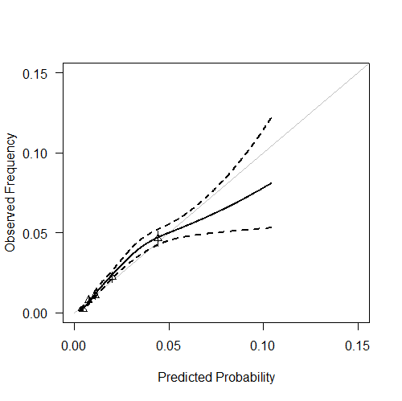

Figure F: Calibration plots for the simplified LLP model for 6-year lung cancer mortality in all datasets

NLST CT arm NLST CXR arm

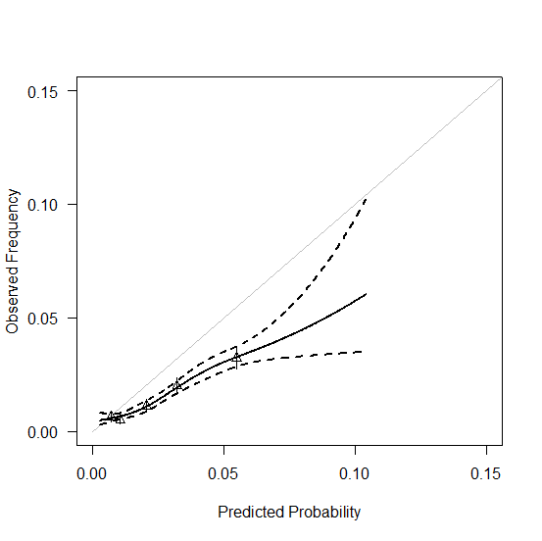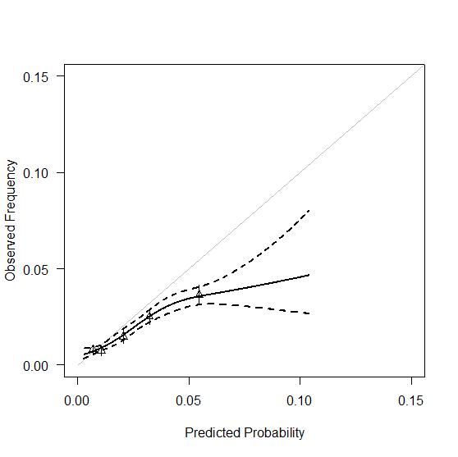

PLCO CXR arm PLCO Control arm
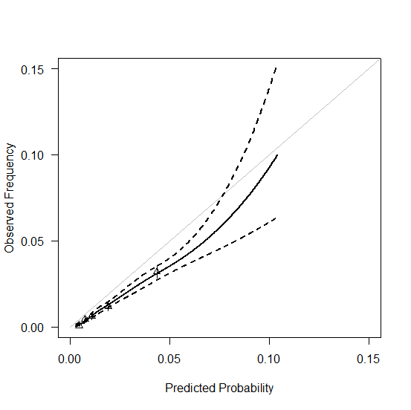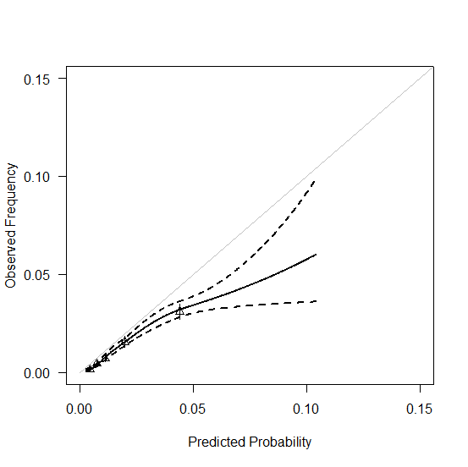

Figure G: Calibration plots for the PLCOm2012 model for 6-year lung cancer incidence in all datasets

NLST CT arm NLST CXR arm
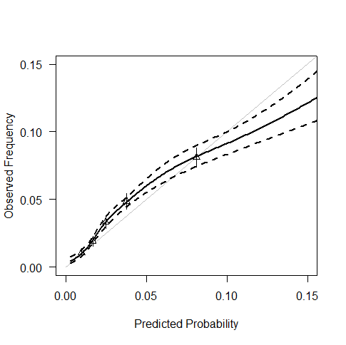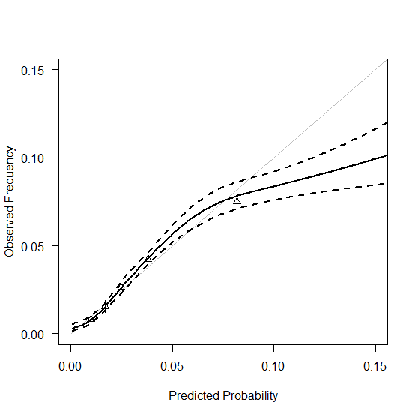

PLCO CXR arm PLCO Control arm 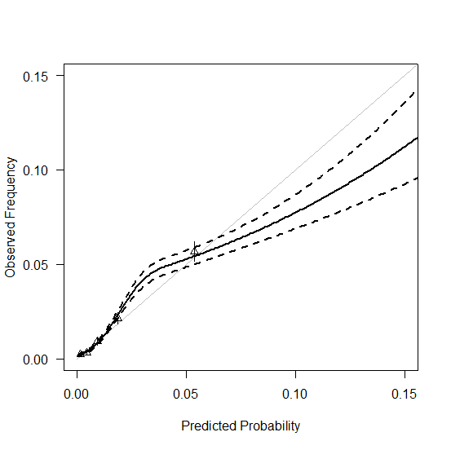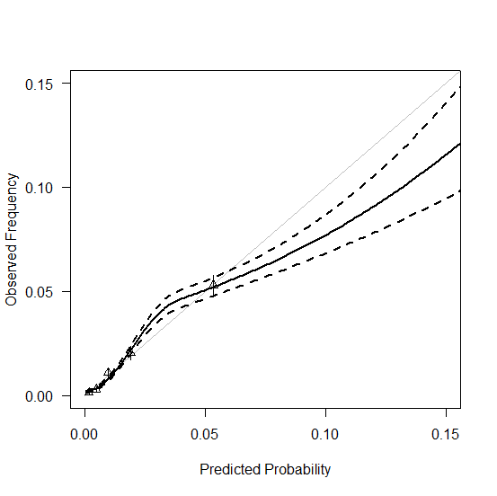

Figure H: Calibration plots for the PLCOm2012 model for 6-year lung cancer mortality in all datasets

NLST CT arm NLST CXR arm

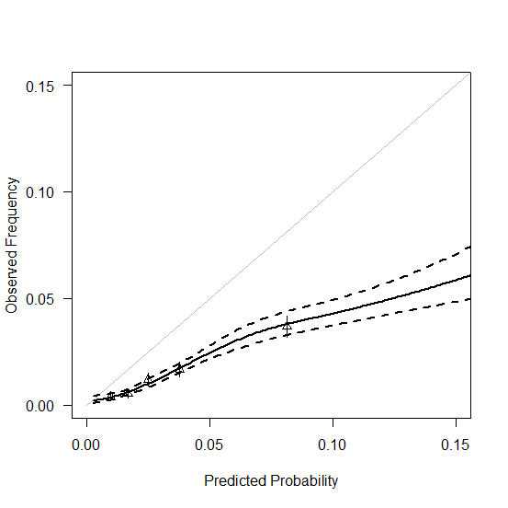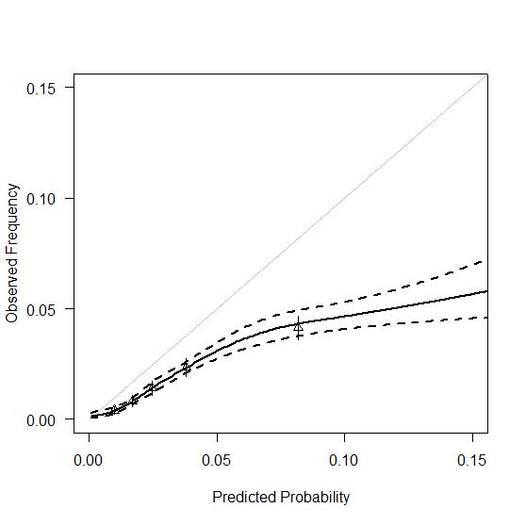

PLCO CXR arm PLCO Control arm

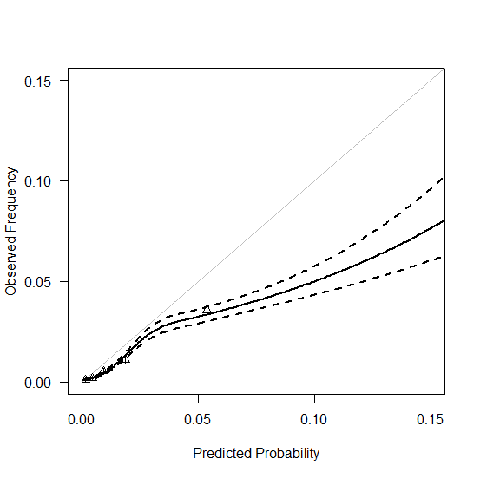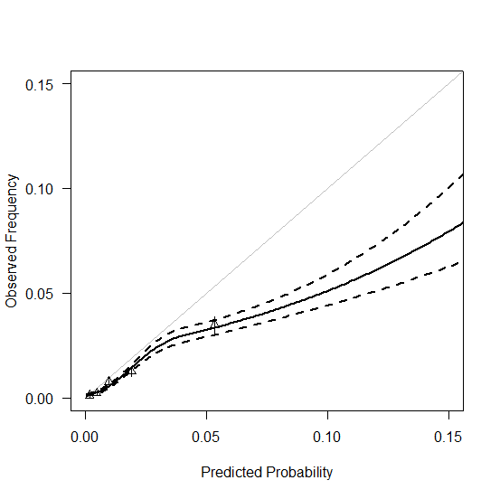

Figure I: Calibration plots for the simplified PLCOm2012 model for 6-year lung cancer incidence in all datasets

NLST CT arm NLST CXR arm
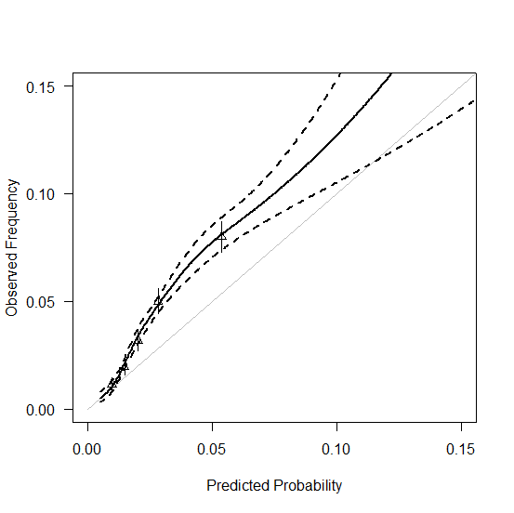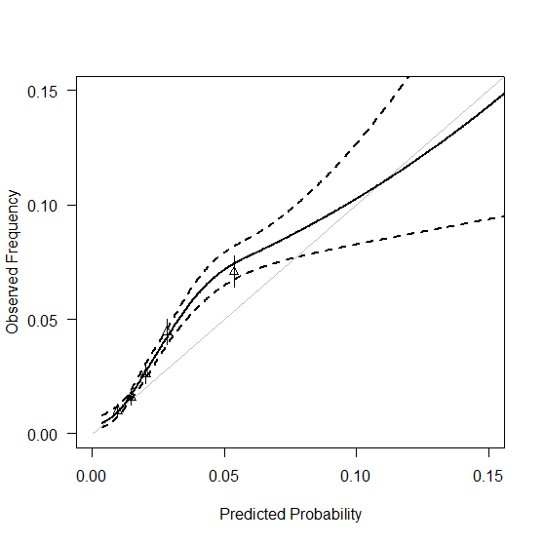

PLCO CXR arm PLCO Control arm

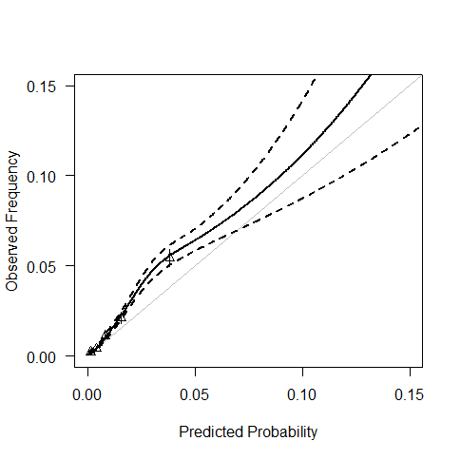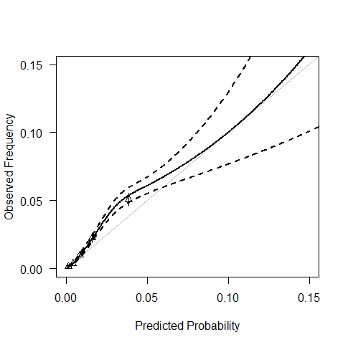

Figure J: Calibration plots for the simplified PLCOm2012 model for 6-year lung cancer mortality in all datasets

NLST CT arm NLST CXR arm

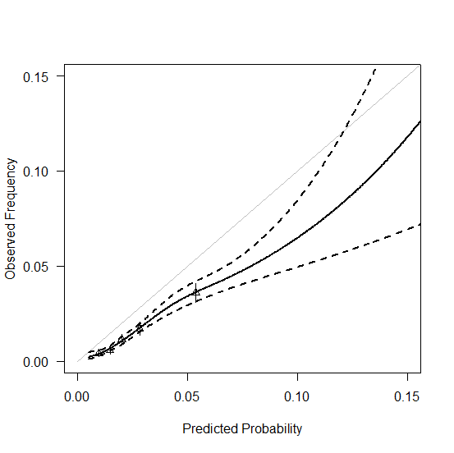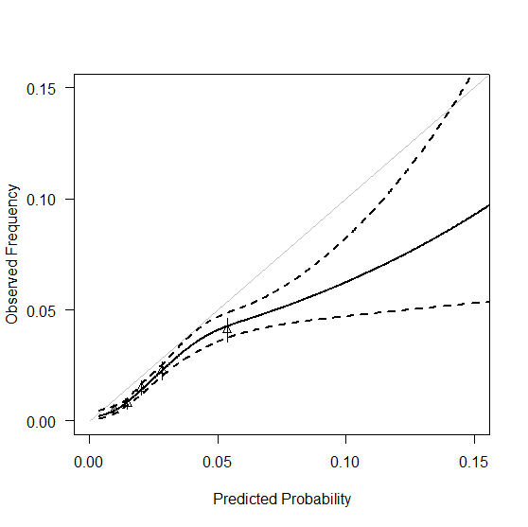

PLCO CXR arm PLCO Control arm

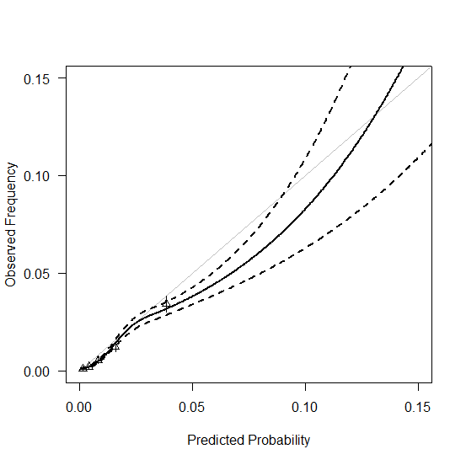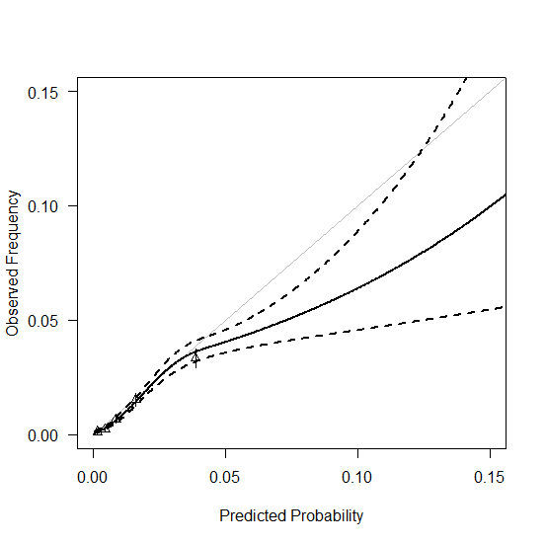

Figure K: Calibration plots for the TSCE incidence model for 6-year lung cancer incidence in all datasets

NLST CT arm NLST CXR arm
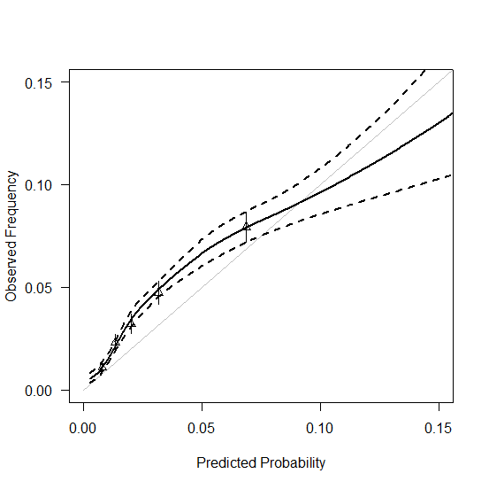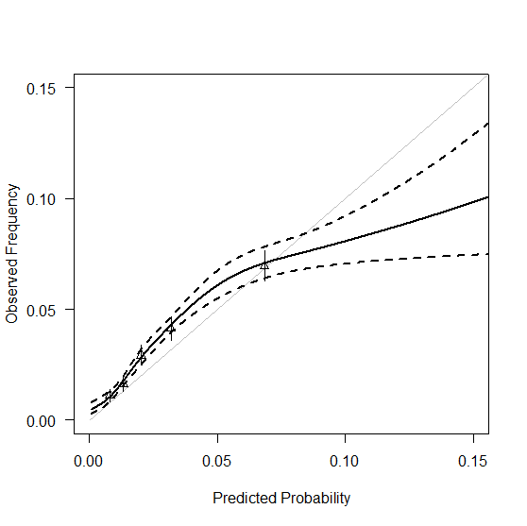

PLCO CXR arm PLCO Control arm
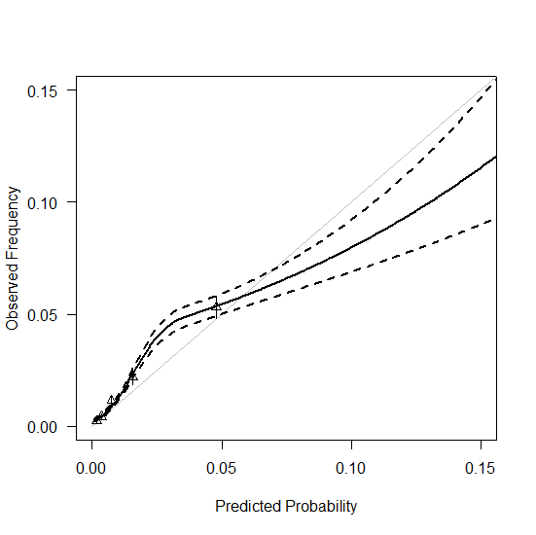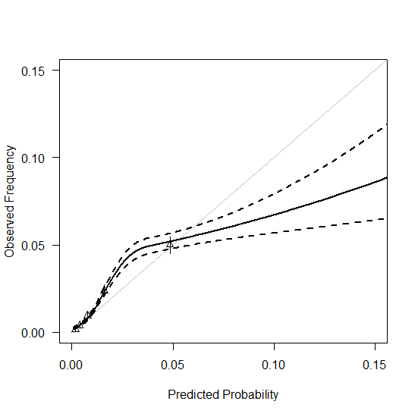

Figure L: Calibration plots for the TSCE incidence model for 6-year lung cancer mortality in all datasets

NLST CT arm NLST CXR arm

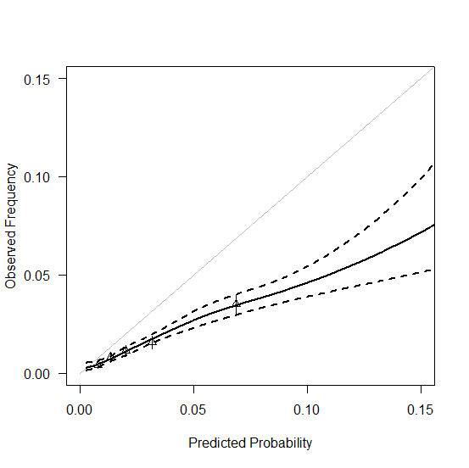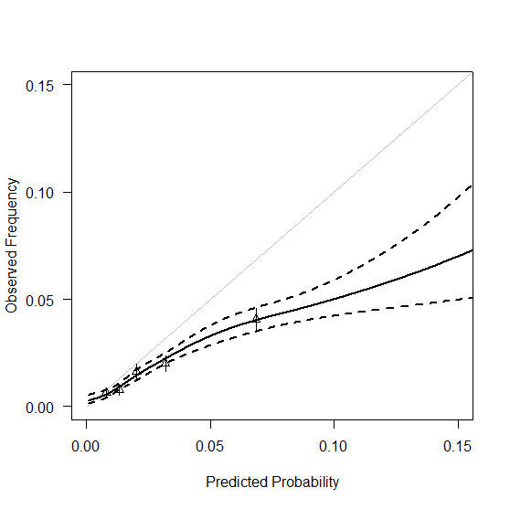

PLCO CXR arm PLCO Control arm

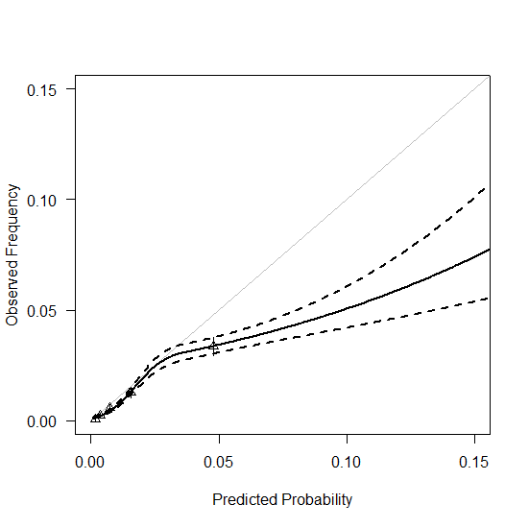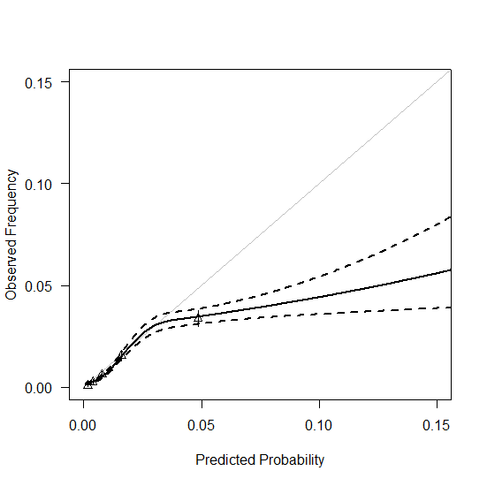

Figure M: Calibration plots for the Knoke model for 6-year lung cancer incidence in all datasets

NLST CT arm NLST CXR arm

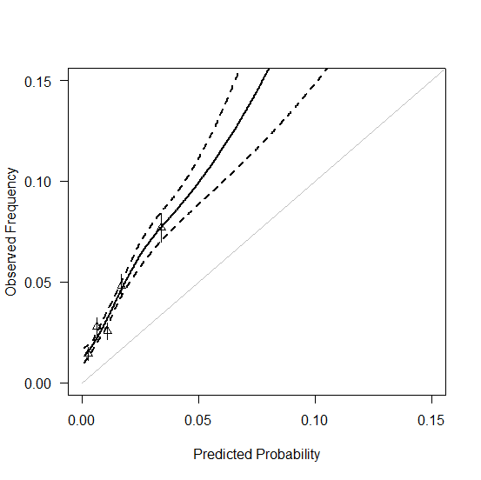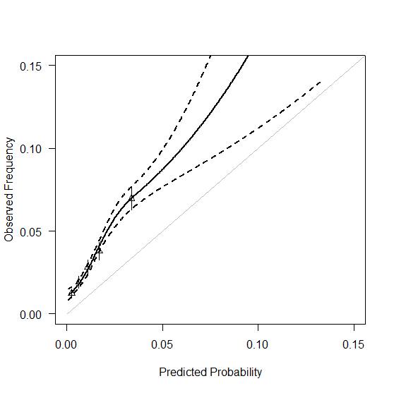

PLCO CXR arm PLCO Control arm

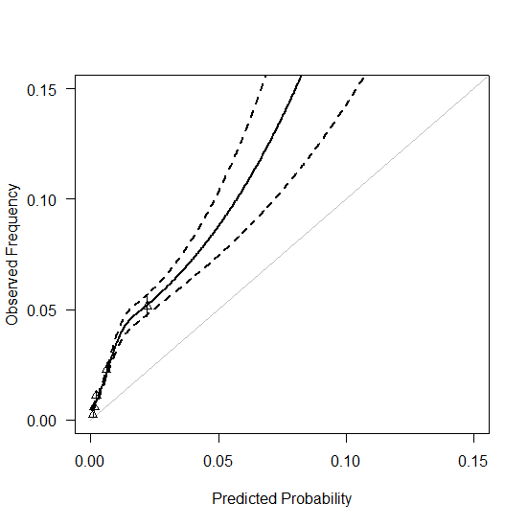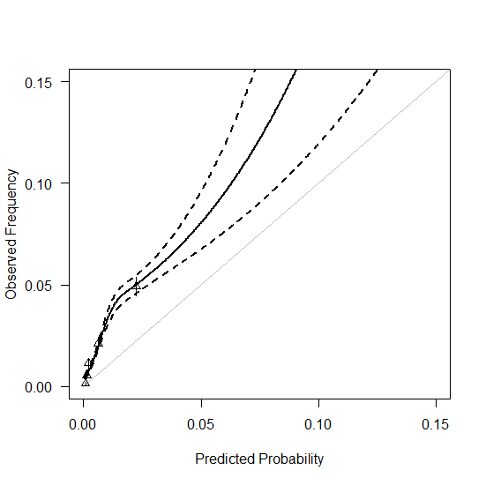

Figure N: Calibration plots for the Knoke model for 6-year lung cancer mortality in all datasets

NLST CT arm NLST CXR arm
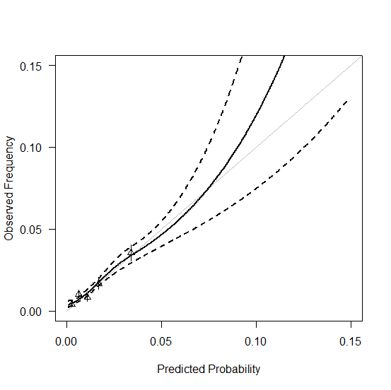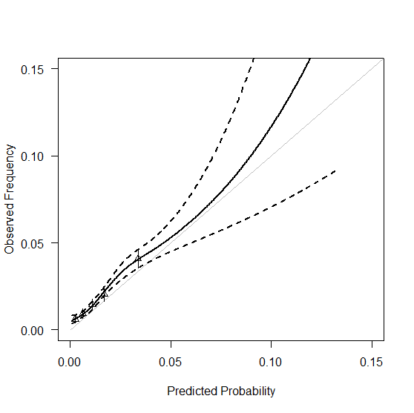

PLCO CXR arm PLCO Control arm

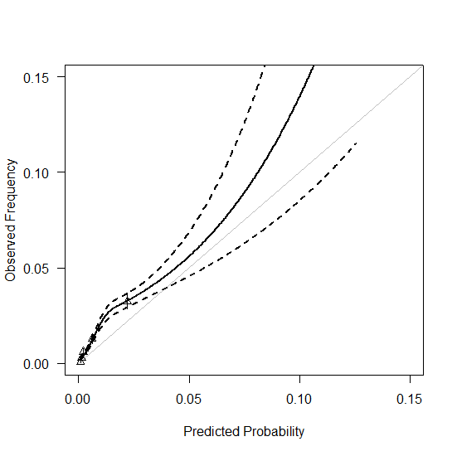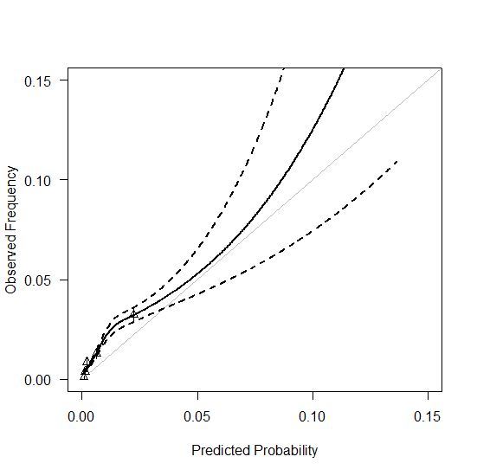

Figure O: Calibration plots for the TSCE CPS lung cancer death model for 6-year lung cancer incidence in all datasets

NLST CT arm NLST CXR arm

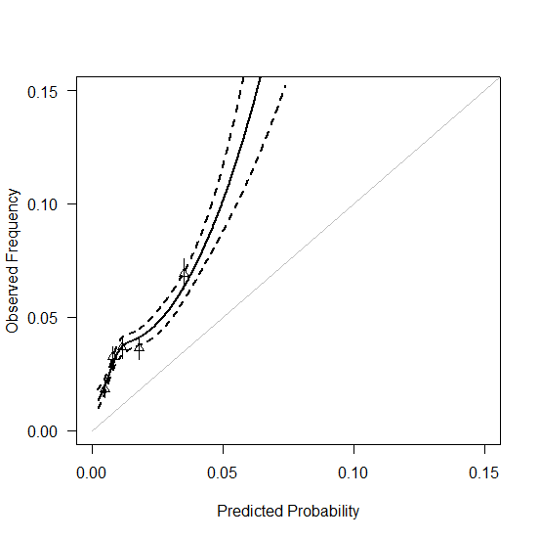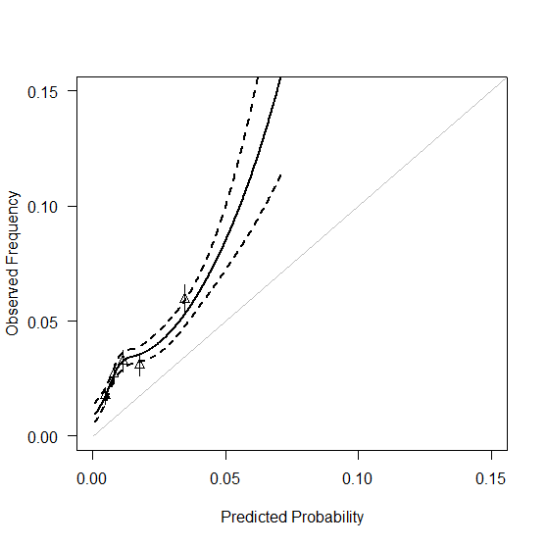

PLCO CXR arm PLCO Control arm
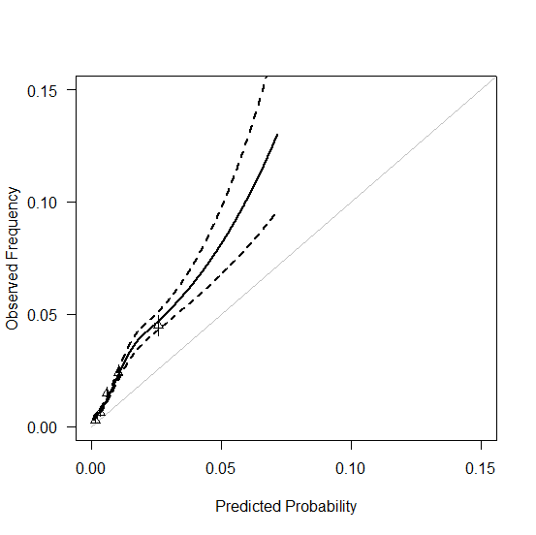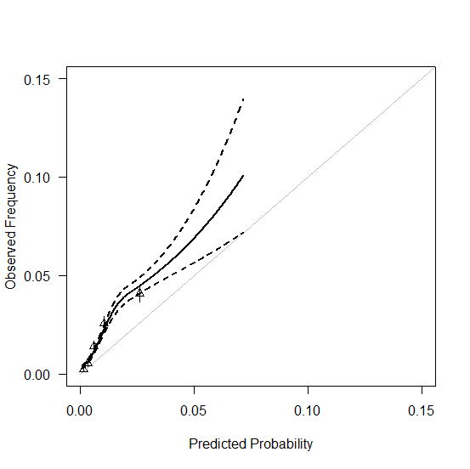

Figure P: Calibration plots for the TSCE CPS lung cancer death model for 6-year lung cancer mortality in all datasets

NLST CT arm NLST CXR arm
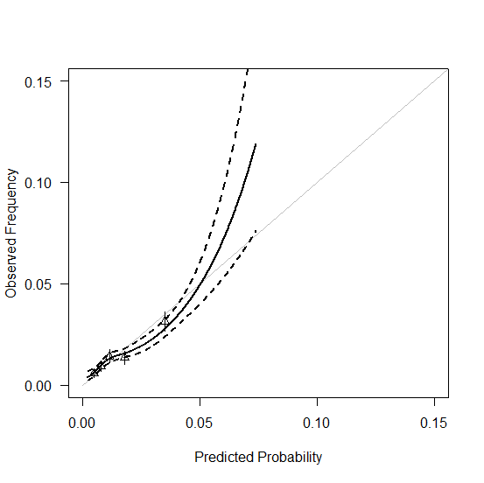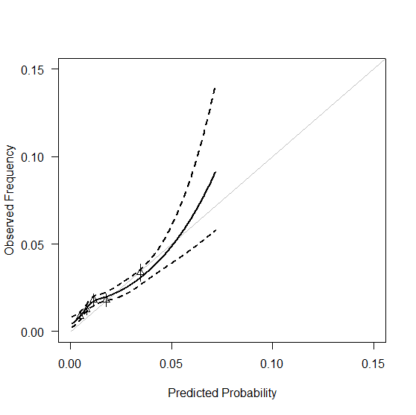

PLCO CXR arm PLCO Control arm
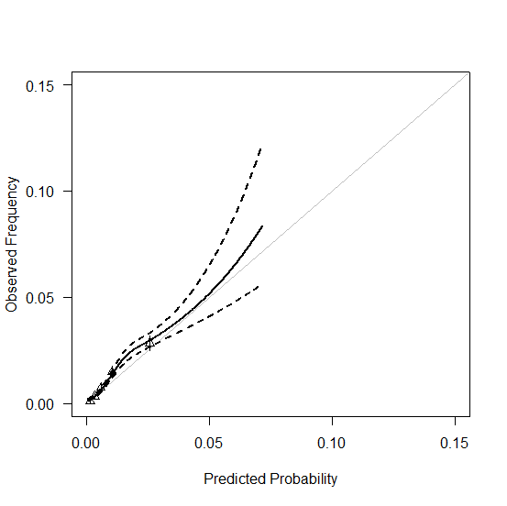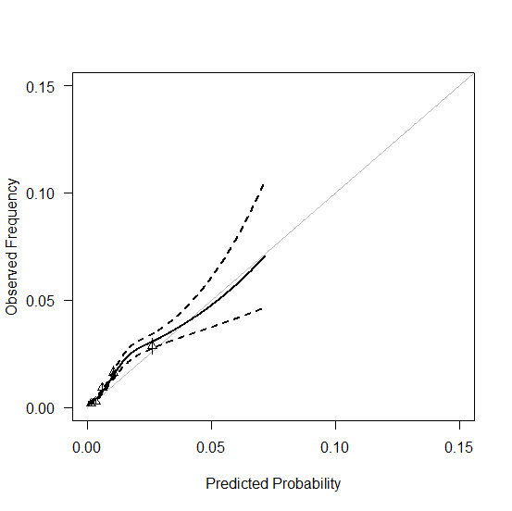

Figure Q: Calibration plots for the TSCE NHS/HPFS lung cancer death model for 6-year lung cancer incidence in all datasets

NLST CT arm NLST CXR arm

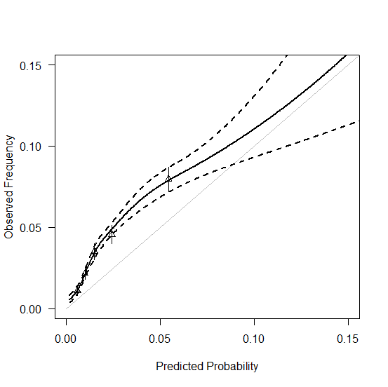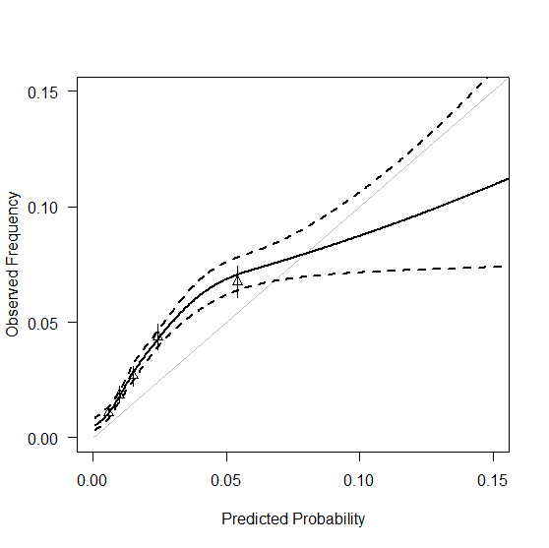

PLCO CXR arm PLCO Control arm

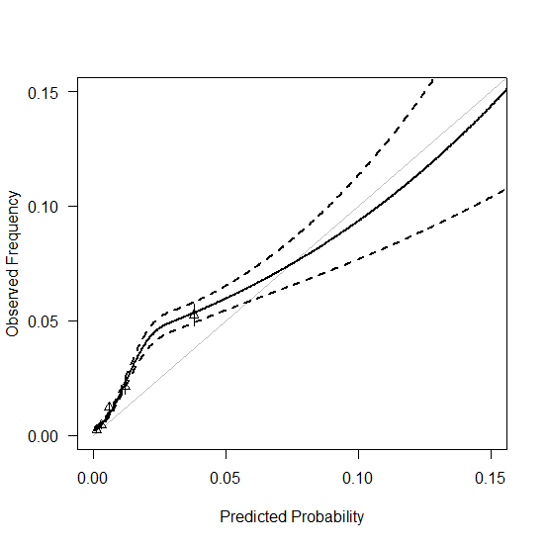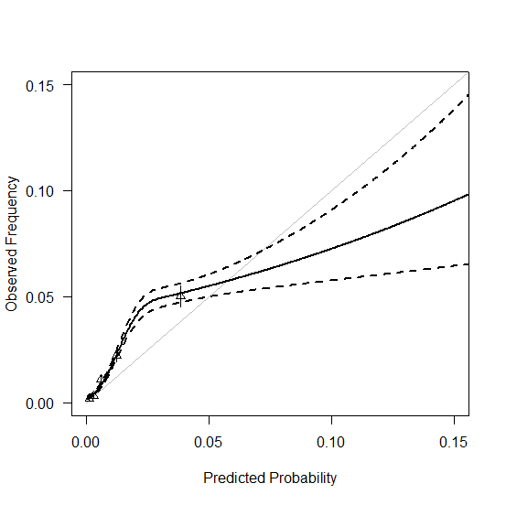

Figure R: Calibration plots for the TSCE NHS/HPFS lung cancer death model for 6-year lung cancer mortality in all datasets

NLST CT arm NLST CXR arm

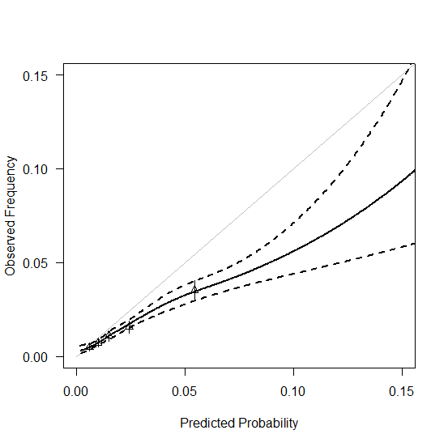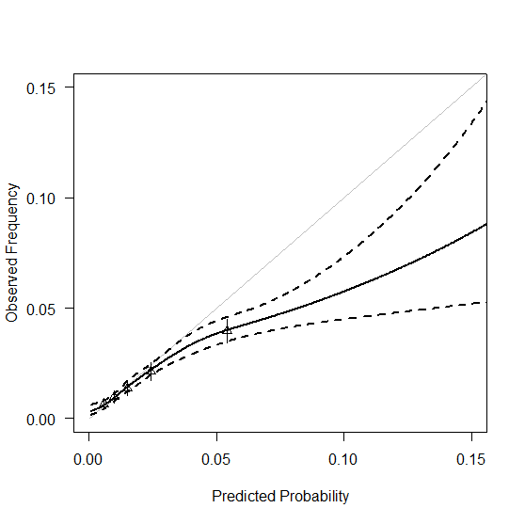

PLCO CXR arm PLCO Control arm
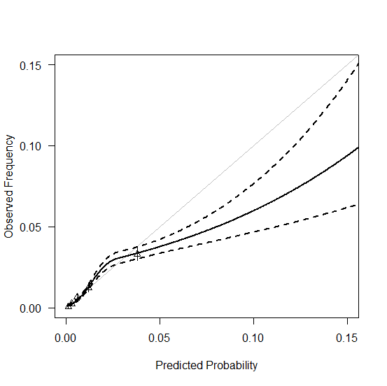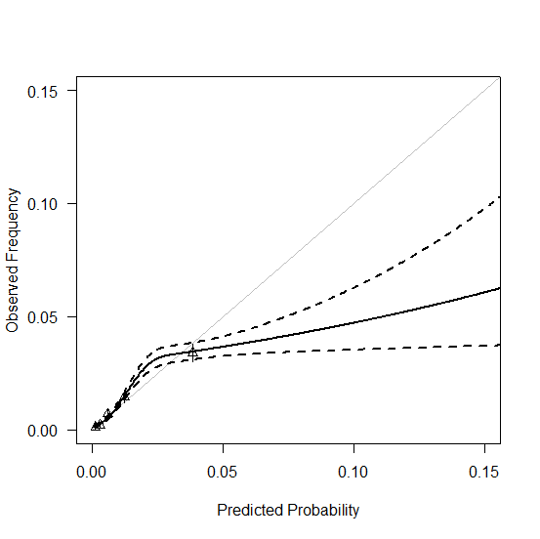

Table A: Calibration intercepts of models for 6-year lung cancer incidence
Intercepts | NLST (CT-arm) | NLST (CXR arm) | PLCO (CXR arm) | PLCO (Control arm)
Bach model | 0.16 | 0.01 | 0.06 | -0.01
LLP model | 0.22 | 0.07 | -0.12 | -0.19
Simplified LLP model | 0.47 | 0.32 | 0.1 | 0.03
PLCOm2102 model | 0.13 | -0.02 | 0.06 | 0.00
Simplified PLCOm2102 model | 0.45 | 0.30 | 0.32 | 0.26
TSCE incidence model | 0.33 | 0.18 | 0.20 | 0.13
Knoke model | 1.06 | 0.91 | 0.78 | 1.02
TSCE CPS death model | 0.96 | 0.82 | 0.72 | 0.66
TSCE NHS/HPFS death model | 0.60 | 0.45 | 0.47 | 0.40

Table B: Calibration slopes of models for 6-year lung cancer incidence
Slopes | NLST (CT-arm) | NLST (CXR arm) | PLCO (CXR arm) | PLCO (Control arm)
Bach model | 1.04 | 1.09 | 0.99 | 0.99
LLP model | 0.68 | 0.73 | 1.05 | 1.05
Simplified LLP model | 0.76 | 0.80 | 1.07 | 1.05
PLCOm2102 model | 0.87 | 0.91 | 0.94 | 0.98
Simplified PLCOm2102 model | 1.03 | 1.04 | 1.02 | 1.04
TSCE incidence model | 0.80 | 0.79 | 0.87 | 0.87
Knoke model | 0.70 | 0.72 | 1.09 | 0.79
TSCE CPS death model | 0.63 | 0.59 | 0.90 | 0.89
TSCE NHS/HPFS death model | 0.77 | 0.76 | 0.85 | 0.84

Table C: Calibration intercepts of models for 6-year lung cancer mortality
Intercepts | NLST (CT-arm) | NLST (CXR arm) | PLCO (CXR arm) | PLCO (Control arm)
Bach model | -0.83 | -0.62 | -0.49 | -0.44
LLP model | -0.77 | -0.57 | -0.67 | -0.61
Simplified LLP model | -0.52 | -0.31 | -0.44 | -0.39
PLCOm2102 model | -0.87 | -0.66 | -0.49 | -0.42
Simplified PLCOm2102 model | -0.54 | -0.33 | -0.22 | -0.17
TSCE incidence model | -0.67 | -0.46 | -0.35 | -0.30
Knoke model | 0.06 | 0.27 | 0.53 | 0.59
TSCE CPS death model | -0.03 | 0.19 | 0.18 | 0.23
TSCE NHS/HPFS death model | -0.40 | -0.19 | -0.08 | -0.03

Table D: Calibration slopes of models for 6-year lung cancer mortality
Slopes | NLST (CT-arm) | NLST (CXR arm) | PLCO (CXR arm) | PLCO (Control arm)
Bach model | 1.21 | 1.17 | 1.12 | 0.97
LLP model | 0.85 | 0.69 | 1.18 | 1.09
Simplified LLP model | 0.91 | 0.79 | 1.21 | 1.09
PLCOm2102 model | 1.01 | 0.92 | 1.01 | 0.95
Simplified PLCOm2102 model | 1.19 | 1.10 | 1.11 | 1.02
TSCE incidence model | 0.91 | 0.84 | 0.94 | 0.86
Knoke model | 0.89 | 0.80 | 0.85 | 0.76
TSCE CPS death model | 0.82 | 0.65 | 0.99 | 0.92
TSCE NHS/HPFS death model | 0.87 | 0.80 | 0.92 | 0.84

