Text S5: Multivariate analysis of factors associated with “spin” in press releases
For the multivariable analysis, we choose a bootstrap model selection variable method; the multivariable model on the full set of variables was evaluated 1000 times on the 1000 bootstrap samples.
Variables with a p-value < 0.25 in the bivariate analysis were included in the 1000 multivariable models (journal, spin in the abstract conclusion, sample size (large/small)). For each variable, the frequency of a p-value <0.05 is calculated and reported on the enclosed barplot.
Variables identified as independent factors associated with spin in the press release (p<0.05) in at least 60% of the bootstrap samples were kept in the final multivariable model. The only variable kept is spin in the abstract conclusion.
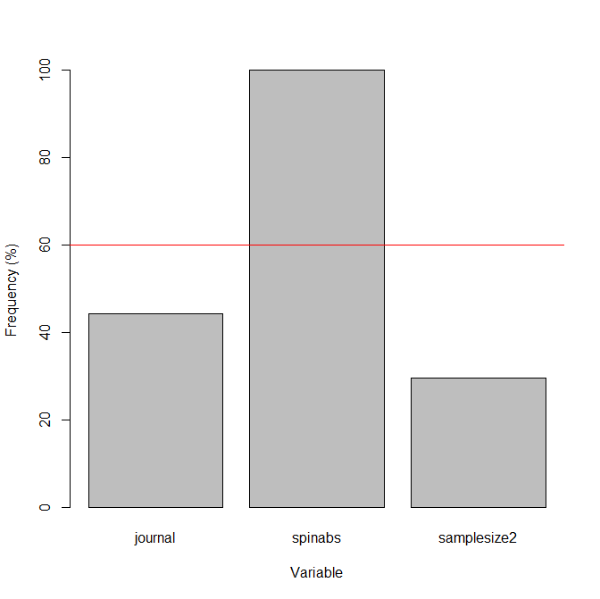
Journal
Sample size
Spin abstract

