S1 Fig
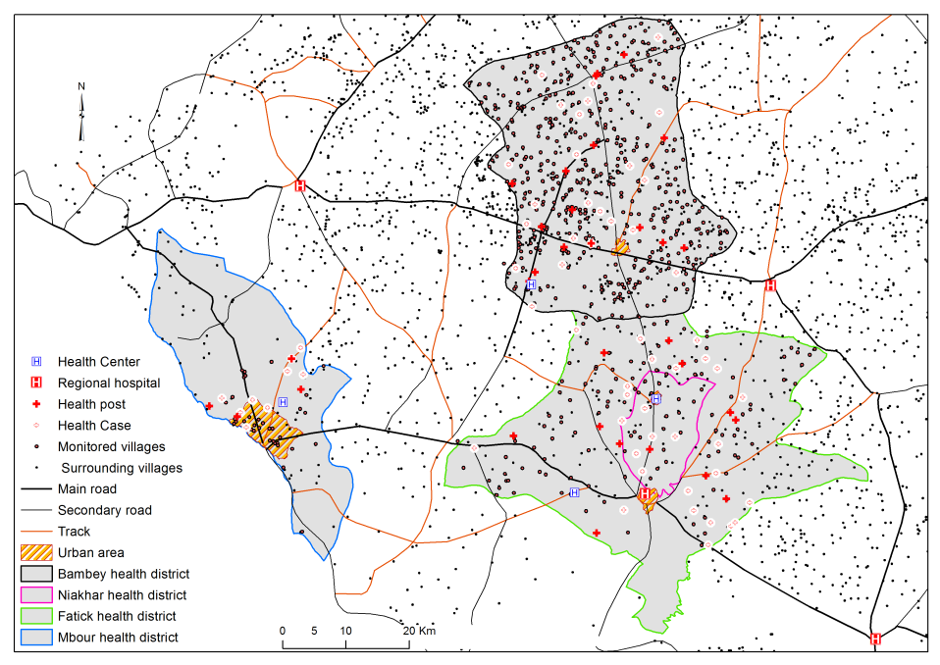
Map of the study area showing surrounding villages
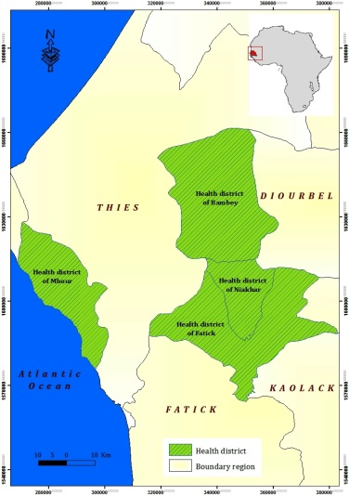

Biting rates from human landing catches in the four monitoring sites:
