S4 Fig

S4A Fig
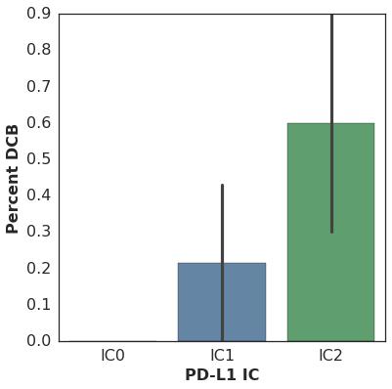
PD-L1 IC staining as reported by the sponsor in the published study (2) and outcome in our cohort were significantly associated in this sub-study (n=29, Spearman rho=0.48 p=0.0083).

S4B Fig
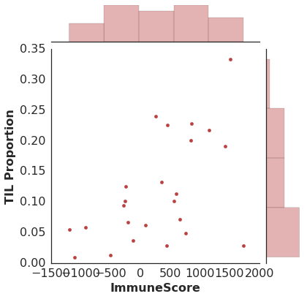
ImmuneScore was associated with TIL proportion (n=24, Spearman rho=0.47 p=0.022).

S4C Fig
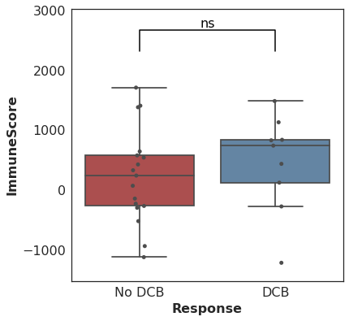
There was no association between ImmuneScore and DCB (DCB, 764.37 (range -1195.08-1509.65); no DCB 263.49 (range -1100.78-1734.28) (n=26, Mann-Whitney p=0.33).

S4D Fig
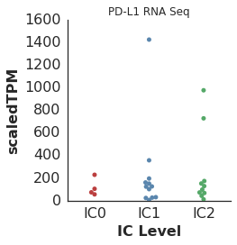
PD-L1 expression as measured by RNA-seq was not associated with PD-L1 IC level (n=26, Spearman rho=0.045 p=0.83). Tumor cell PD-L1 staining was not available.

S4E Fig

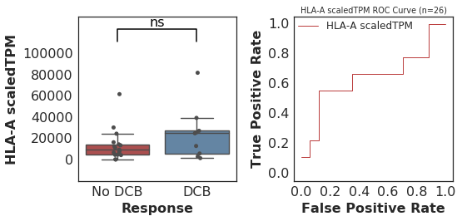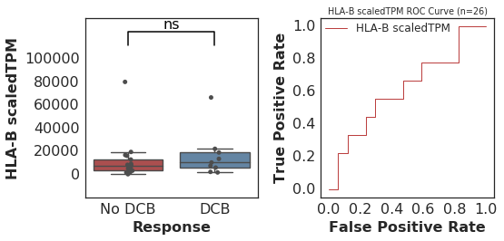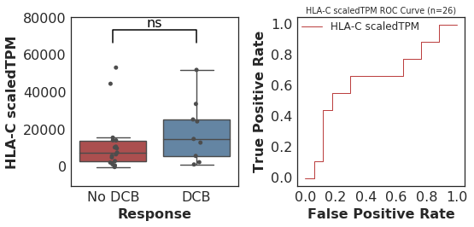
HLA Class I expression was not associated with DCB (HLA-A: n=26, Mann-Whitney p=0.26, HLA-B: n=26, Mann-Whitney p=0.36, HLA-C: n=26, Mann-Whitney p=0.24).

S4F Fig
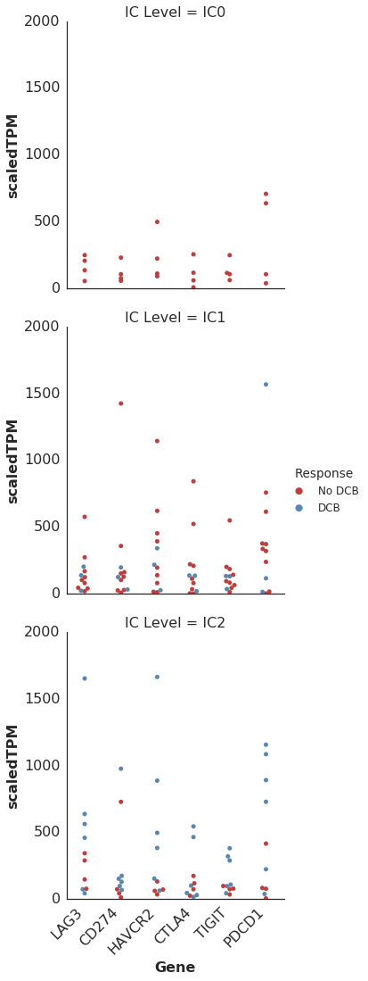
Expression of other inhibitory markers, in particular HAVCR2 (also known as TIM-3) was higher in DCB patients in the IC2 group.

S4G Fig
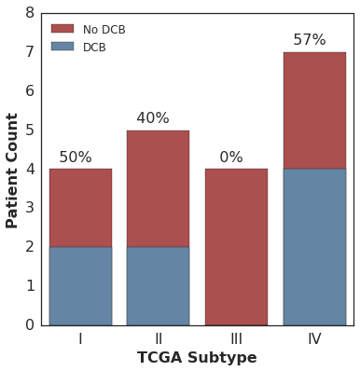
No association was found between TCGA RNA Subtype and response in this sub-study (n=20, Fisher's Exact p=0.36).

