S3 Fig

Paid price of soft drinks over time
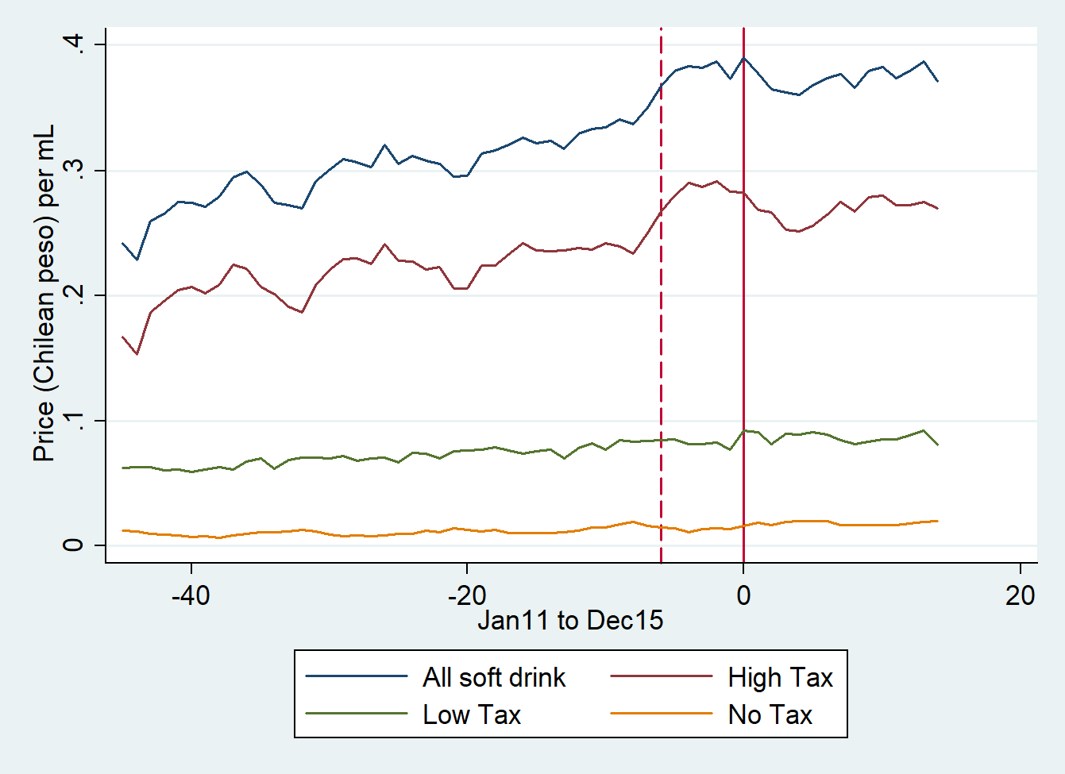

Note: The dashed and solid red line show the announcement and the implementation of the tax policy, respectively.

