S8 Figure. Crude vs. adjusted data for studies reporting adjusted odds ratios

S8A Figure. Pre-term birth meta-analysis: crude vs. adjusted pooled odds ratio
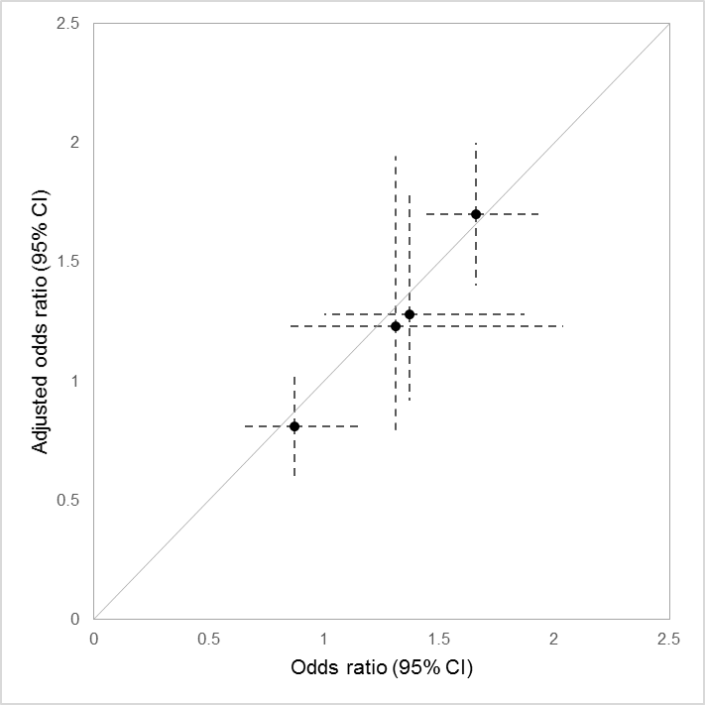
Crude odds ratio vs. adjusted odds ratios (with 95% confidence intervals) for the four studies which provided adjusted odds ratios for bariatric surgery and pre-term birth [Kjaer et al. 2013, Roos et al. 2013, Adams et al. 2015, Johansson et al. 2015]. The solid grey line represents the line of equality.

S8B Figure. Post-term birth meta-analysis: crude vs. adjusted pooled odds ratio
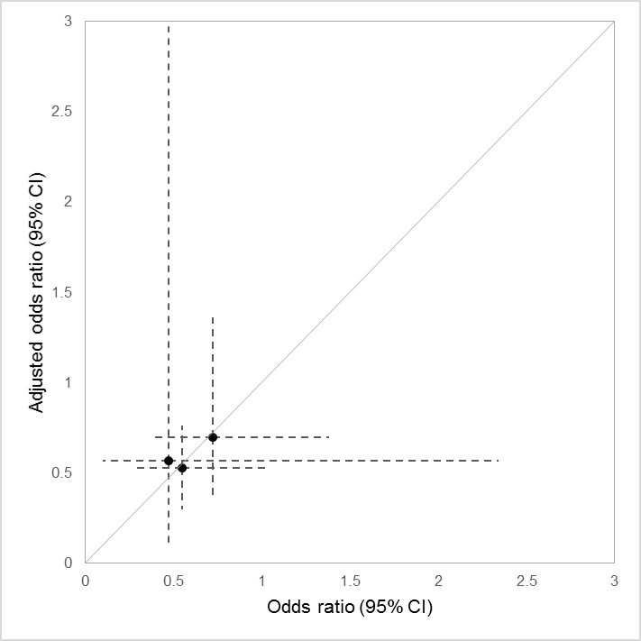
Crude odds ratio vs. adjusted odds ratios (with 95% confidence intervals) for the three studies which provided adjusted odds ratios for bariatric surgery and post-term birth [Wax et al. 2008, Kjaer et al. 2013, Adams et al. 2015]. The solid grey line represents the line of equality.

S8C Figure. Large for gestational age meta-analysis: crude vs. adjusted pooled odds ratio
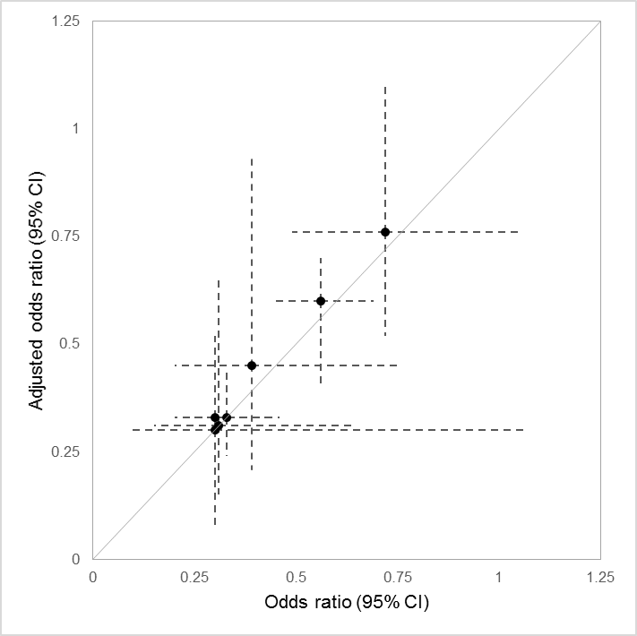
Crude odds ratio vs. adjusted odds ratios (with 95% confidence intervals) for the seven studies which provided adjusted odds ratios for bariatric surgery and large for gestational age [Weintraub et al. 2008, Burke et al. 2010, Lesko and Peaceman 2012, Kjaer et al. 2013, Roos et al. 2013, Adams et al. 2015, Johansson et al. 2015]. The solid grey line represents the line of equality.

S8D Figure. Small for gestational age meta-analysis: crude vs. adjusted pooled odds ratio
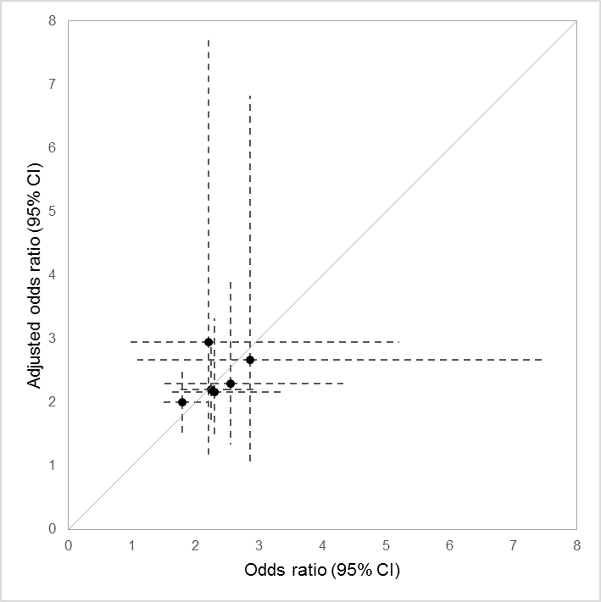
Crude odds ratio vs. adjusted odds ratios (with 95% confidence intervals) for the six studies which provided adjusted odds ratios for bariatric surgery and small for gestational age [Lesko and Peaceman 2012, Kjaer et al. 2013, Roos et al. 2013, Adams et al. 2015, Johansson et al. 2015, Hammeken et al. 2017]. The solid grey line represents the line of equality.

S8E Figure. Congenital anomalies meta-analysis: crude vs. adjusted pooled odds ratio
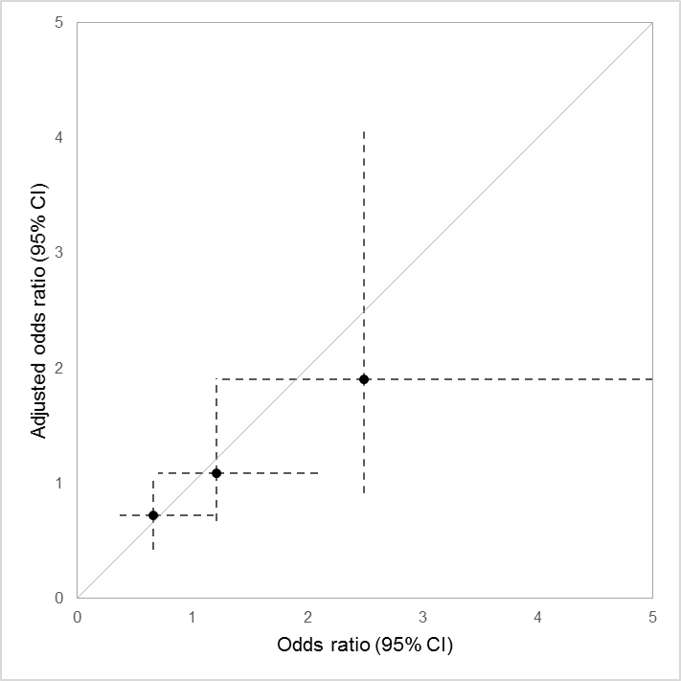
Crude odds ratio vs. adjusted odds ratios (with 95% confidence intervals) for the three studies which provided adjusted odds ratios for bariatric surgery and congenital anomalies [Weintraub et al. 2008, Josefsson et al. 2013, Johansson et al. 2015]. The solid grey line represents the line of equality.

