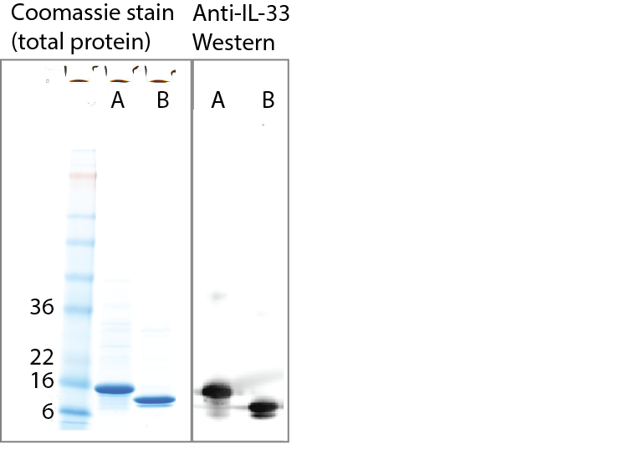
S4 Fig. SDS-PAGE analysis of E.coli-produced IL-33 95-204 variant. On the left is total protein staining with Coomassie blue and molecular weight markers and sizes (in kD) are indicated. On the right is Western analysis of the same samples using anti-hu IL-33 antibody (R&D Systems). Lanes A: Sample fractions before thrombin cleavage (as described in the online methods); Lanes B: Fractions following thrombin cleavage.

