Supporting Information
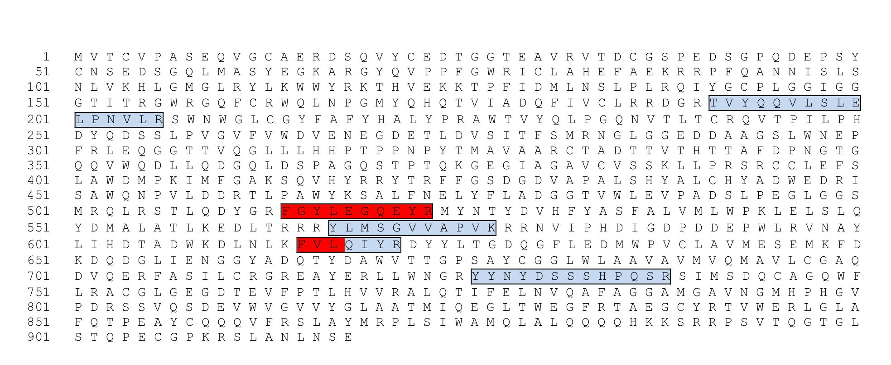
Supporting Figure 1

