A.

RACI_PhaseII-CCPp_GWAS_10cohorts_info7_CD40-rs4810485-44000000-44250000.pdf

ichip_Phenogenetic-IMSGC_combined-protLevel-rs4810485_44e6-4425e4.pdfB.

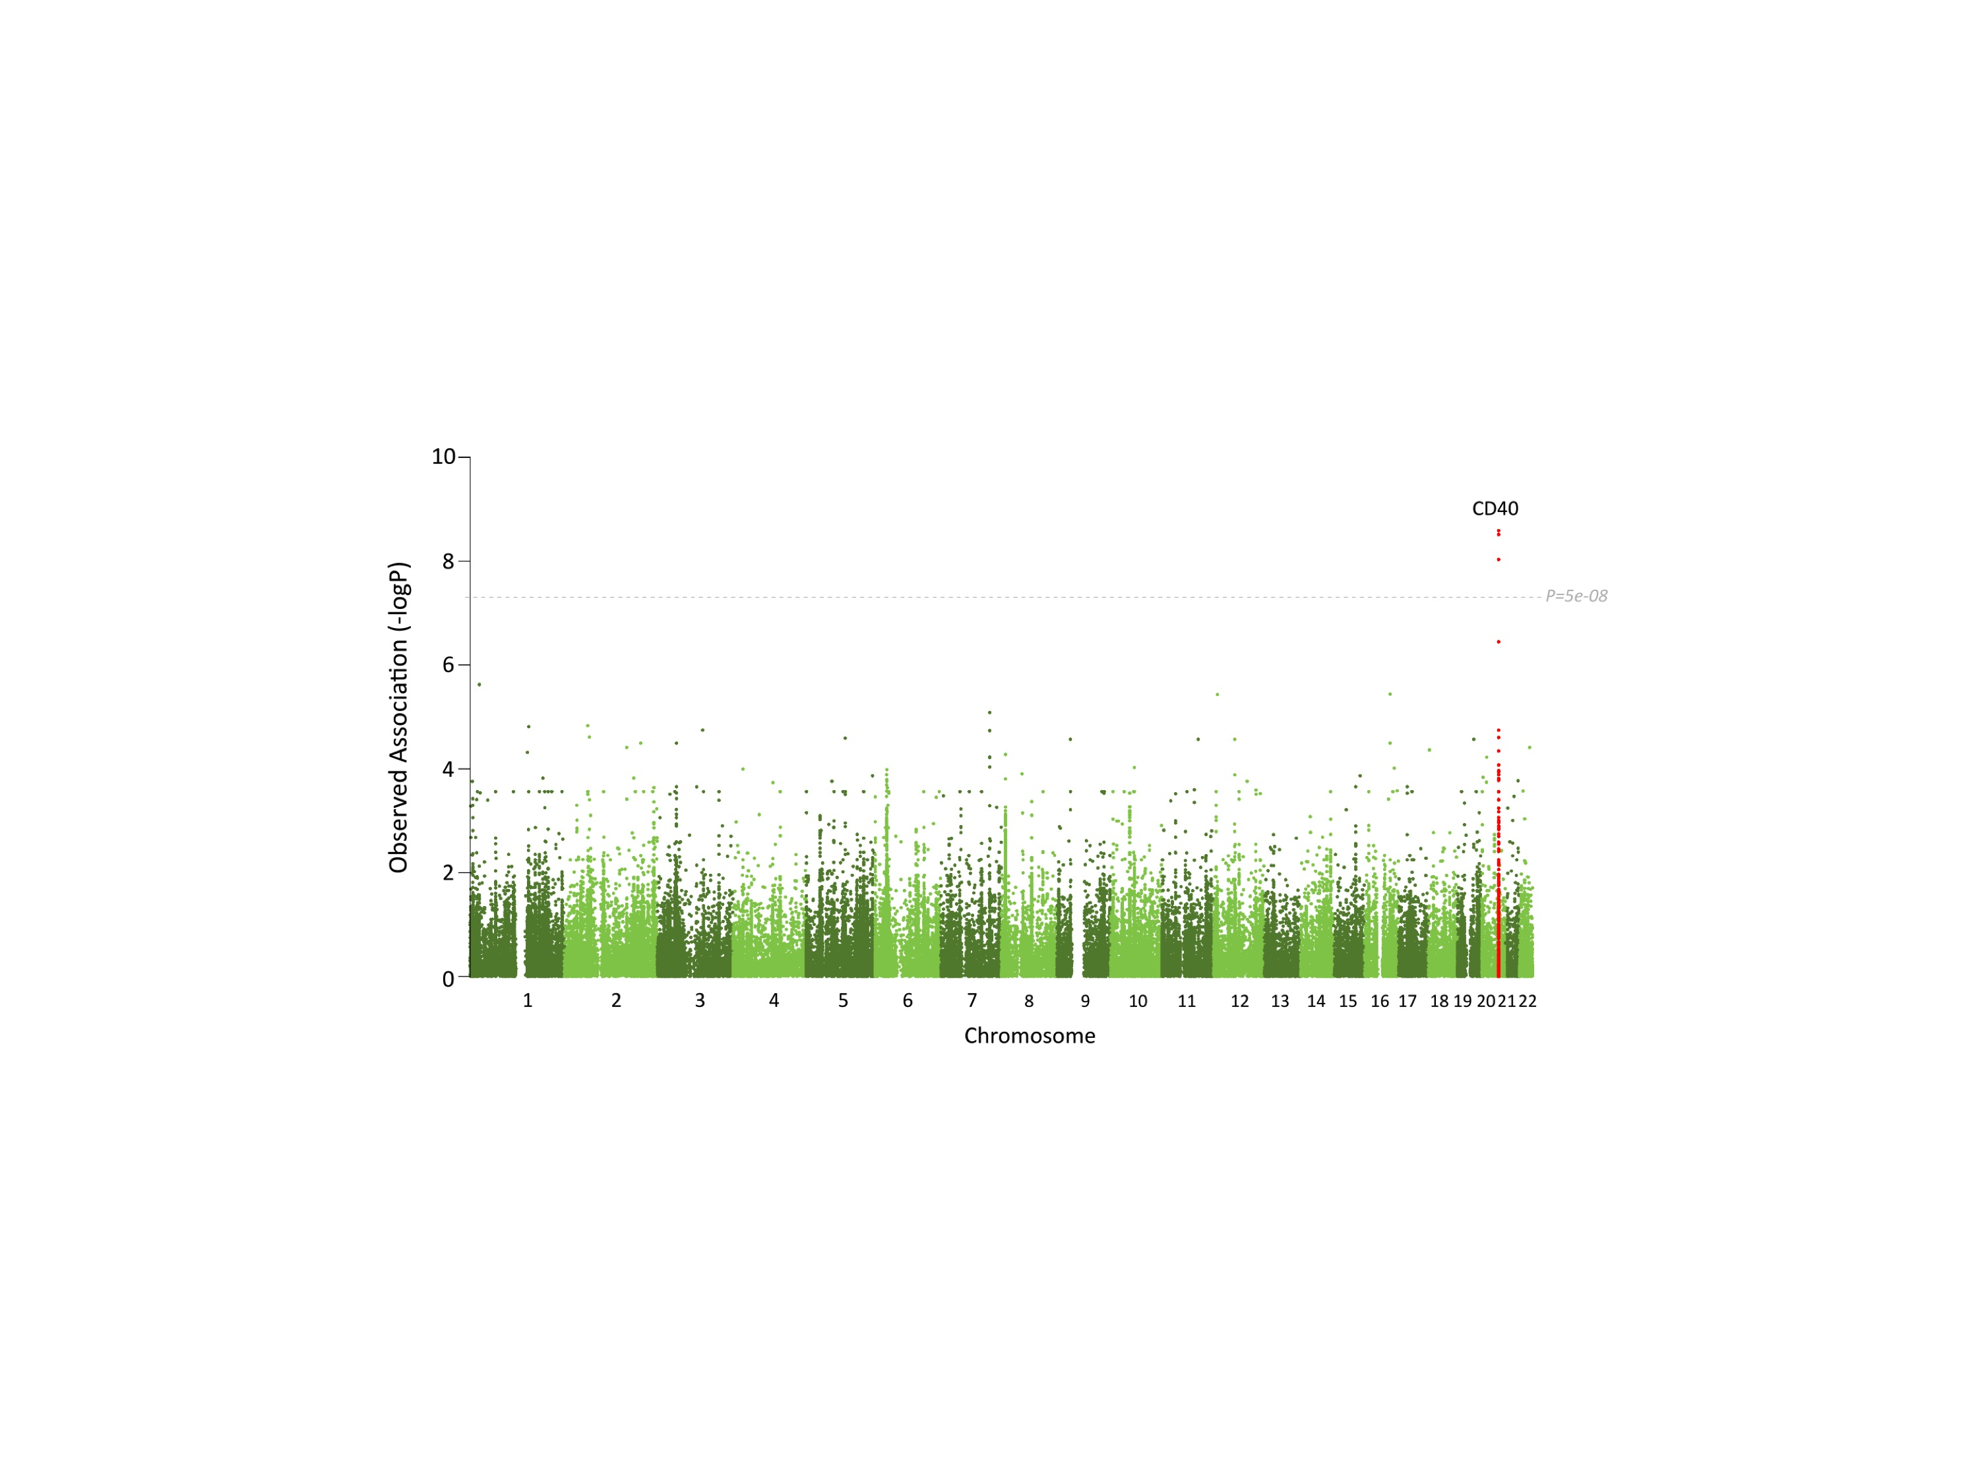C.