Figure S7. Comparison of genetic effect estimates when participants are excluded or included based on medication use with adjustments in WHI.
- HDL-C
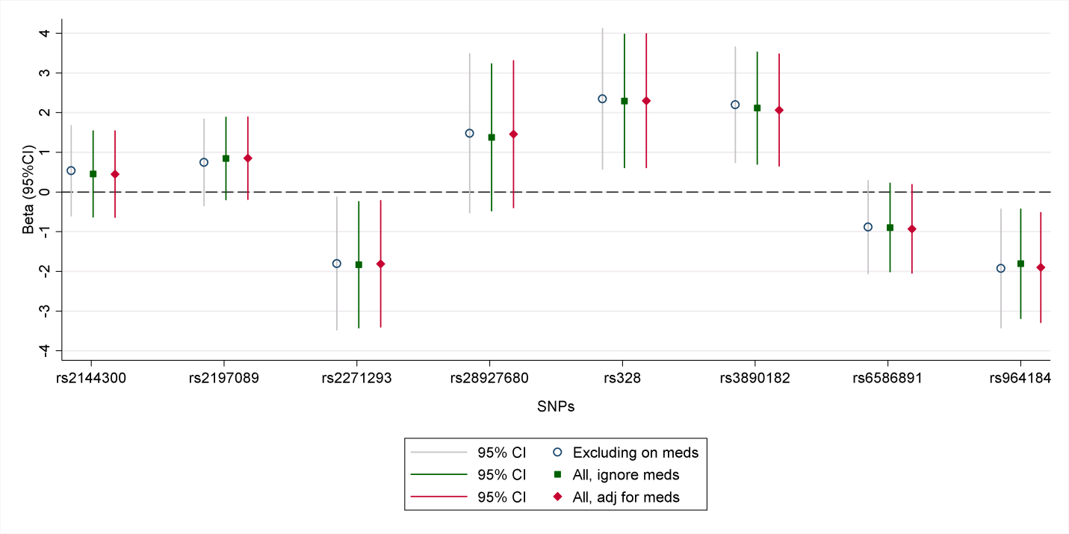

- LDL-C
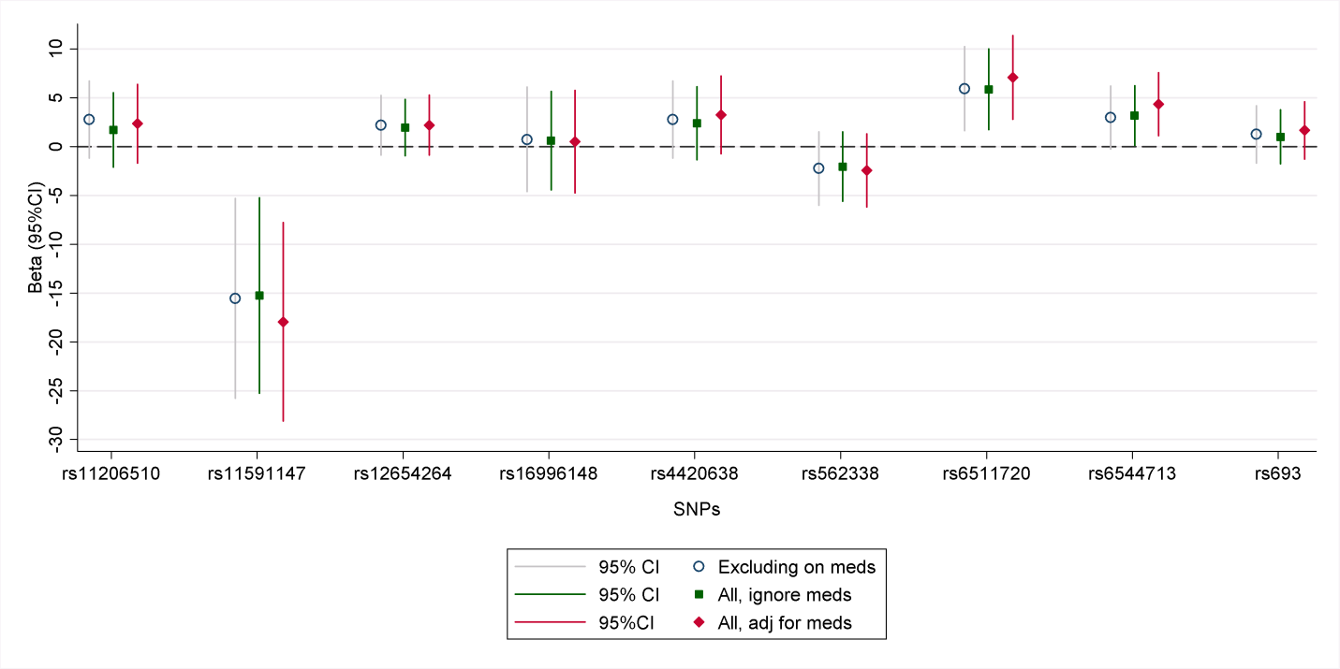
- ln(TG)
