Supplementary Figure S3: PCs 1-5 obtained from 3D coordinates of facial landmarks, represented by (A) Scatterplots and (B) Facial morphs.

These PCs were obtained from Procrustes landmark coordinates after accounting for BMI and sex.
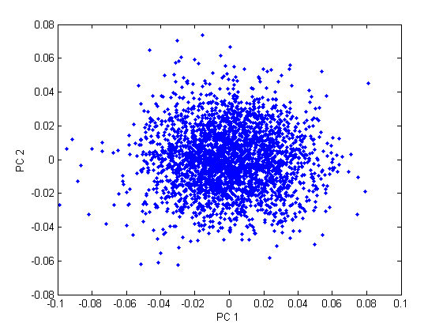
- Scatterplots of PCs:

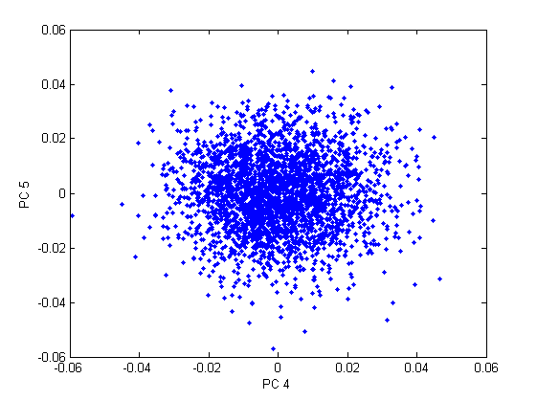
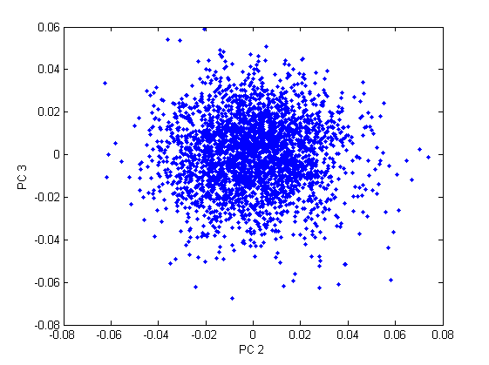
- Facial morphs displaying the shape changes associated with each PC.

