Figure S4 Manhattan plot of the genome-wide P values of association. Association was assessed using logistic regression analysis with adjustment for the first principal components of population stratification.
- Manhattan plot for Central Samples.
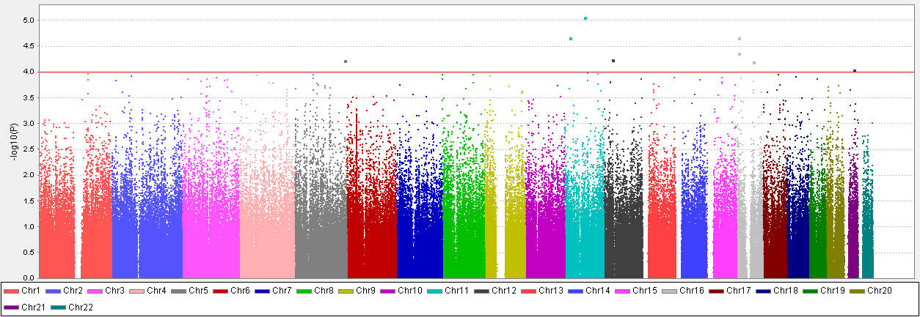
- Manhattan plot for Southern Samples
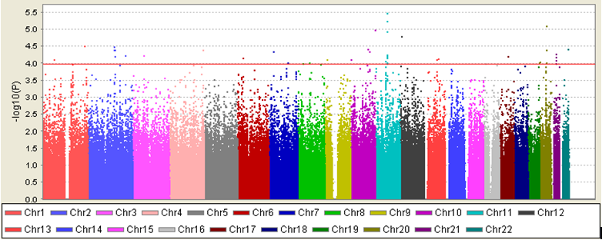
C. Manhattan plot for combined GWAS Samples