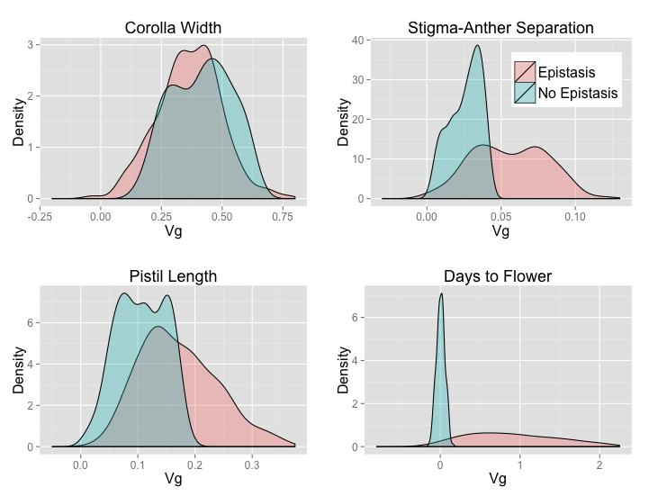
Supplemental Figure 5. Distributions for corrected genetic variance for the Uniform distribution of allele frequencies.

