Figure S3 Quantile-Quantile plot
- QQ plot of Central samples.
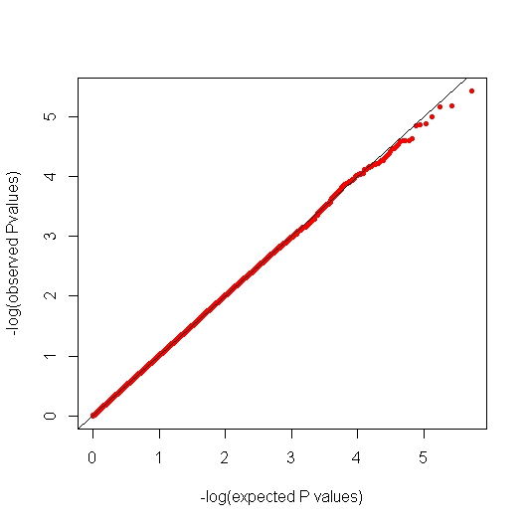
λ=1.013
- QQ plot of Southern Samples
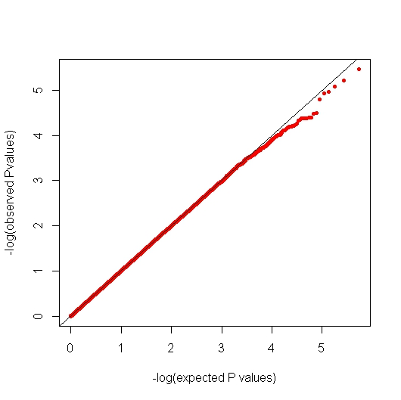
λ=1.003

- QQ plot of combined GWAS Samples
