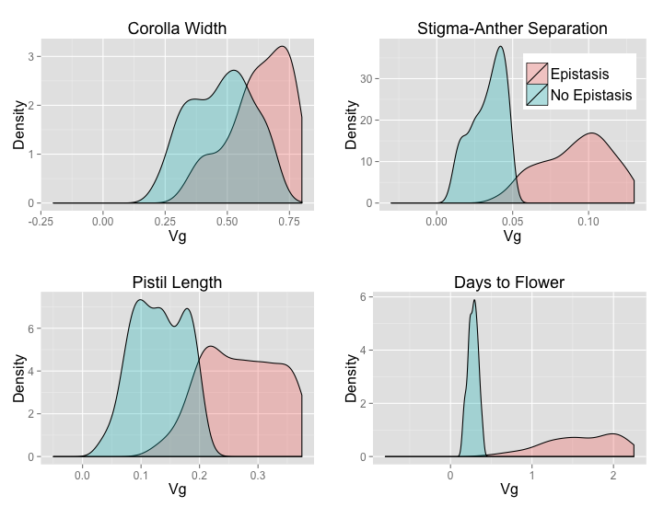
Supplemental Figure 7. Distributions for uncorrected genetic variance for the Uniform distribution of allele frequencies.

