2p24, CHB+JPT HapMap Phase 2
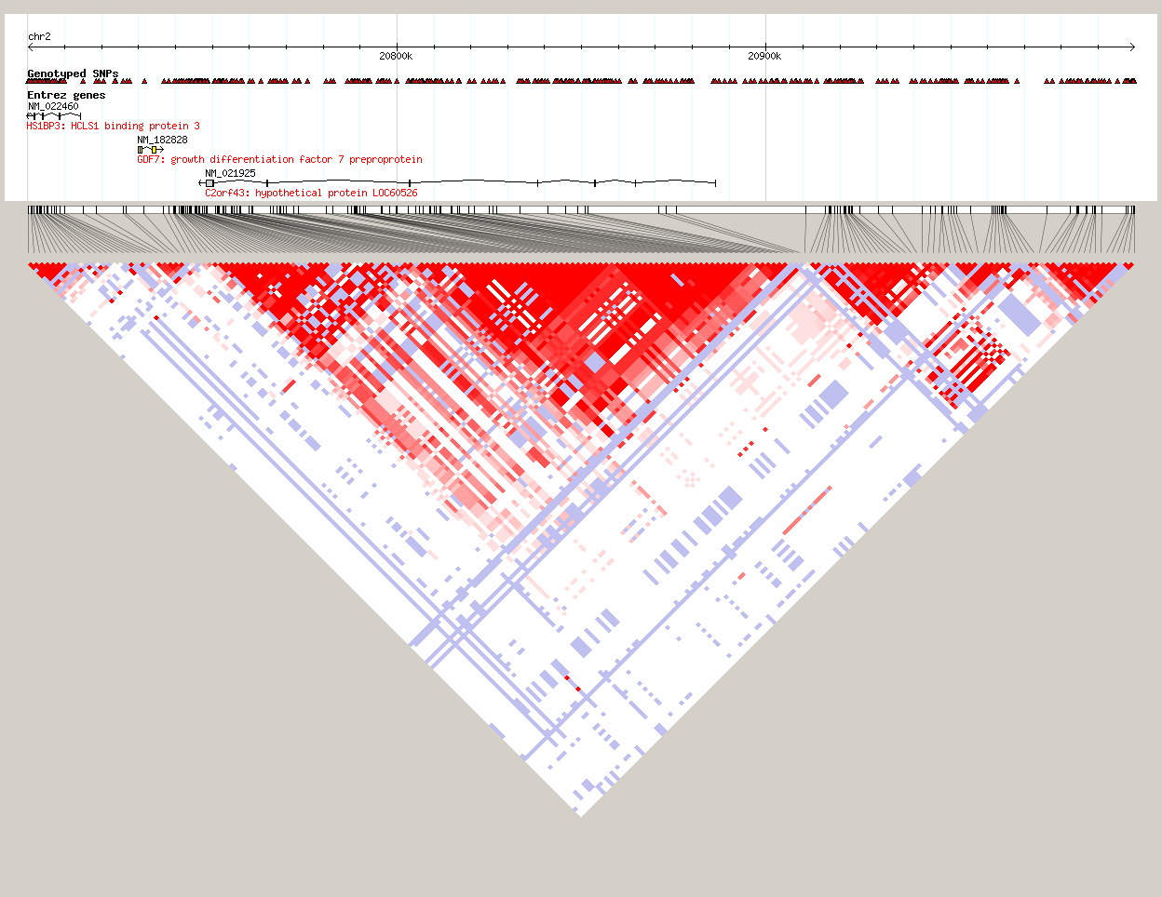
Signal in African Americans
Index Signal
2p24, YRI HapMap Phase 2
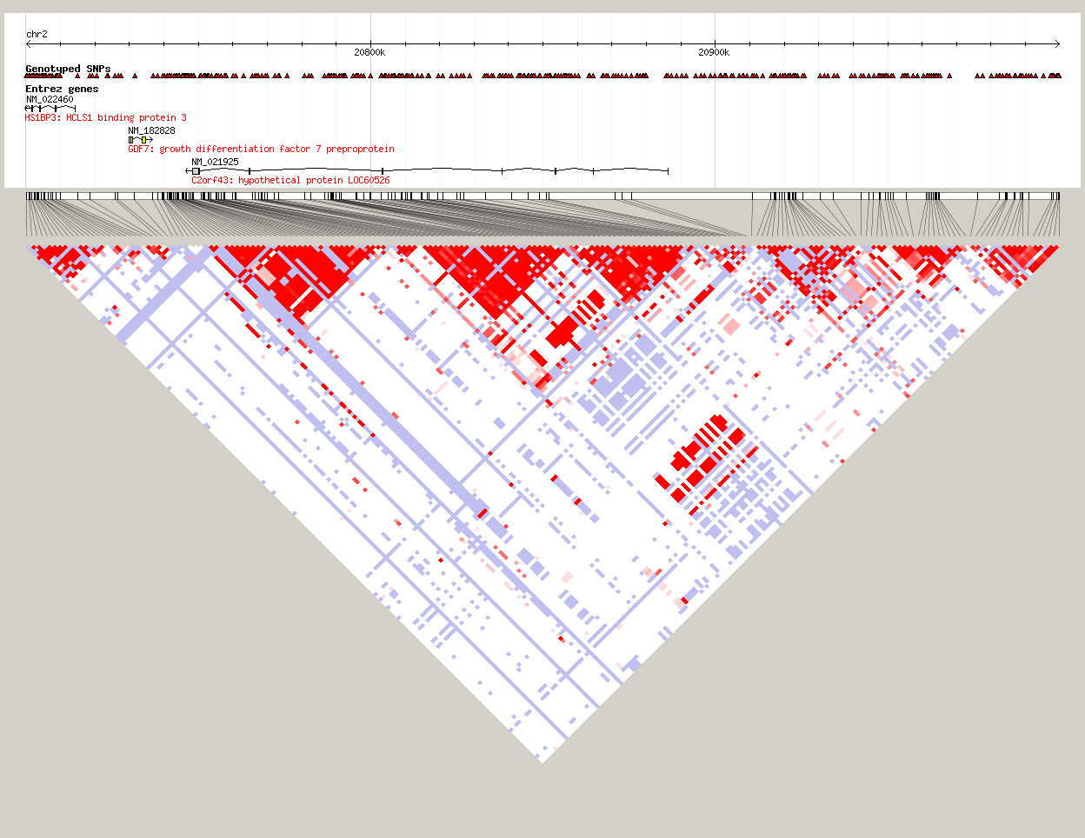
Signal in African Americans
Index Signal
Signal in African Americans
Index Signal
Index Signal
2p15 CEU HapMap Phase 2
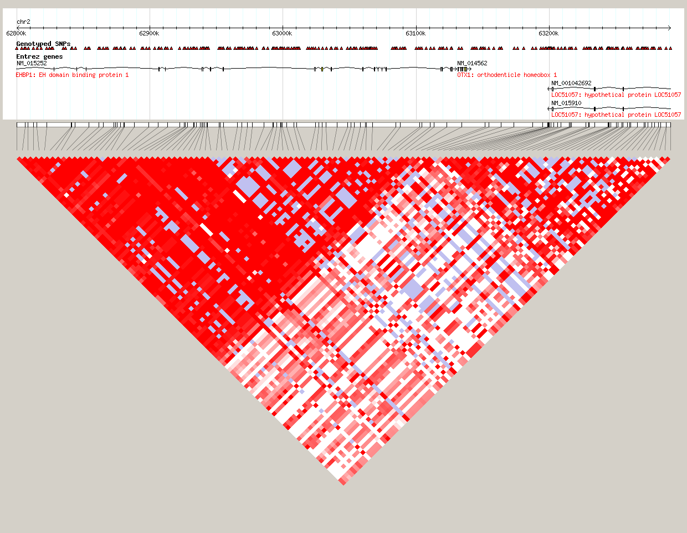
Signal in African Americans
Index Signal
2p15 YRI HapMap Phase 2
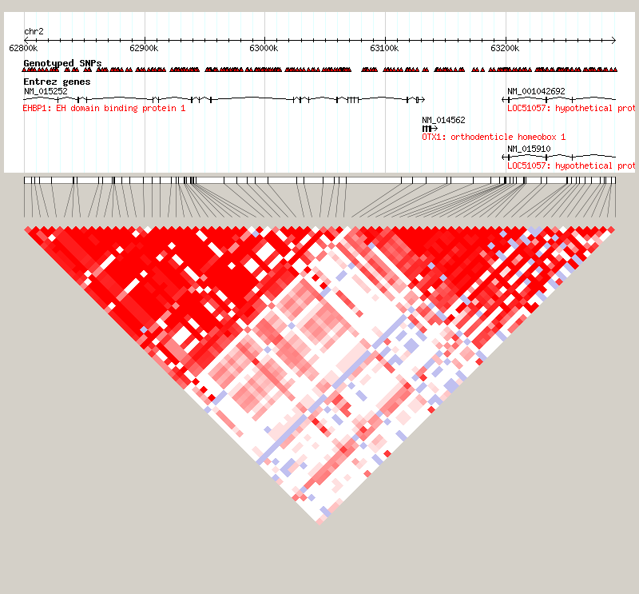
Signal in African Americans
Index Signal
3q21, CEU HapMap Phase 2
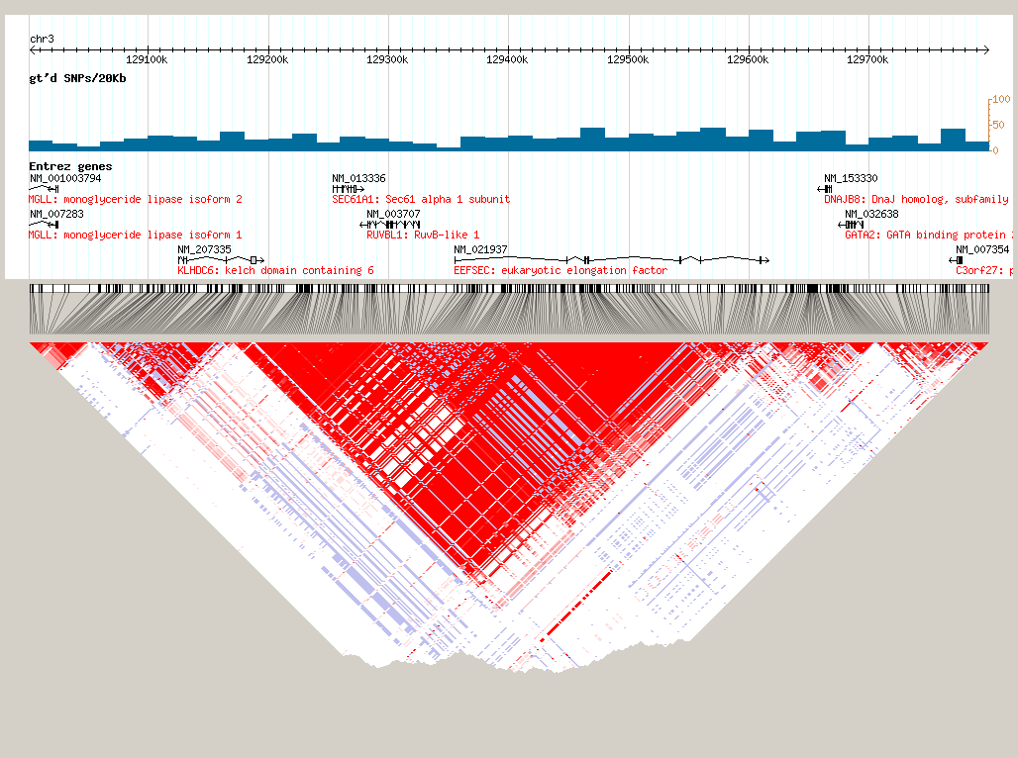
Index Signal
Signal in African Americans

3q21, YRI HapMap Phase 2
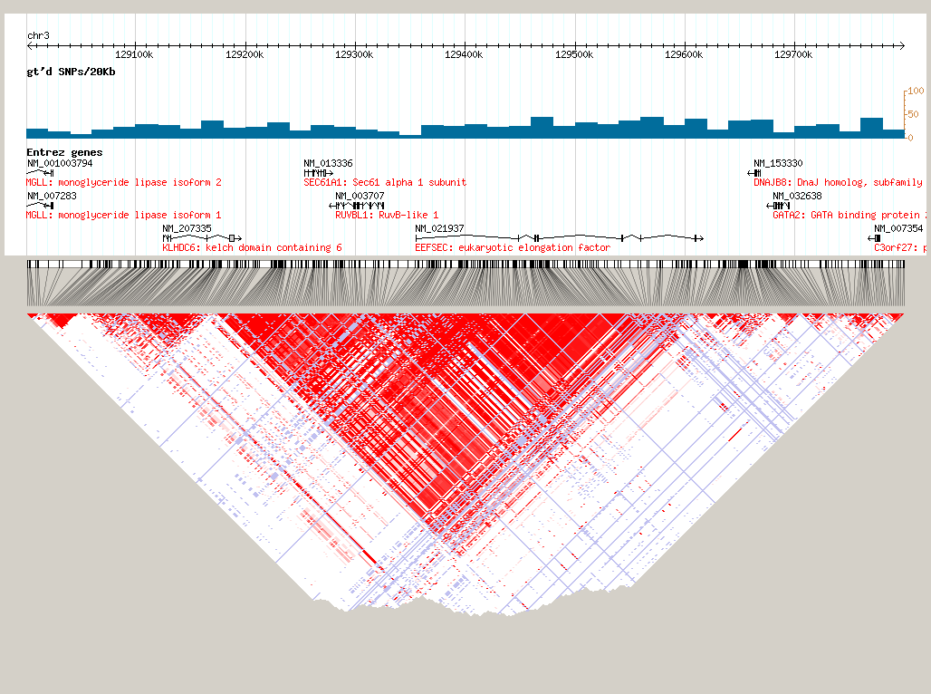
Signal in African Americans
Index Signal

Index Signal
Signal in African Americans

6q22, CHB+JPT HapMap Phase 2
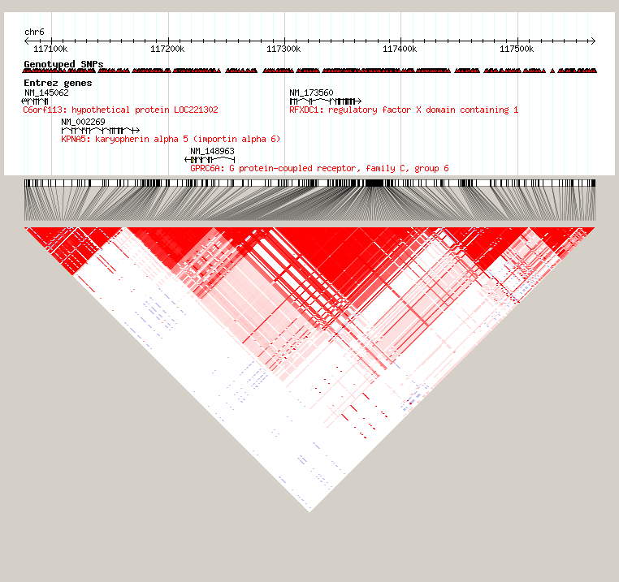
Signal in African Americans
Index Signal

6q22, YRI HapMap Phase 2
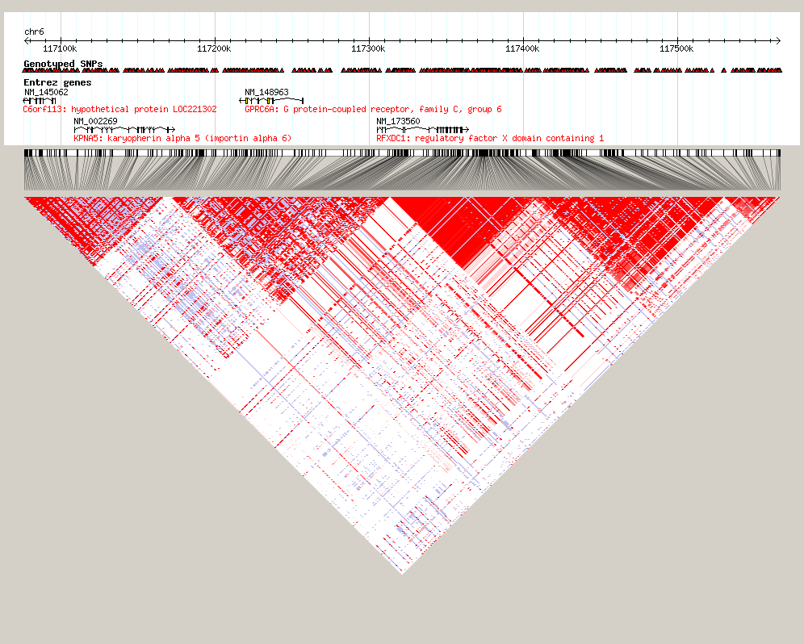
Signal in African Americans
Index Signal

6q25, CEU HapMap Phase 2
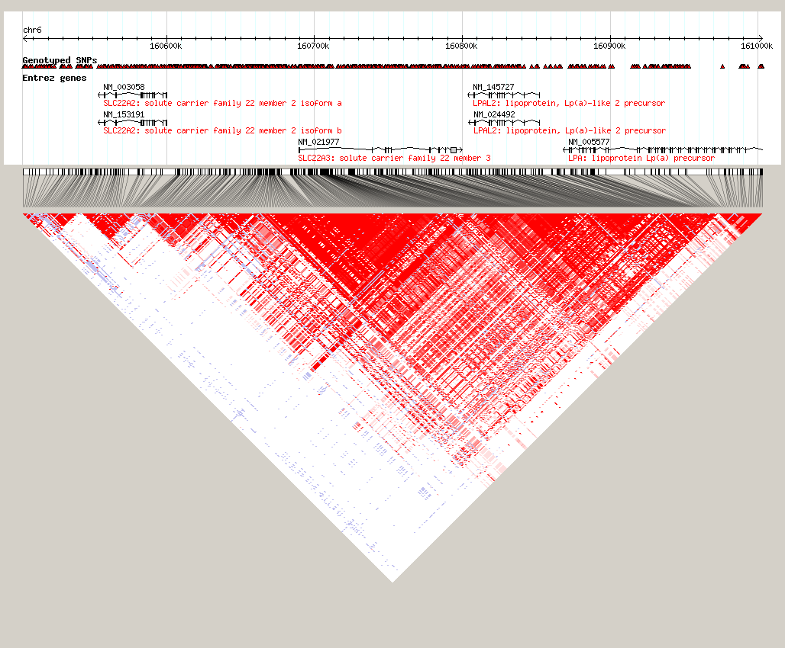
Signal in African Americans
Index Signal
6q25, YRI HapMap Phase 2
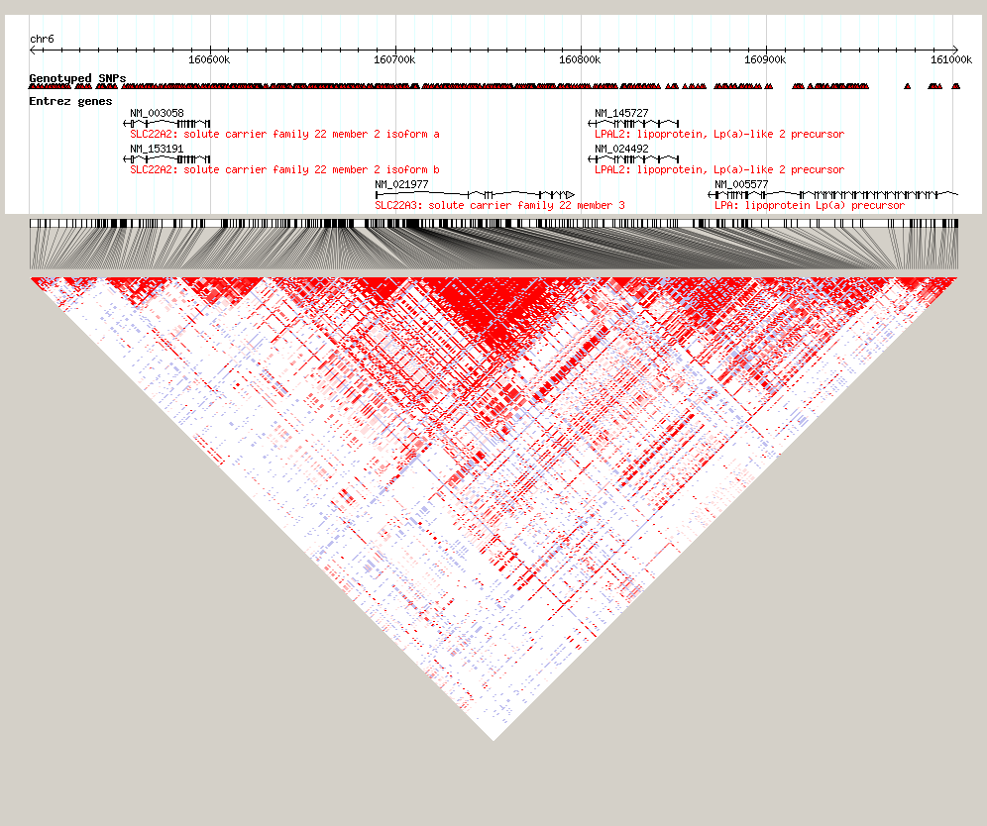
Signal in African Americans
Index Signal

7p15, CEU HapMap Phase 2
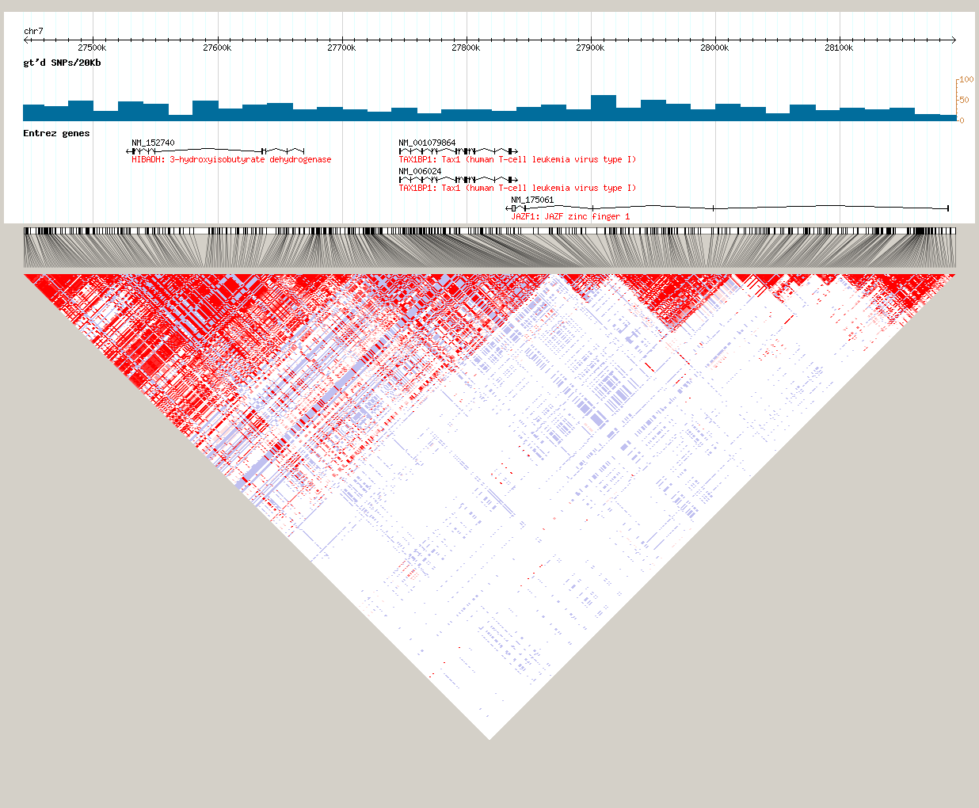
Index Signal
Signal in African Americans
Index Signal
7p15, YRI HapMap Phase 2
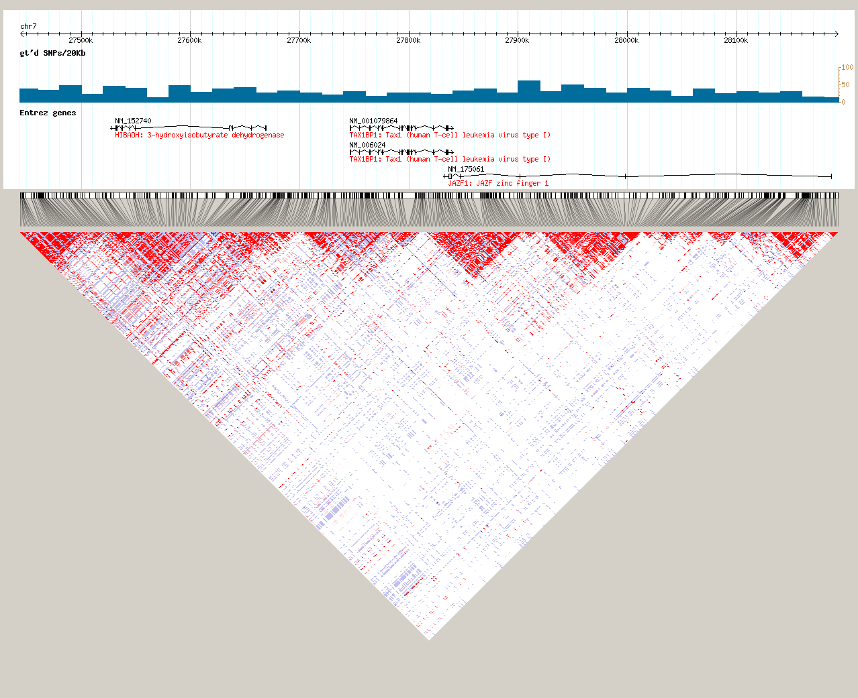
Signal in African Americans
Index Signal

8p21, CEU HapMap Phase 2
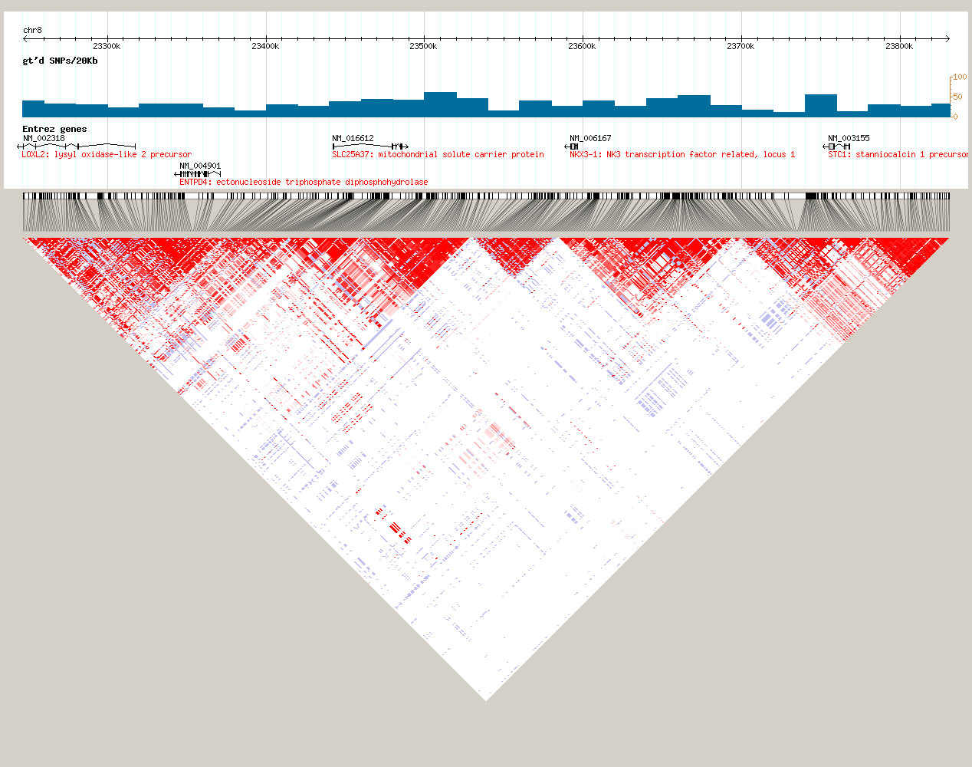
Signal in African Americans
Index Signal
8p21, YRI HapMap Phase 2
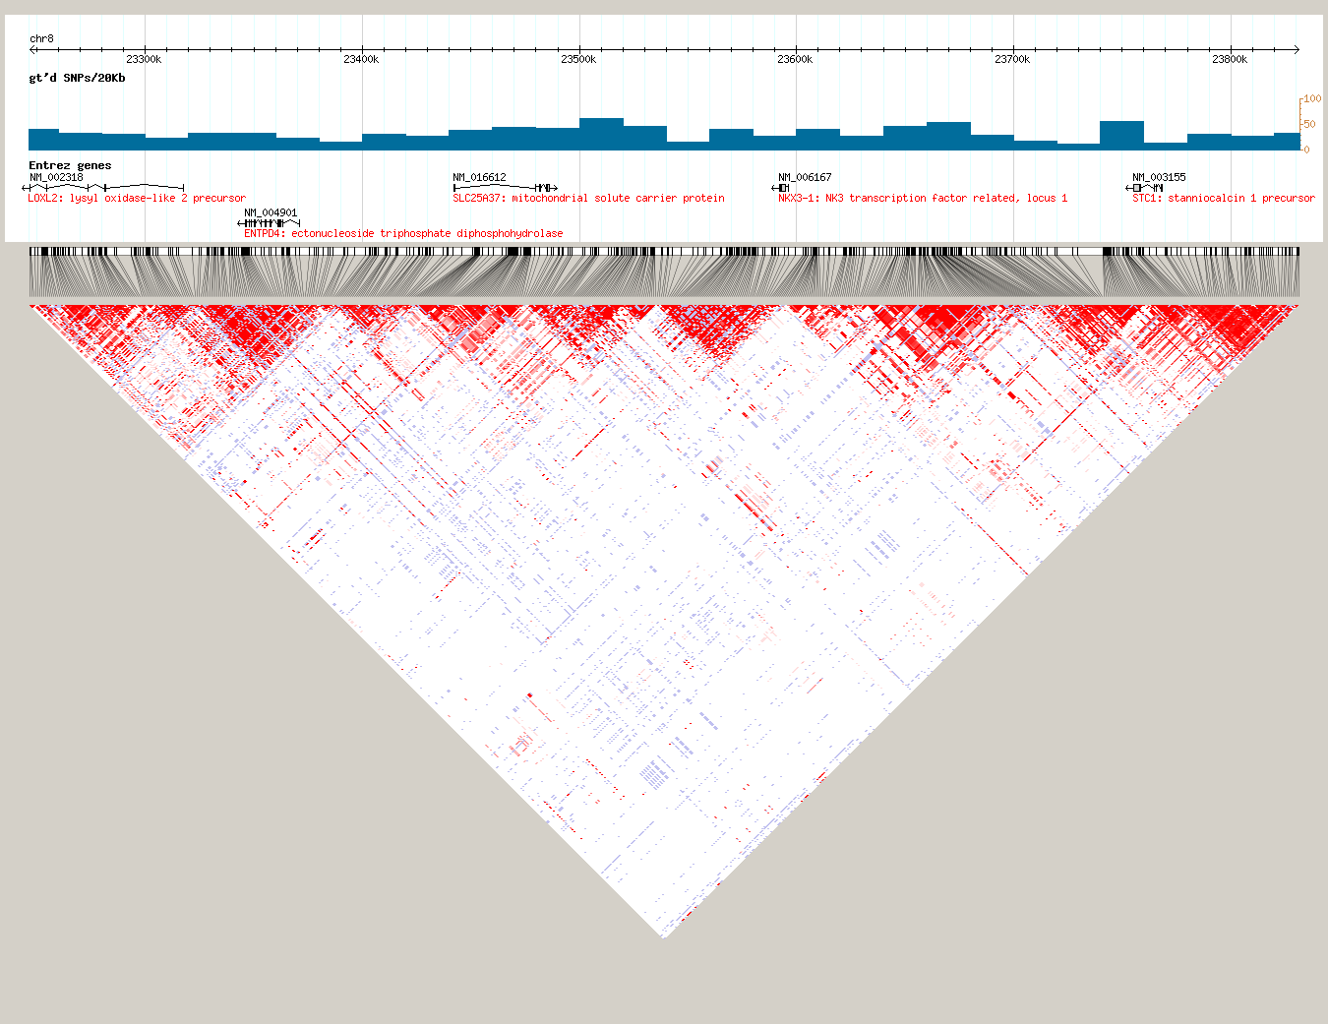
Signal in African Americans
Index Signal

10q11, CEU HapMap Phase 2
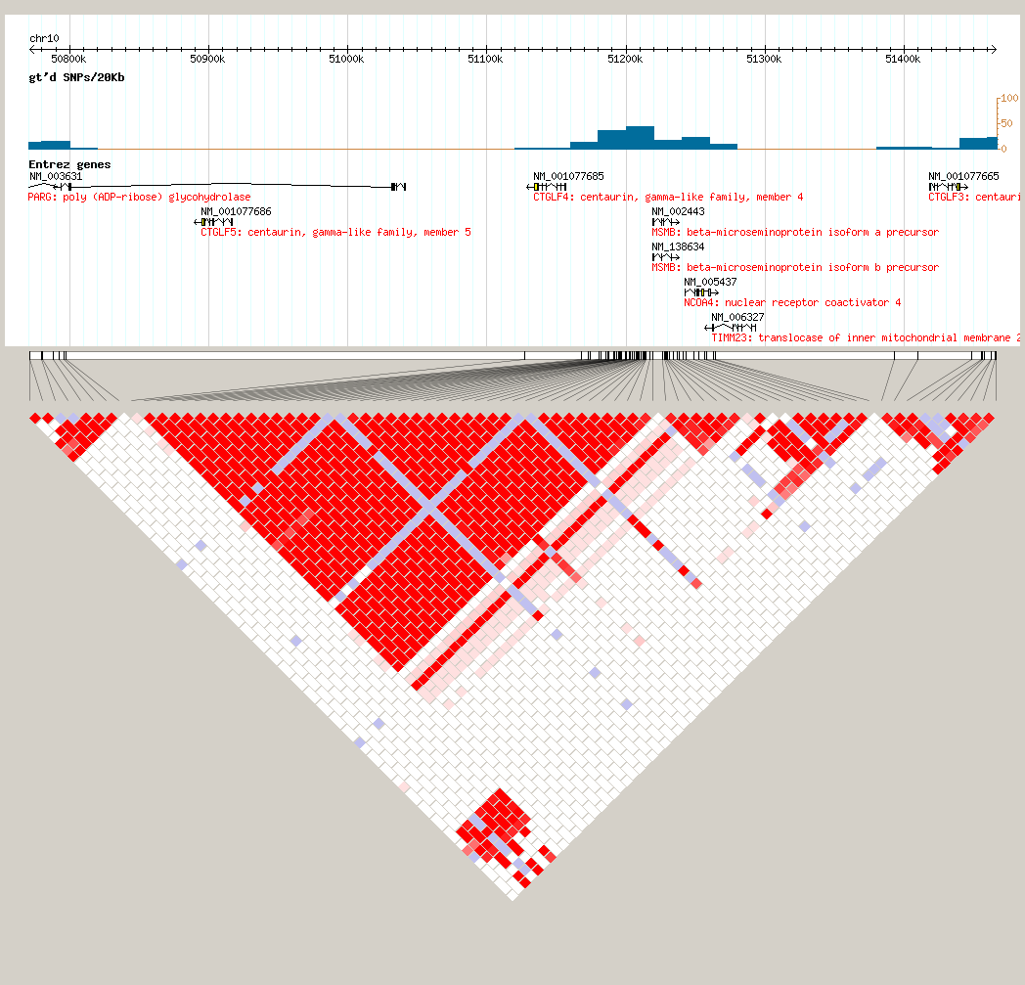
Signal in African Americans
Index Signal
10q11, YRI HapMap Phase 2
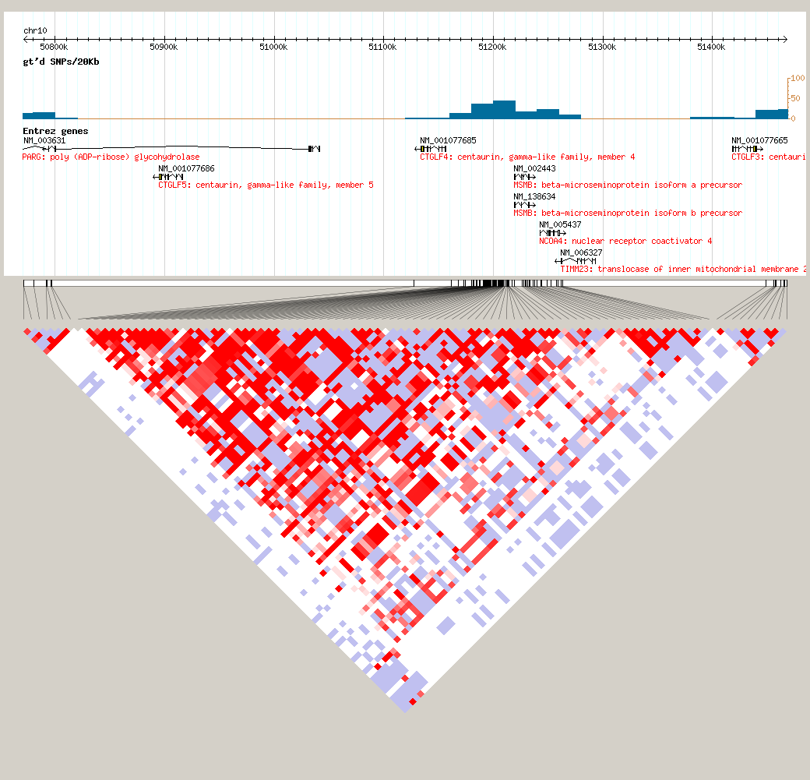
Index Signal
Signal in African Americans

11q13, CEU HapMap Phase 2
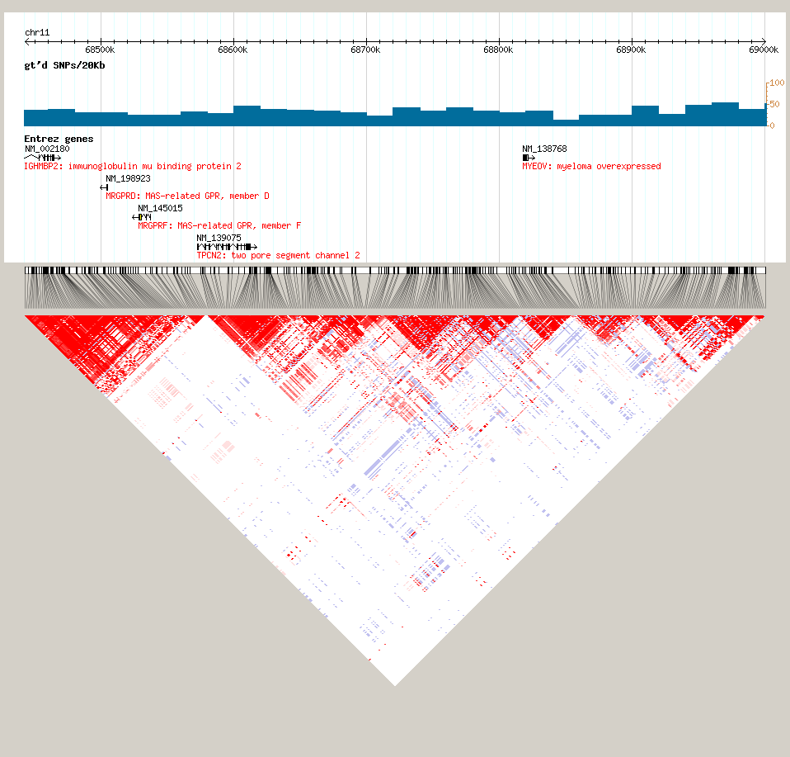
Signal in African Americans
Index Signals
11q13, YRI HapMap Phase 2
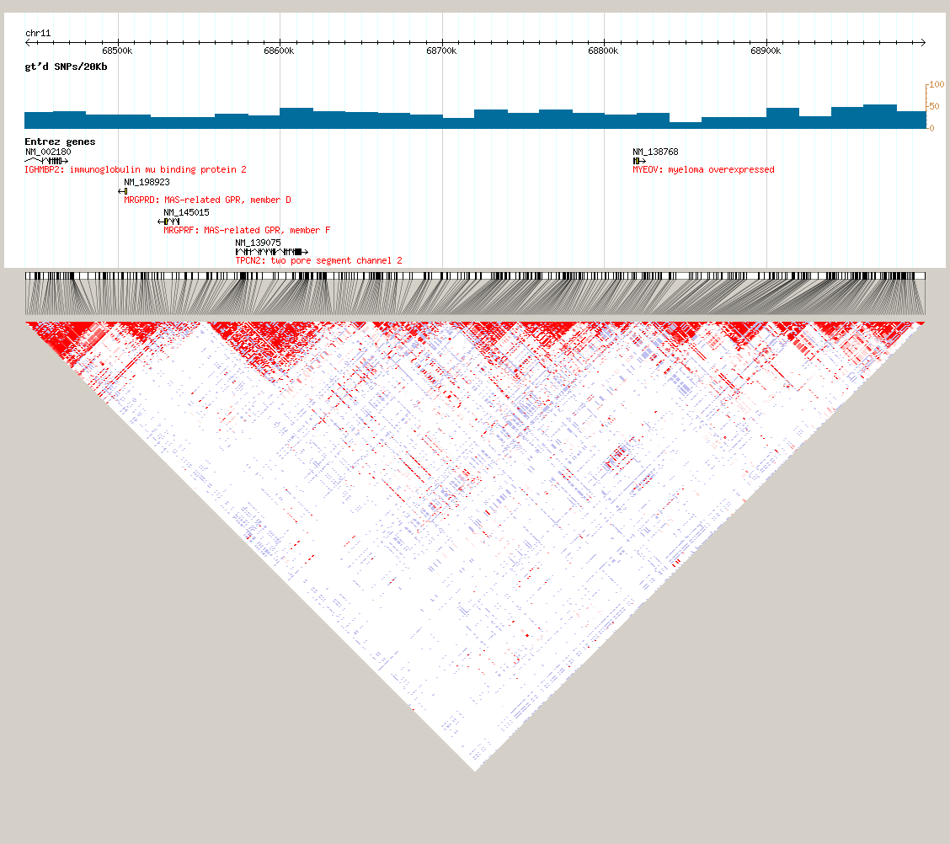
Signal in African Americans
Index Signals

19q13, CEU HapMap Phase 2
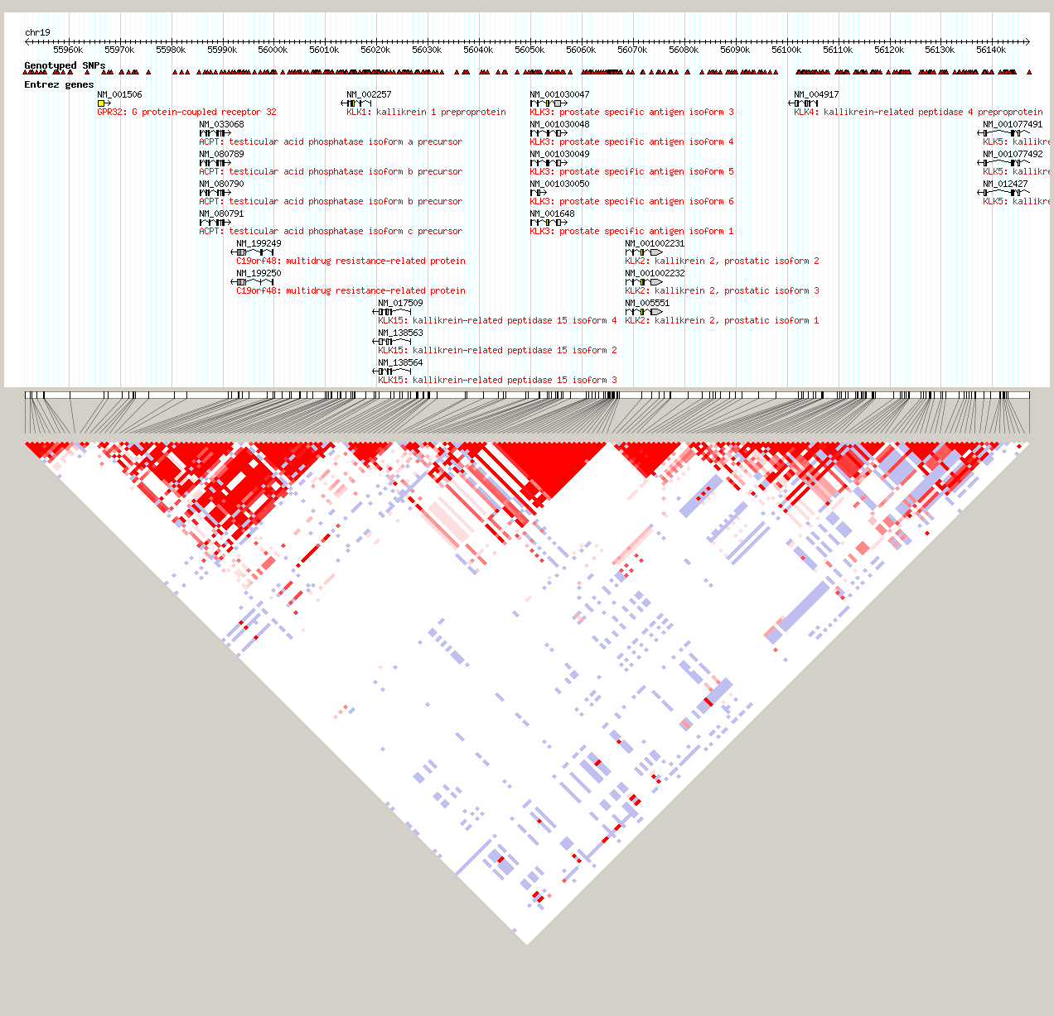
Signal in African Americans
Index Signals
19q13, YRI HapMap Phase 2
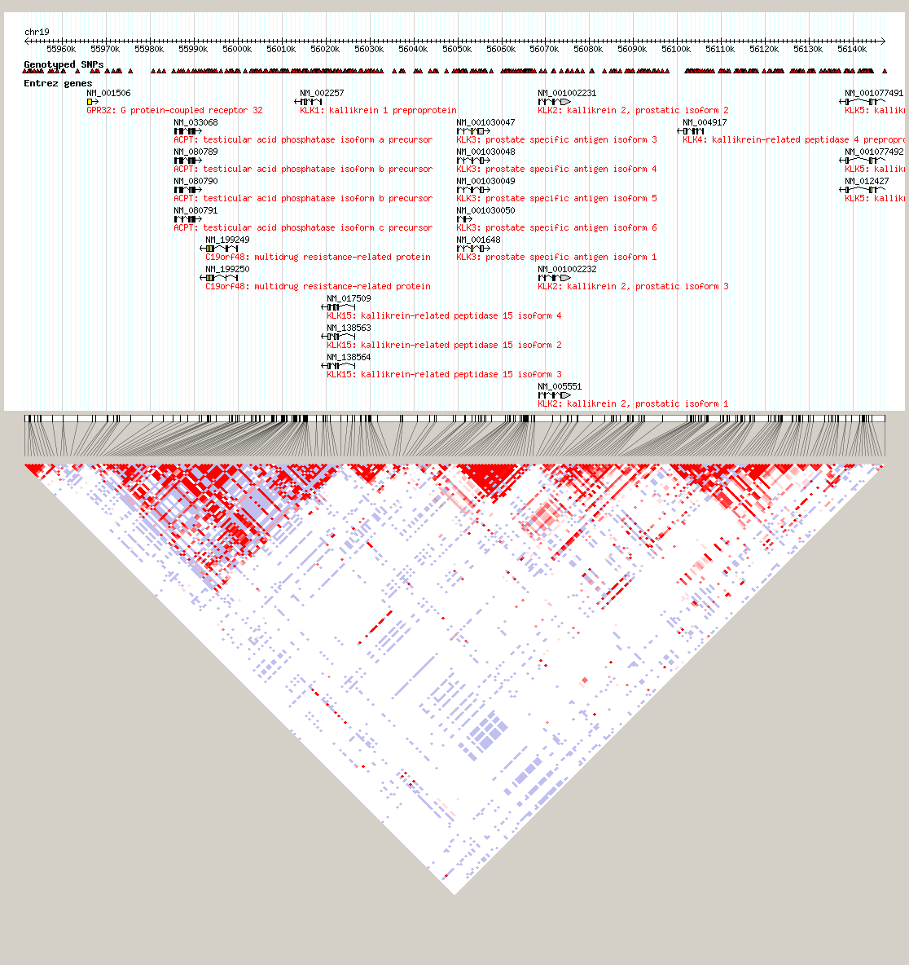
Signal in African Americans
Index Signals

Xp11, CEU HapMap Phase 2
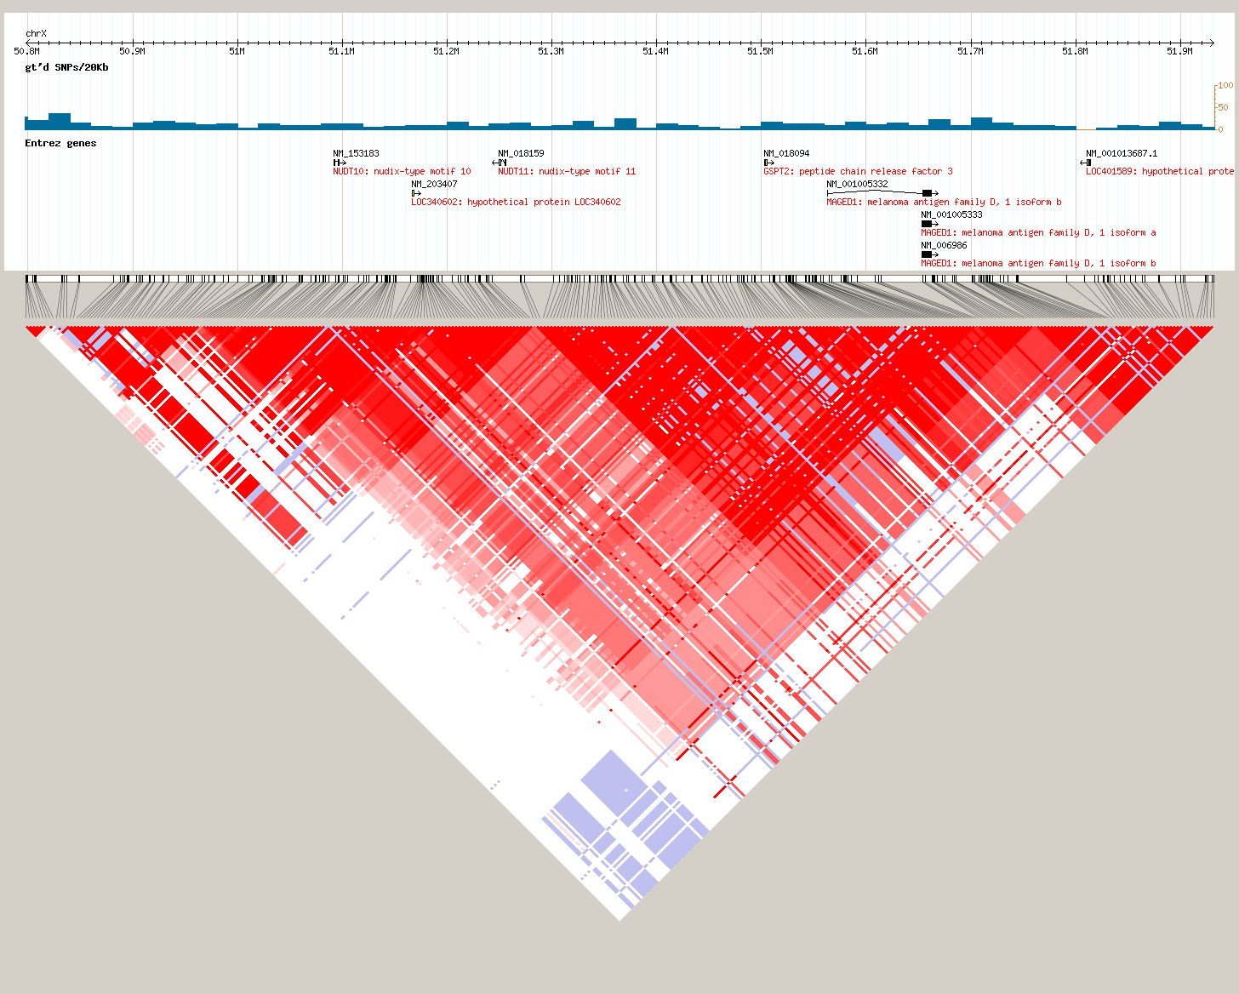
Signal in African Americans
Index Signals
Xp11, YRI HapMap Phase 2
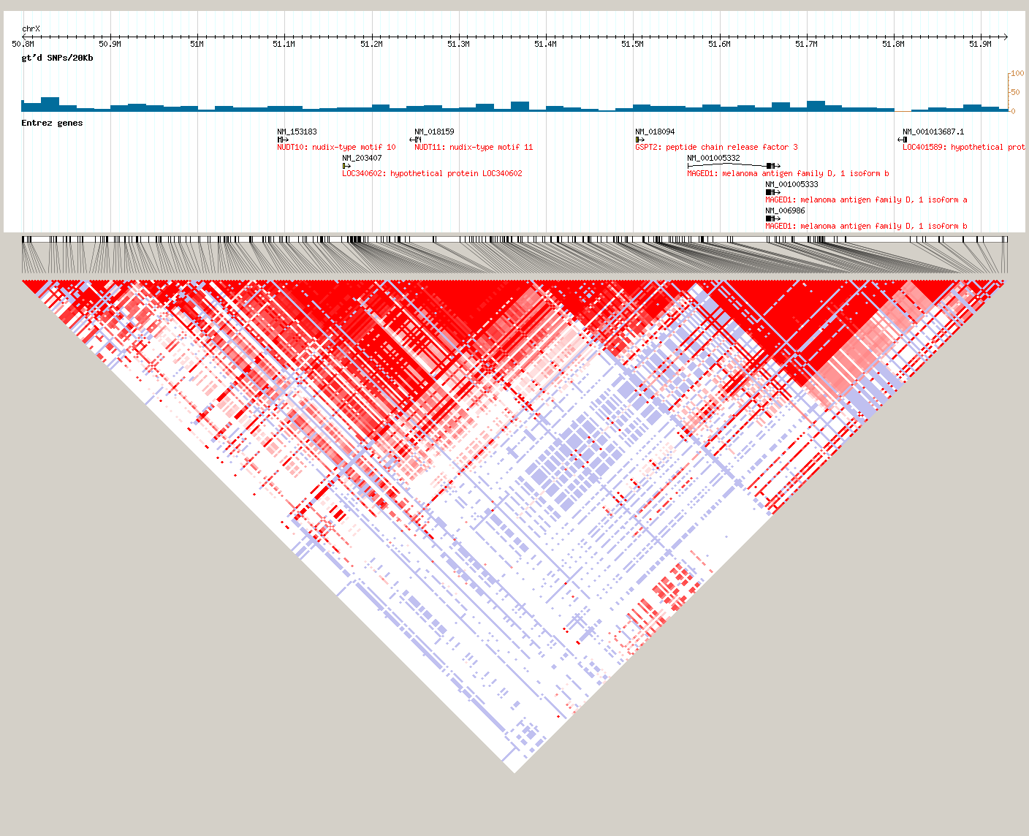
Index Signals
Signal in African Americans

