Figure S5. Comparison of unadjusted, minimally adjusted, adjusted models for LDL-C, by population.

- European Americans
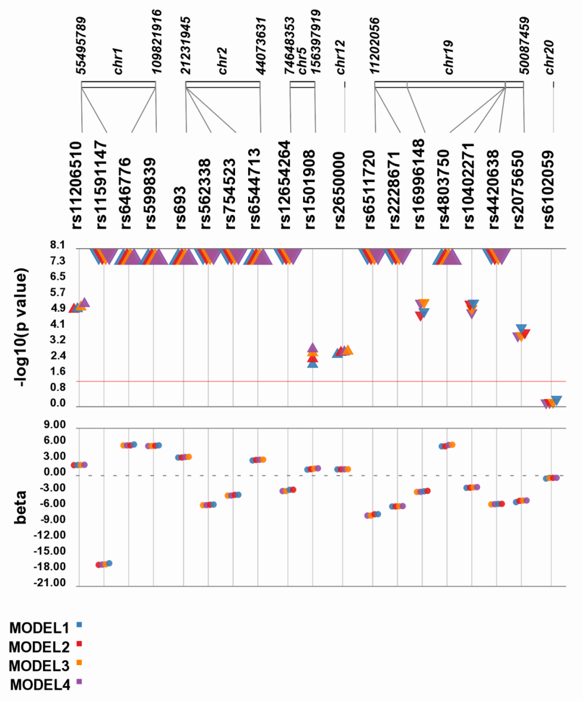

- African Americans
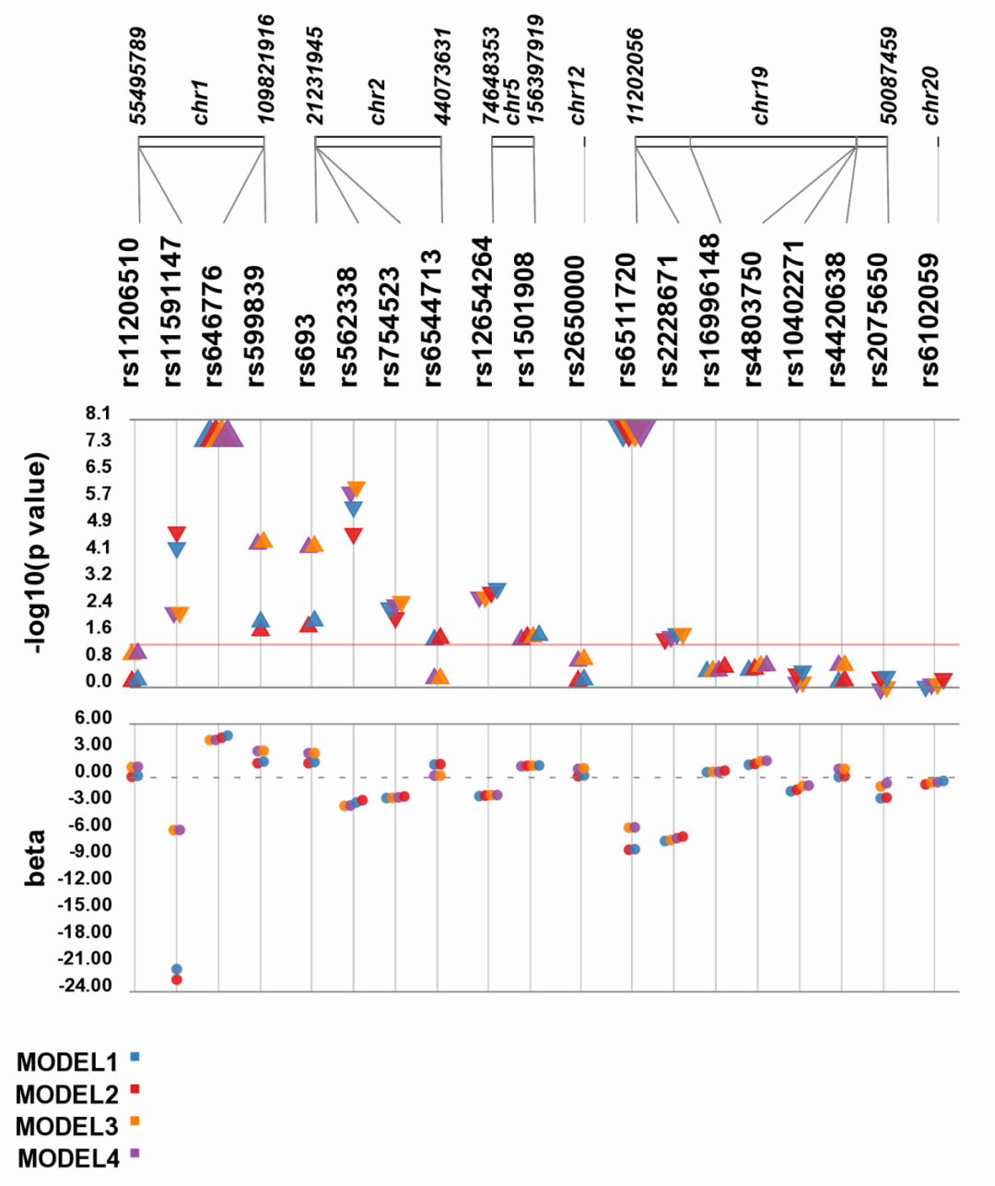

- American Indians
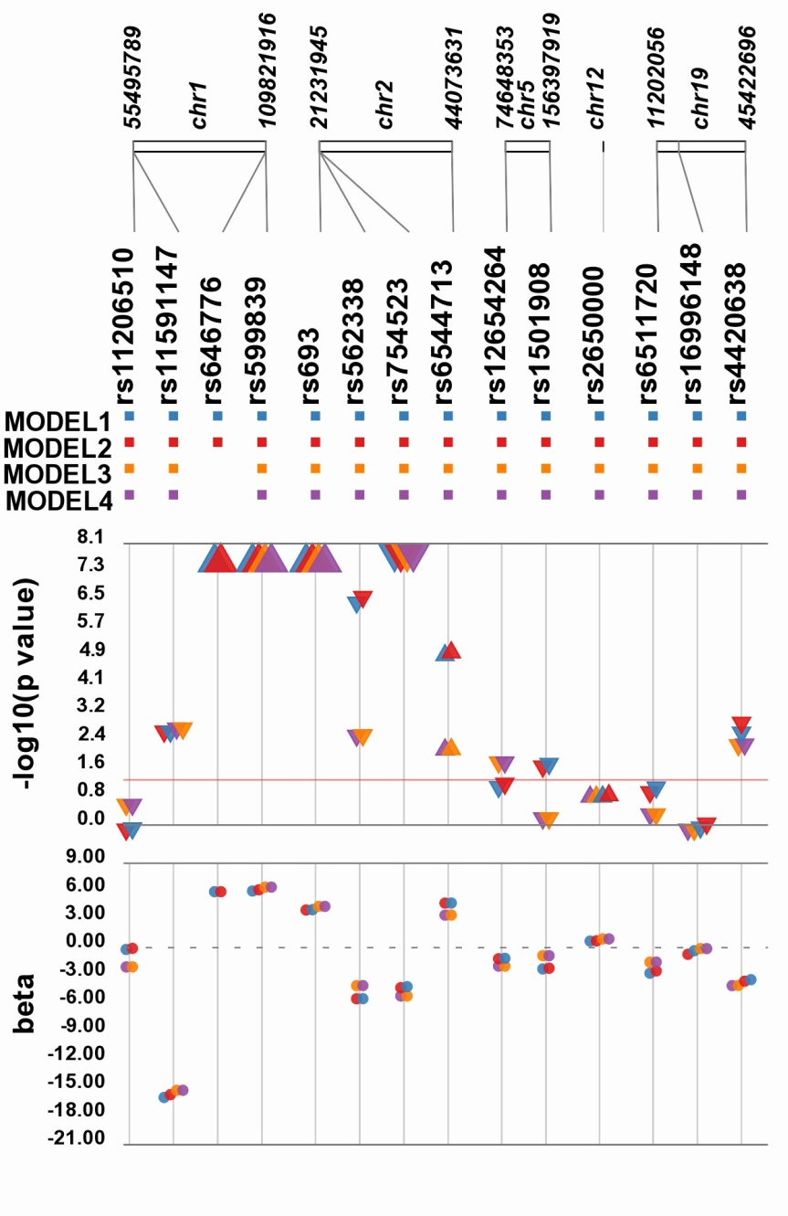

- Mexican Americans/Hispanics
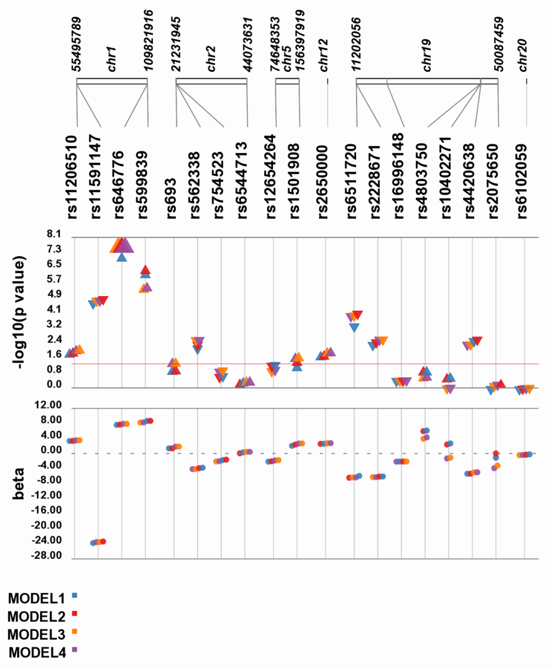

- Japanese/East Asians
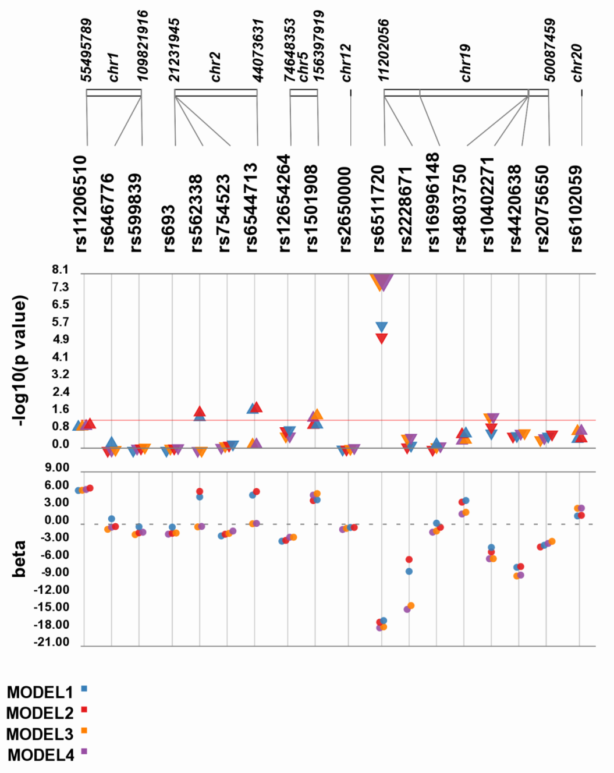

- Native Hawaiians/Pacific Islanders
