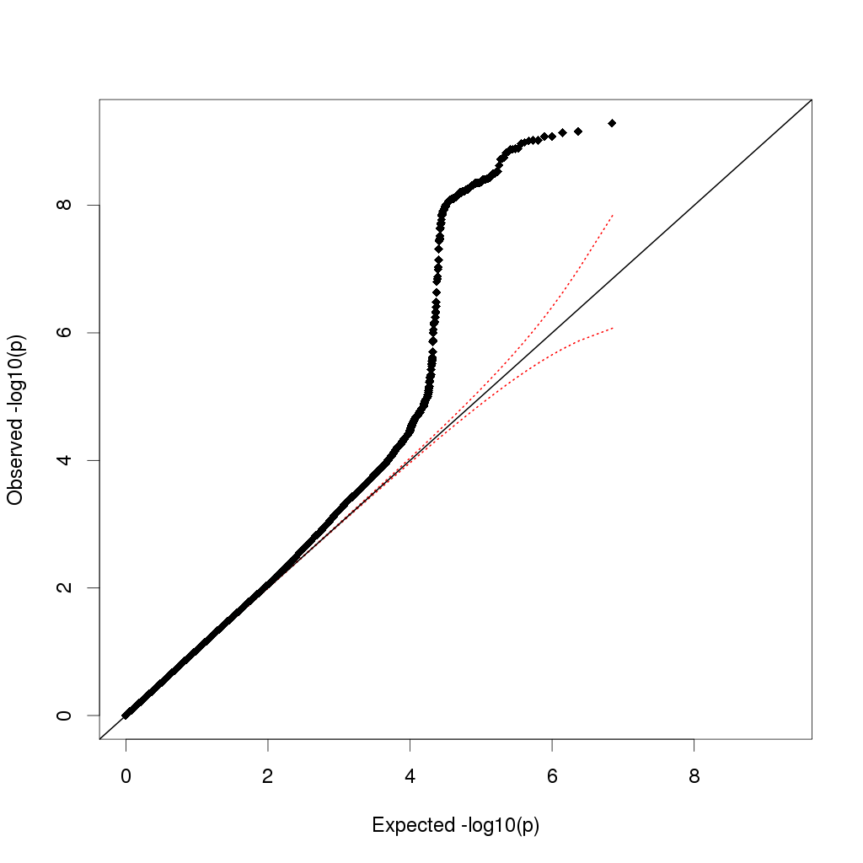
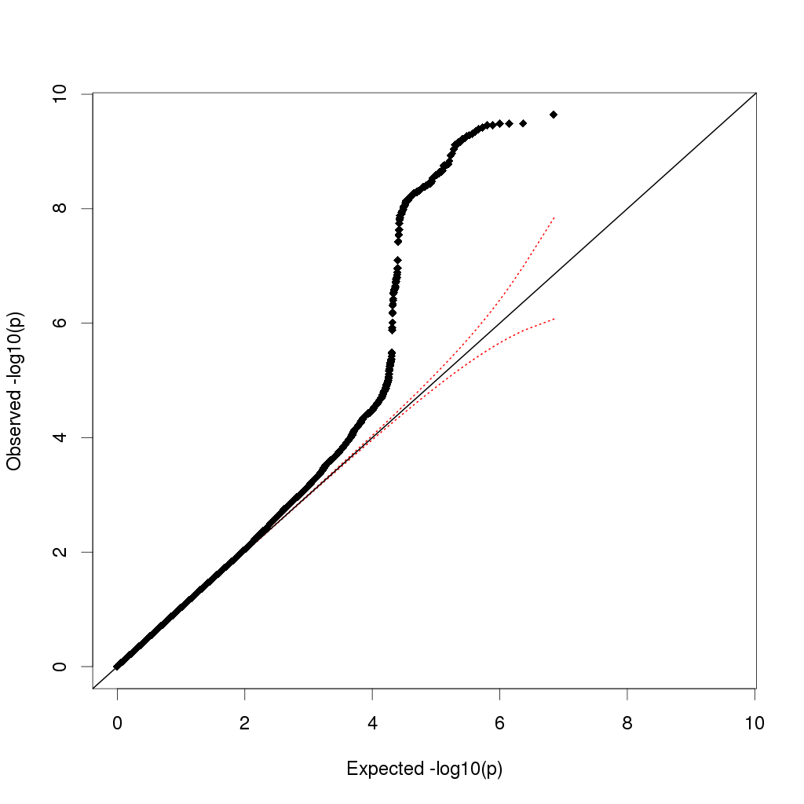
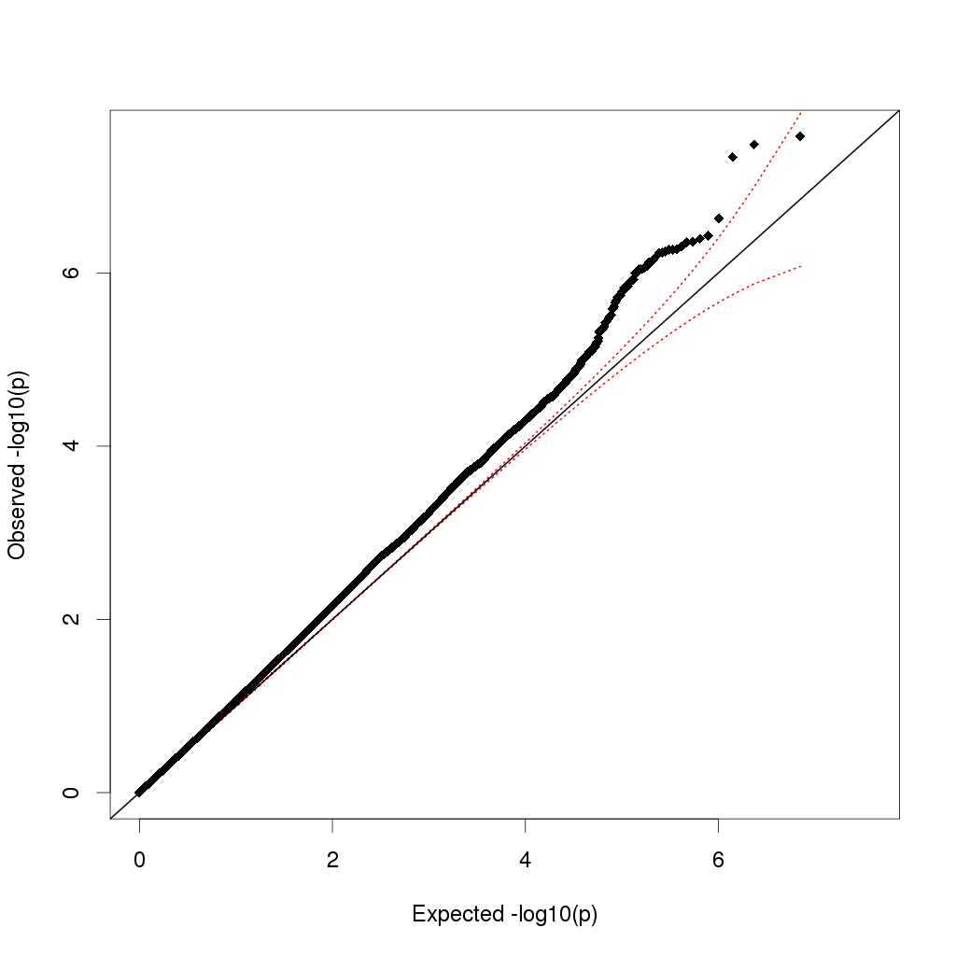
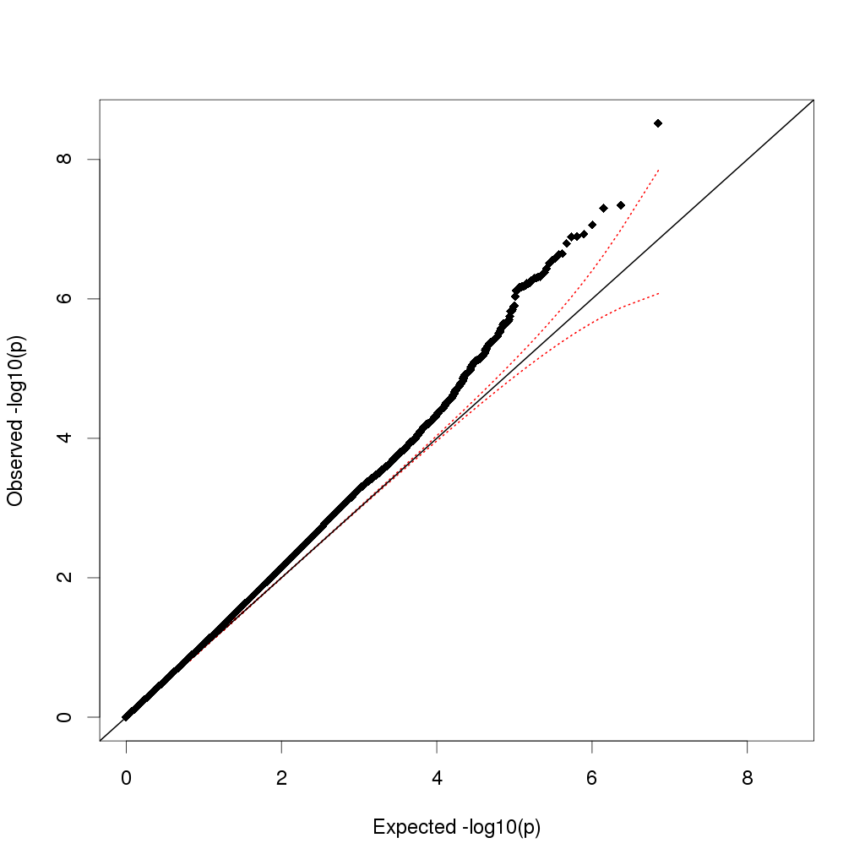
Figure S1 – QQ-plots for cardioembolic stroke and all ischaemic stroke analyses

QQ-plots of expected p-values (x-axis) against observed p-values (y-axis) for analyses of (clockwise from top left) cardioembolic stroke (age-at-onset informed), cardioembolic stroke (uninformed), all ischaemic stroke (uninformed), all ischaemic stroke (age-at-onset informed). Lambda values for each plot are given in Table S4.

