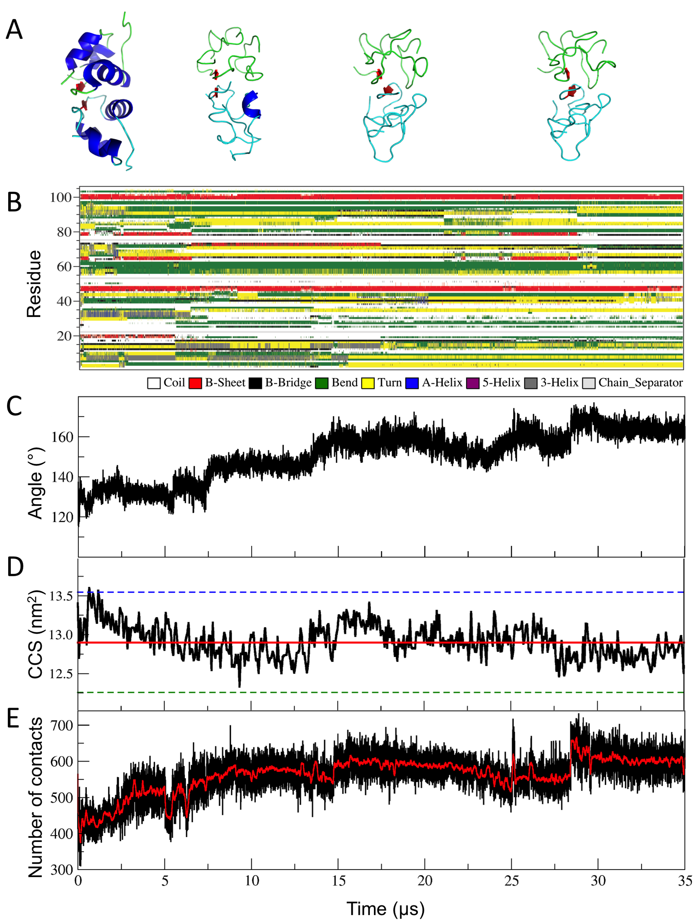
Figure S7. 0.035 ms long independent MD simulations in the gas phase of [hIns₂]⁶⁺. (A) Models of [hIns₂]⁶⁺ obtained from MD simulations in the gas phase (from left to right, at 0 μs, 5.31 μs, 20.52 μs and 34.2 μs). (B) Secondary structure analysis for [hIns₂]⁶⁺. (C) The angle between the COM of monomer I – β-sheet region – monomer II. (D) CCS values. (E) Number of contact pairs between the carbon atoms of the monomers within 0.60 nm. The figure captions are same with the ones used in Figure 3.

