S4 Fig

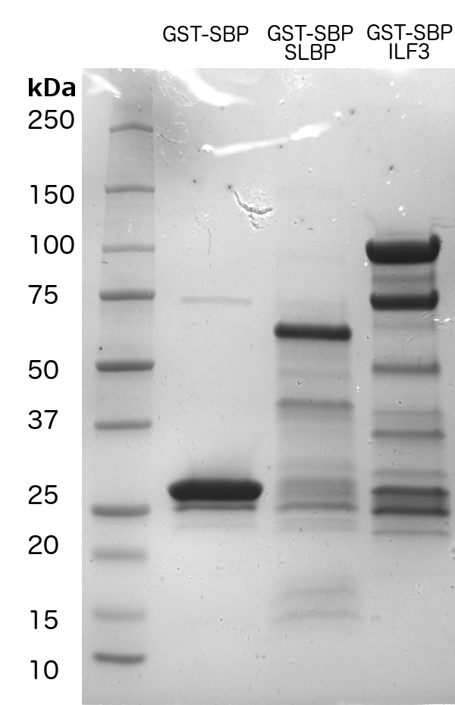

Legend: SDS-PAGE gel showing the result of GST affinity purification of GST-SBP, GST-SBP-SLBP and GST-SBP-ILF3. Proteins of this purity were used in RBNS and gel shift assays.

