Supplementary information
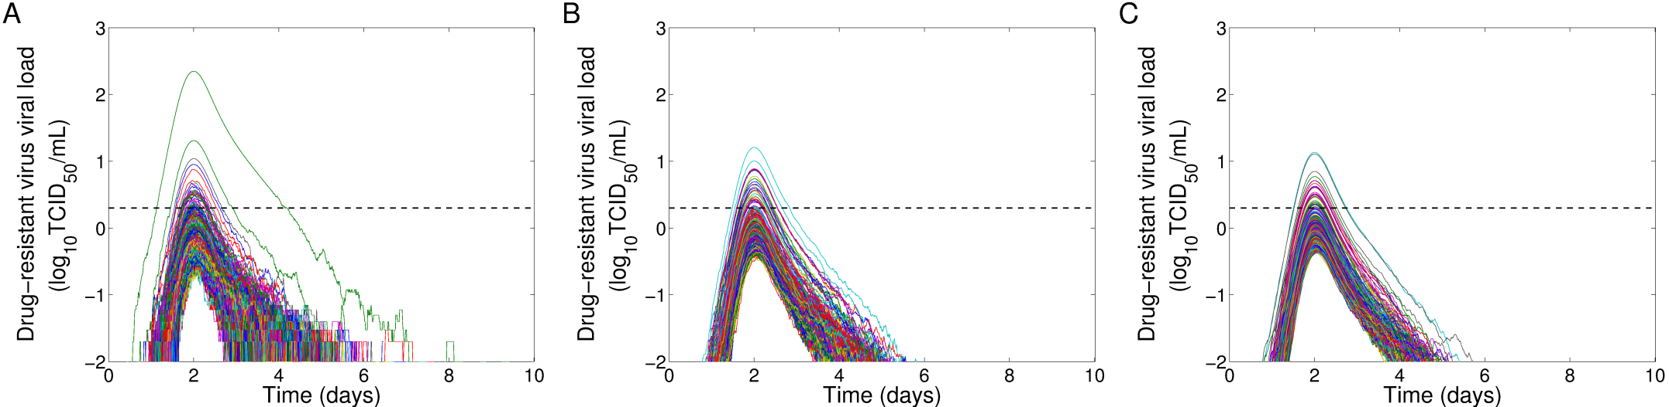
Fig. S8: Effect of conversion factor on individual drug-resistant virus viral shedding: (A) 1 TCID₅₀/mL =10² virions; (B) 1 TCID₅₀/mL =10³ virions; (C) 1 TCID₅₀/mL =10⁴ virions; The dashed line represents the limit of detection (LOD) of influenza virus.

