Fig S3

Atrial arrhythmogenicity of KCNJ2-linked short QT syndrome mutations: insights from virtual human atria

Dominic G. Whittaker, Haibo Ni, Aziza El Harchi, Jules C. Hancox, Henggui Zhang

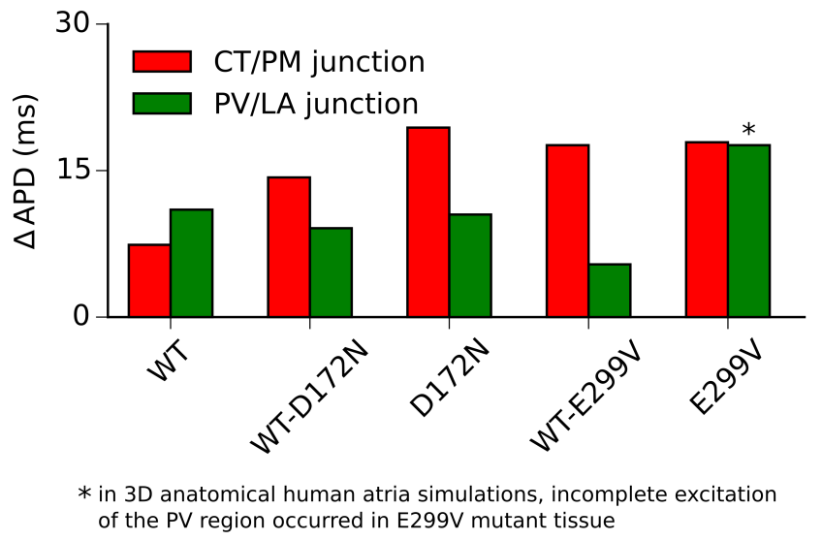

Fig S3. Differences in regional cell model tissue APD. ΔAPD at the CT/PM and PV/LA junctions as determined in 1D tissue models.

