cytofkit: Usage of Shiny APP
Table of Contents
Launch the Shiny APP 1
Loading .RData to Shiny APP 1
Scatter Plot 2
Run FlowSOM 3
Heat Map 4
Progression Plot 5
Subset Relationship 5
Marker Expression Profile 6
Run Diffusionmap 7

Launch the Shiny APP
- cytofkit Shiny APP is integrated into the cytofkit pacakge, and can be deployed locally using the following command:
- require(cytofkit)
cytofkitShinyAPP()
- cytofkit Shiny APP is also hosted by shinyapps.io, and can be used through the public link: cytofkitShinyAPP

Loading .RData to Shiny APP
After the analysis was done using cytofkit, a special RData file will be saved with suffix of .RData. This RData file is saved for loading to the shiny APP to explore the results (The RData file used in this vignette can be found on the github ).
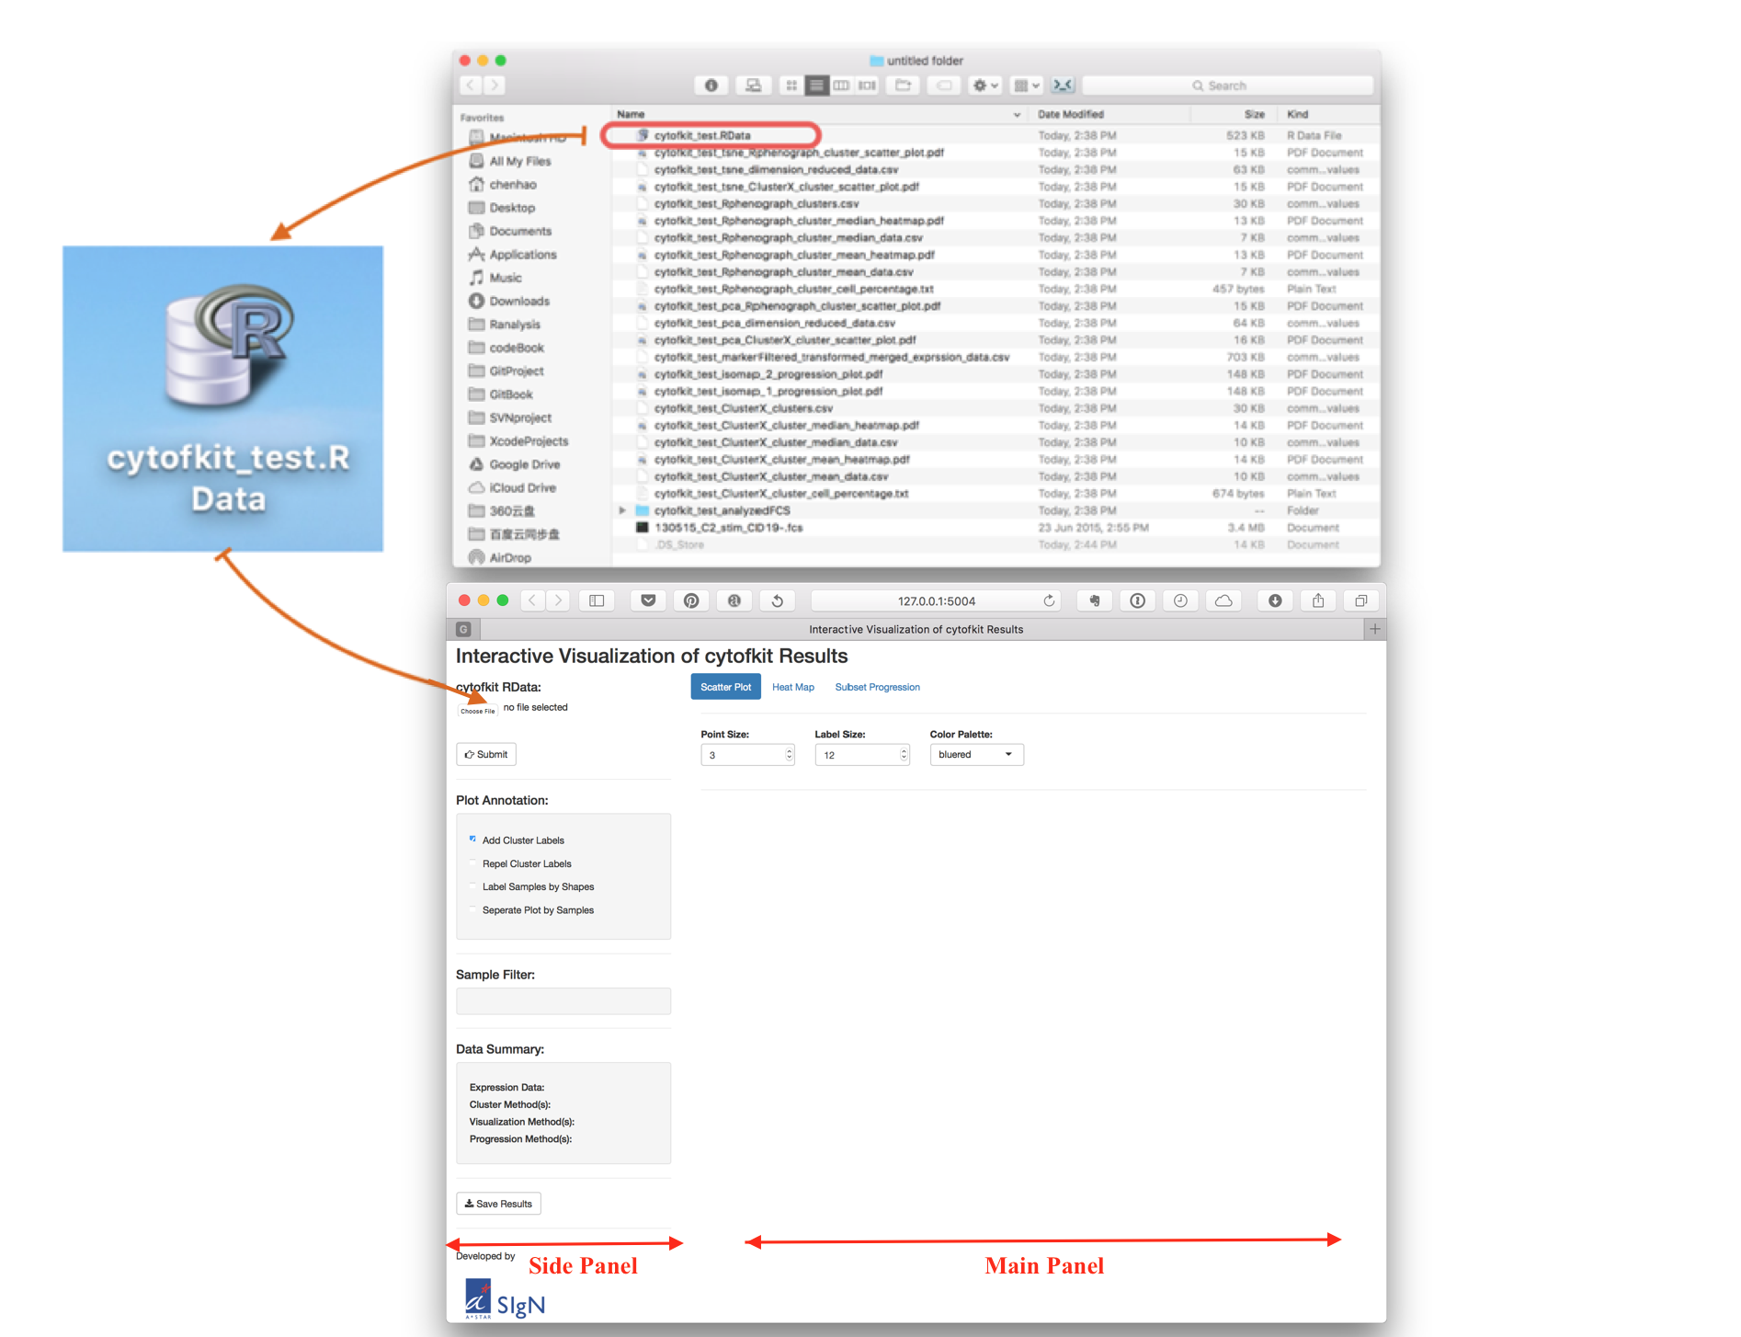
Click the up-left Choose File button to choose RData file, then click the submit button below to load the data.
As shown in the figure above, there are one side panel and one main panel for the cytofkit shiny APP. On the side panel, there are some global control widgets like loading the data, filtering the samples, annotating the plot and saving the results. And a summary of the data information.

Scatter Plot
On the top of the main panel, there are three tap panels, they are Scatter Plot, Heat Map and Subset Progression. By default, the Scatter Plot will be on once the RData file is loaded. On the side panel, there are some control
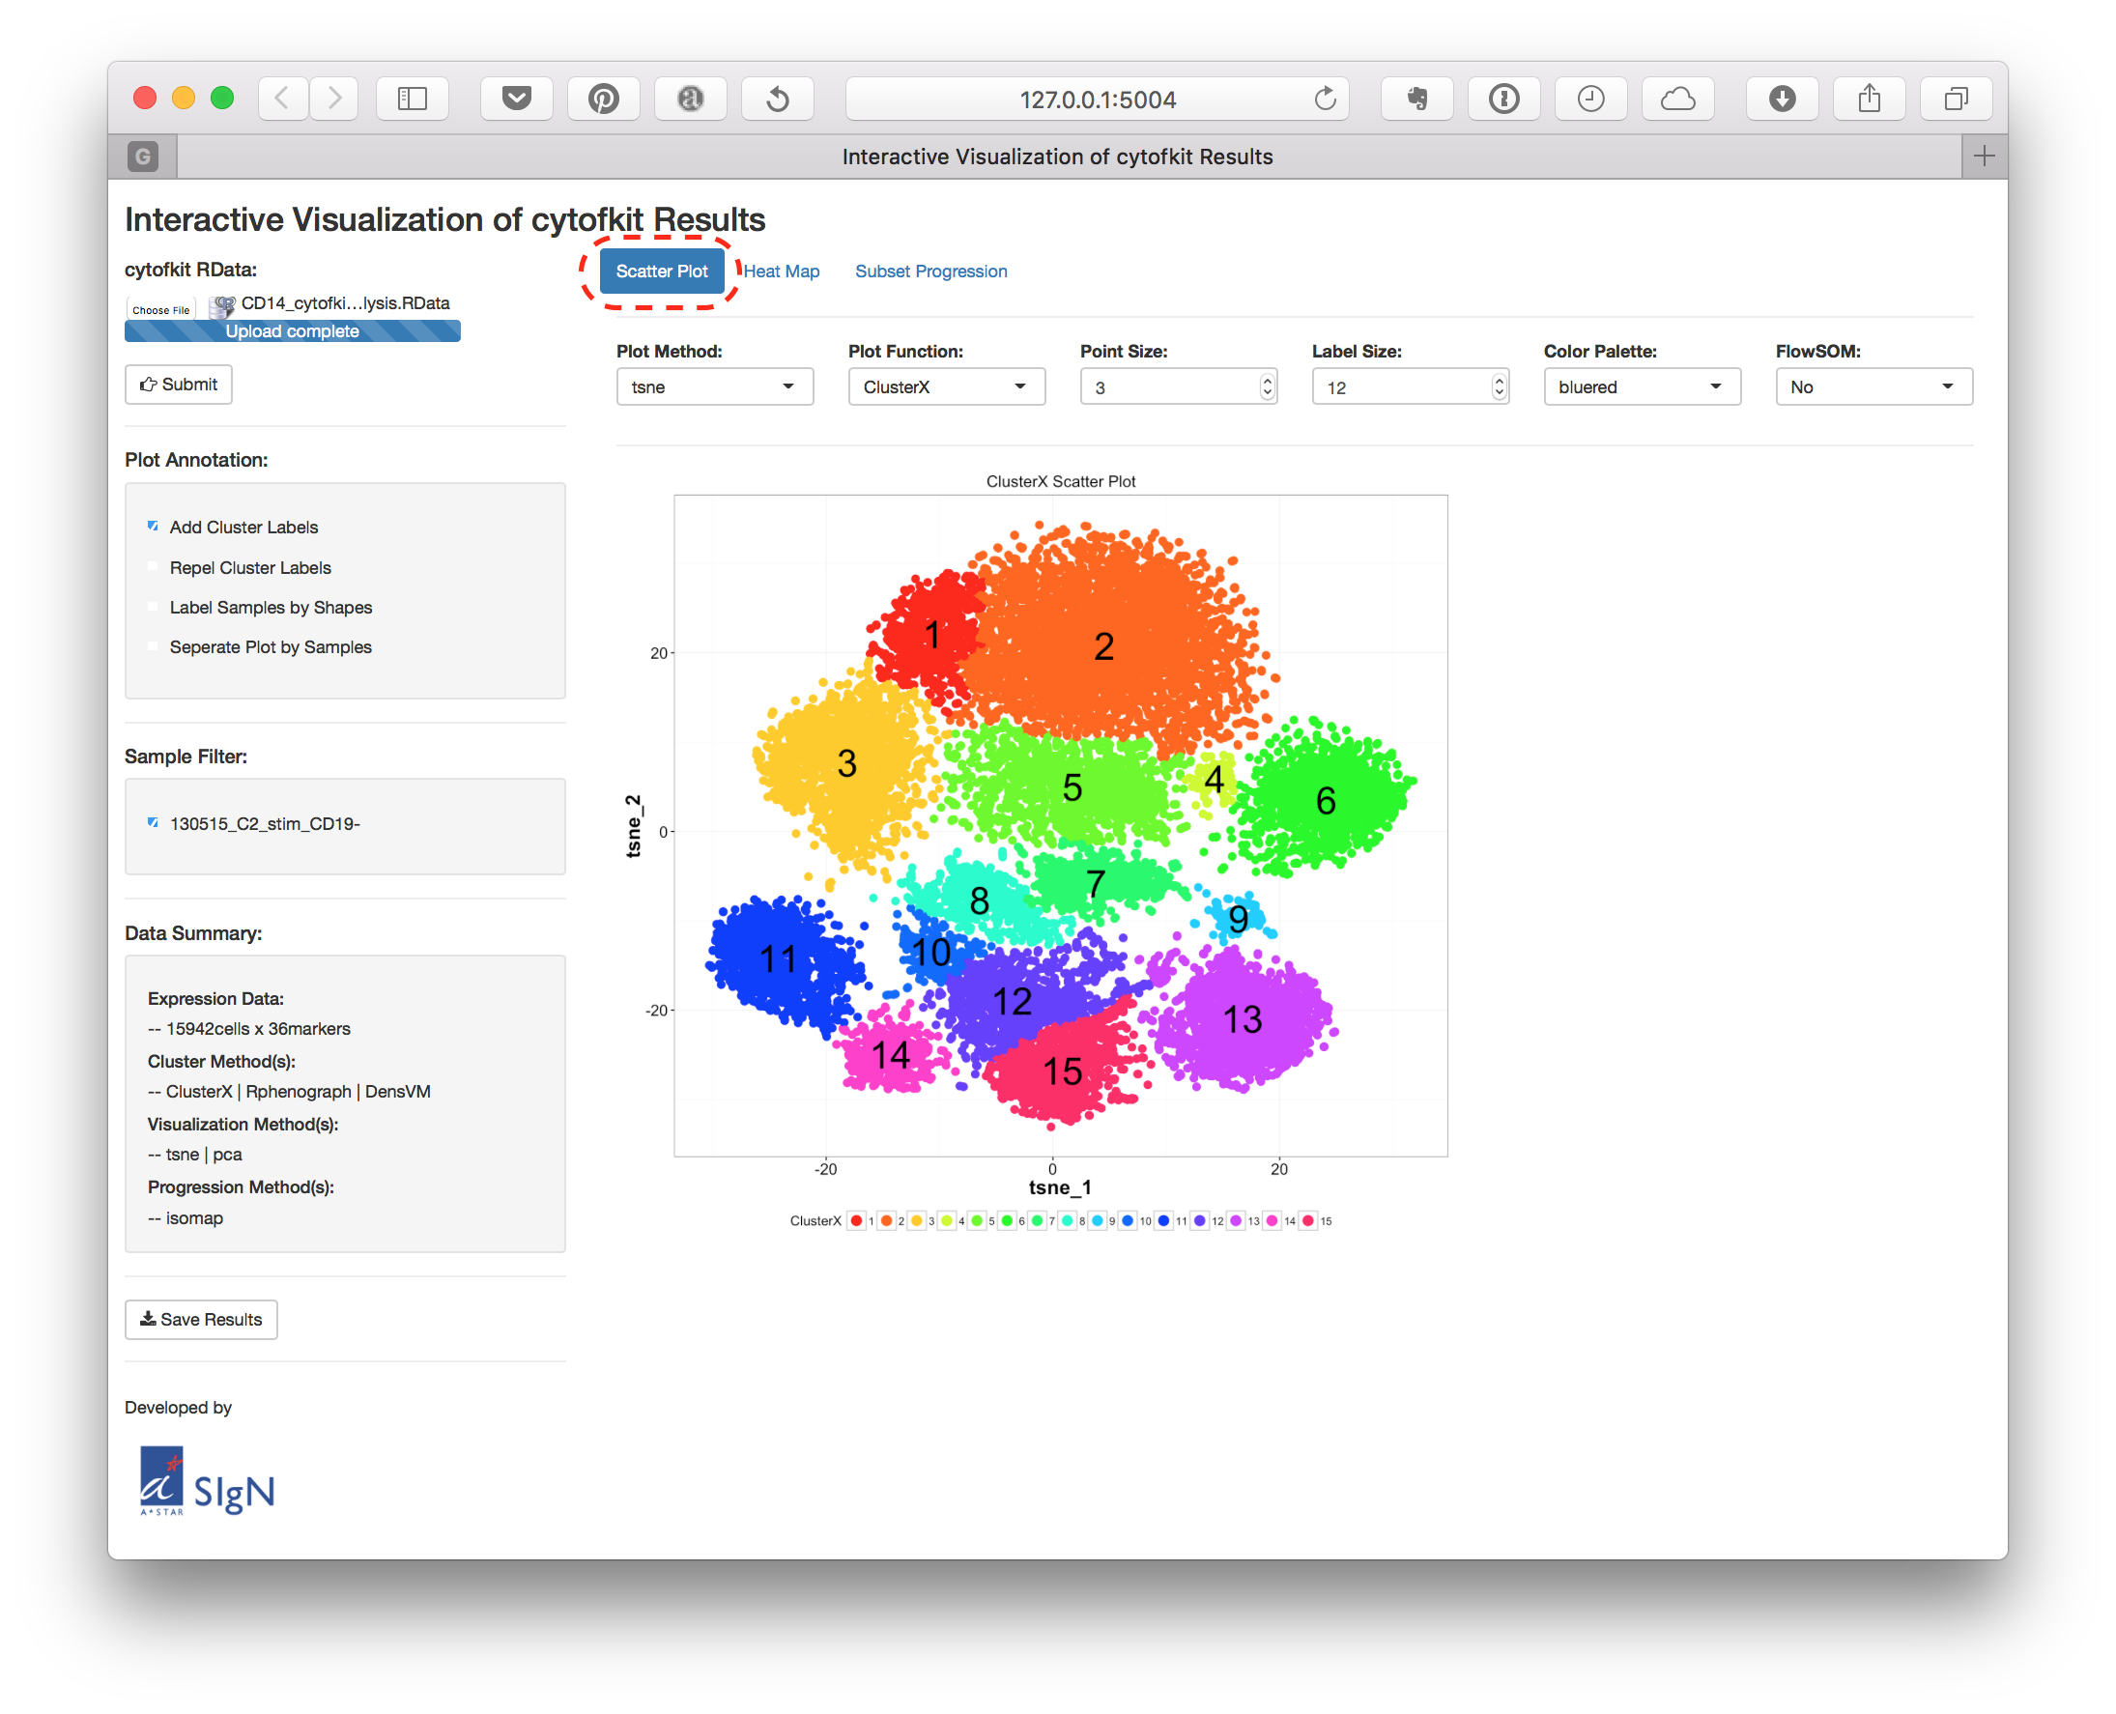
On the Scatter Plot main panel, you can:
- Choose the Plot Method, which is your data visualization methods, like t-sne, ISOMAP or PCA.
- Choose the Plot Function, to check the clustering results, the marker expression pattern on the scatter plot.
- Adjust the size of the points using Point Size.
- Adjust the cluster label size using Label Size.
- If you are checking the expression pattern of markers, you can change the color palette using Color Palette.

Run FlowSOM
You can directly run FlowSOM clustering using the shiny APP. By selecting the FlowSOM to Yes, the FlowSOM clustering setup page will be shown as below:
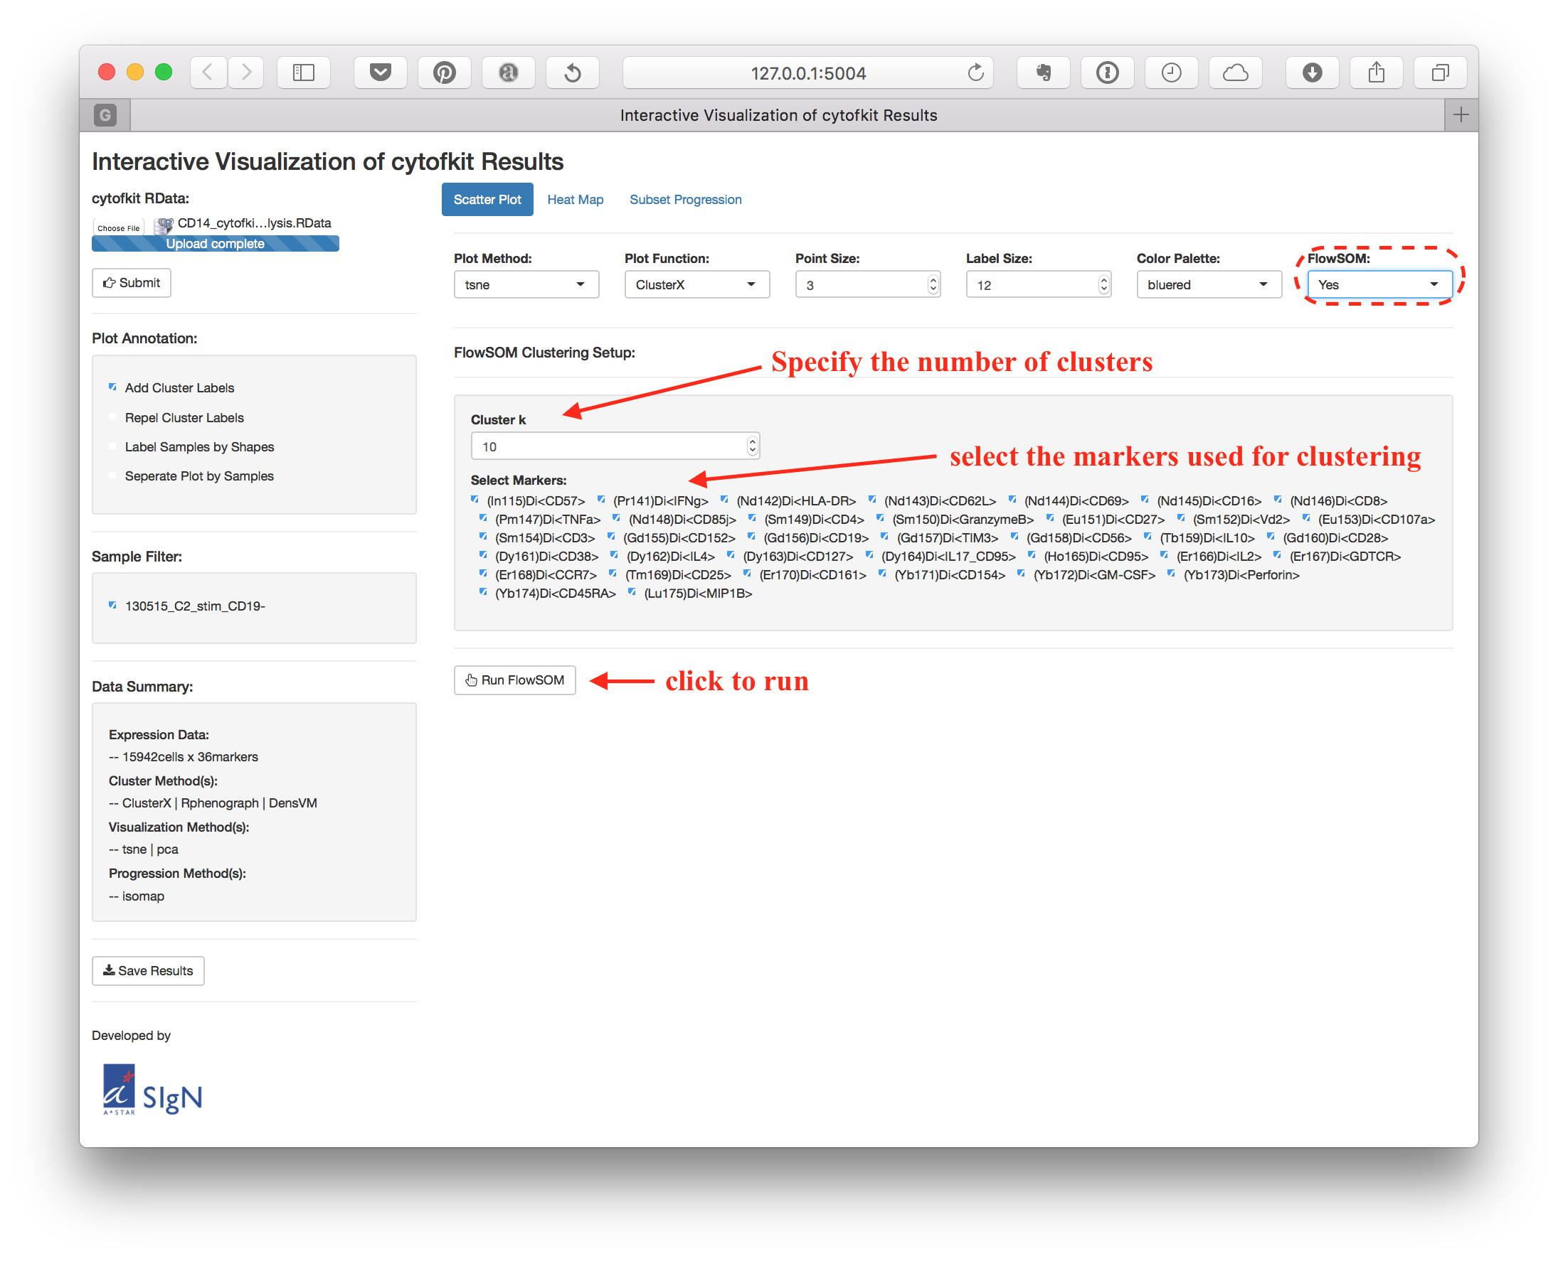
After the FlowSOM was done, the results will be added to the RData object and can be explored on the shiny APP.

Heat Map
The second tap panel is the Heat Map panel. The mean/median expression level of markers for each cluster as well as the percentage of cells in each cluster for each sample can be visualized on this Heat Map panel.
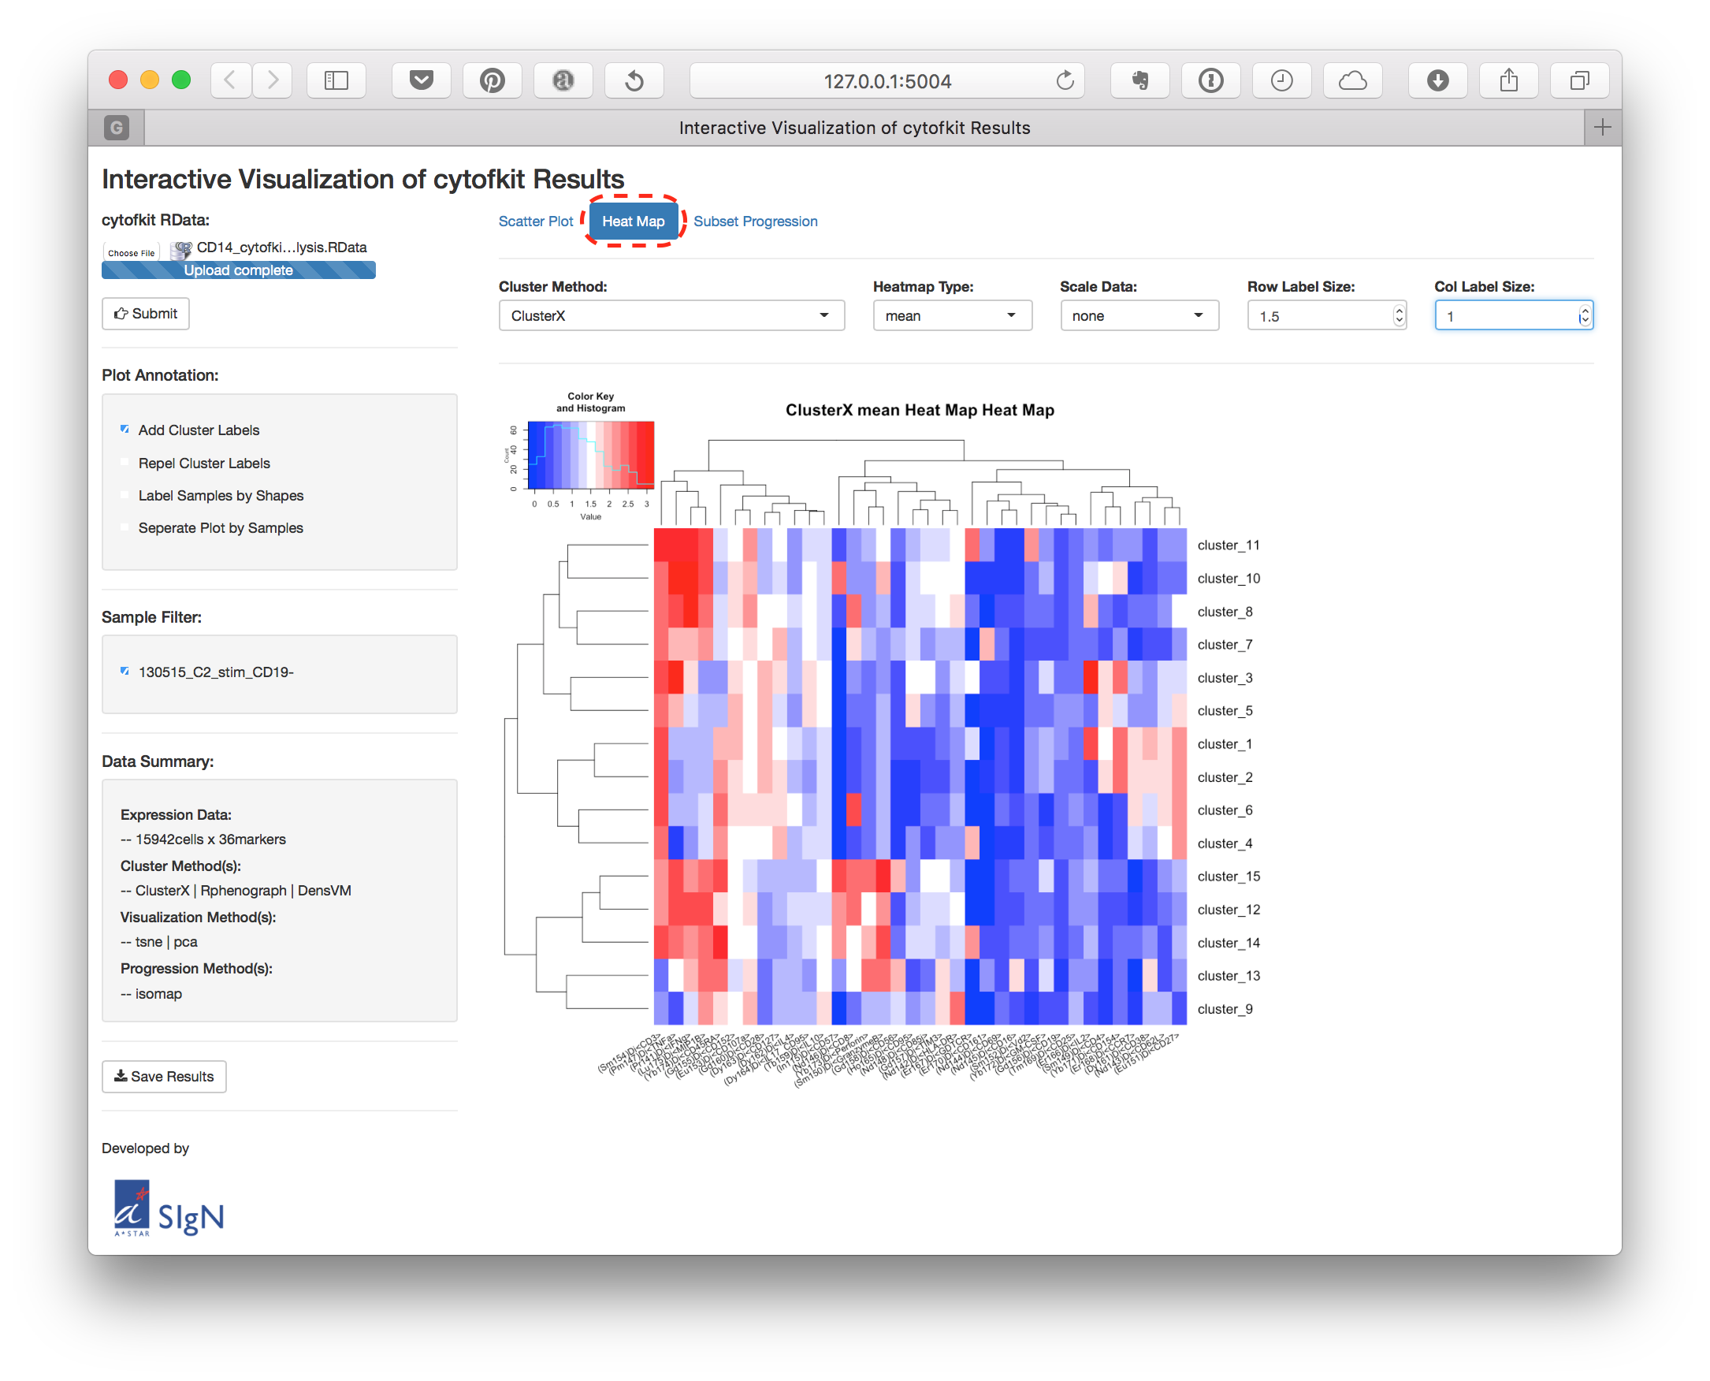
You can:
- Choose the Cluster Method to check the result of a selected clustering method.
- Select the Heatmap Type to visualize the cluster mean, median or percentage.
- Choose the Scale Data to scale the values by row, column or none (by default).
- Customize the size of the labels by adjusting Row Label Size and Col Label Size.

Progression Plot
On the third tap panel, Subset Progression panel, there are three radio buttons which represent the Subset Relationship, Marker Expression Profile and the Run Diffusionmap.

Subset Relationship
Select the Subset Relationship, a scatter plot showing the estimated relationship of the clusters will be displayed.
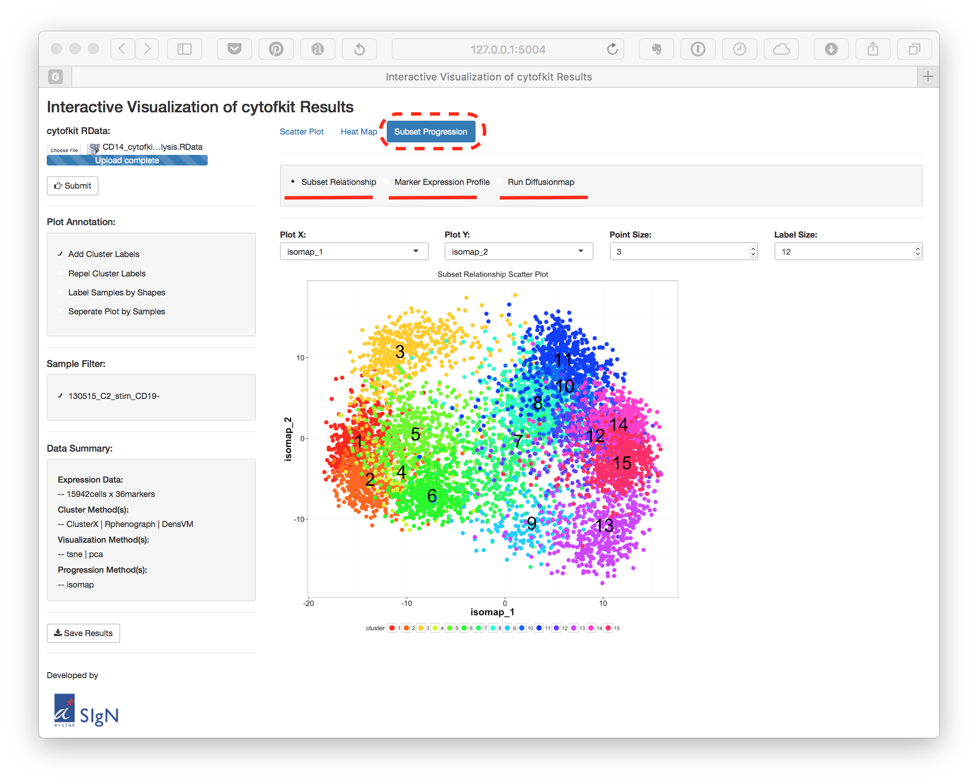

Marker Expression Profile
Select the Marker Expression Profile, the selected expression trend of selected markers along a selected ordering method will be shown.
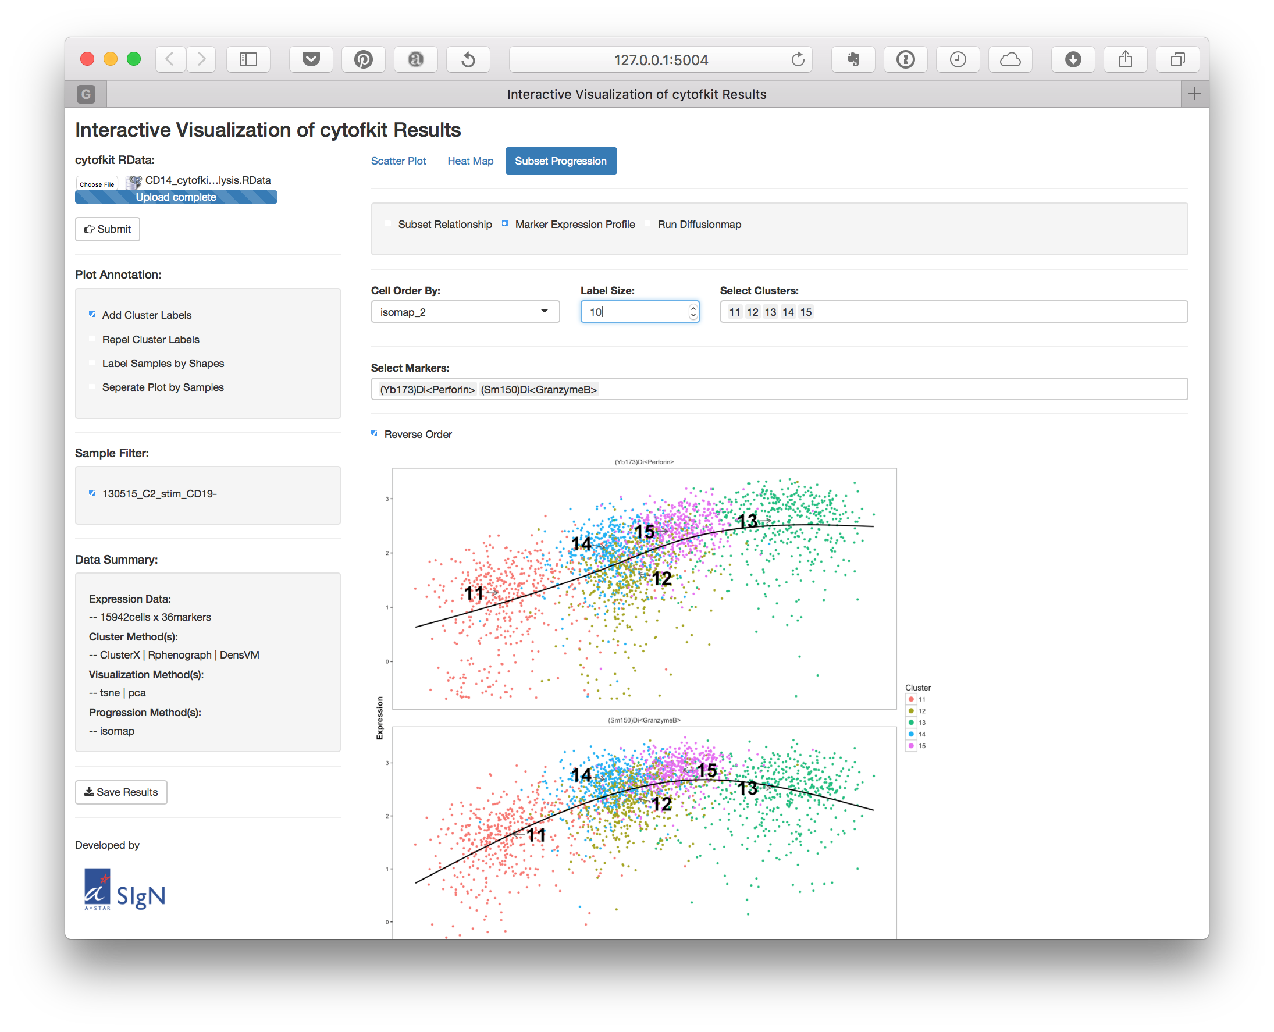
Here you can choose the Cell Order By method, Select Clusters and Select markers to visualize. The clusters will be color-coded, and the cluster label can be added with customized size.

Run Diffusionmap
You can directly run Diffusion map on the shiny APP, A setup page for runing the Diffusion map will be shown when you choose Run Diffusionmap.
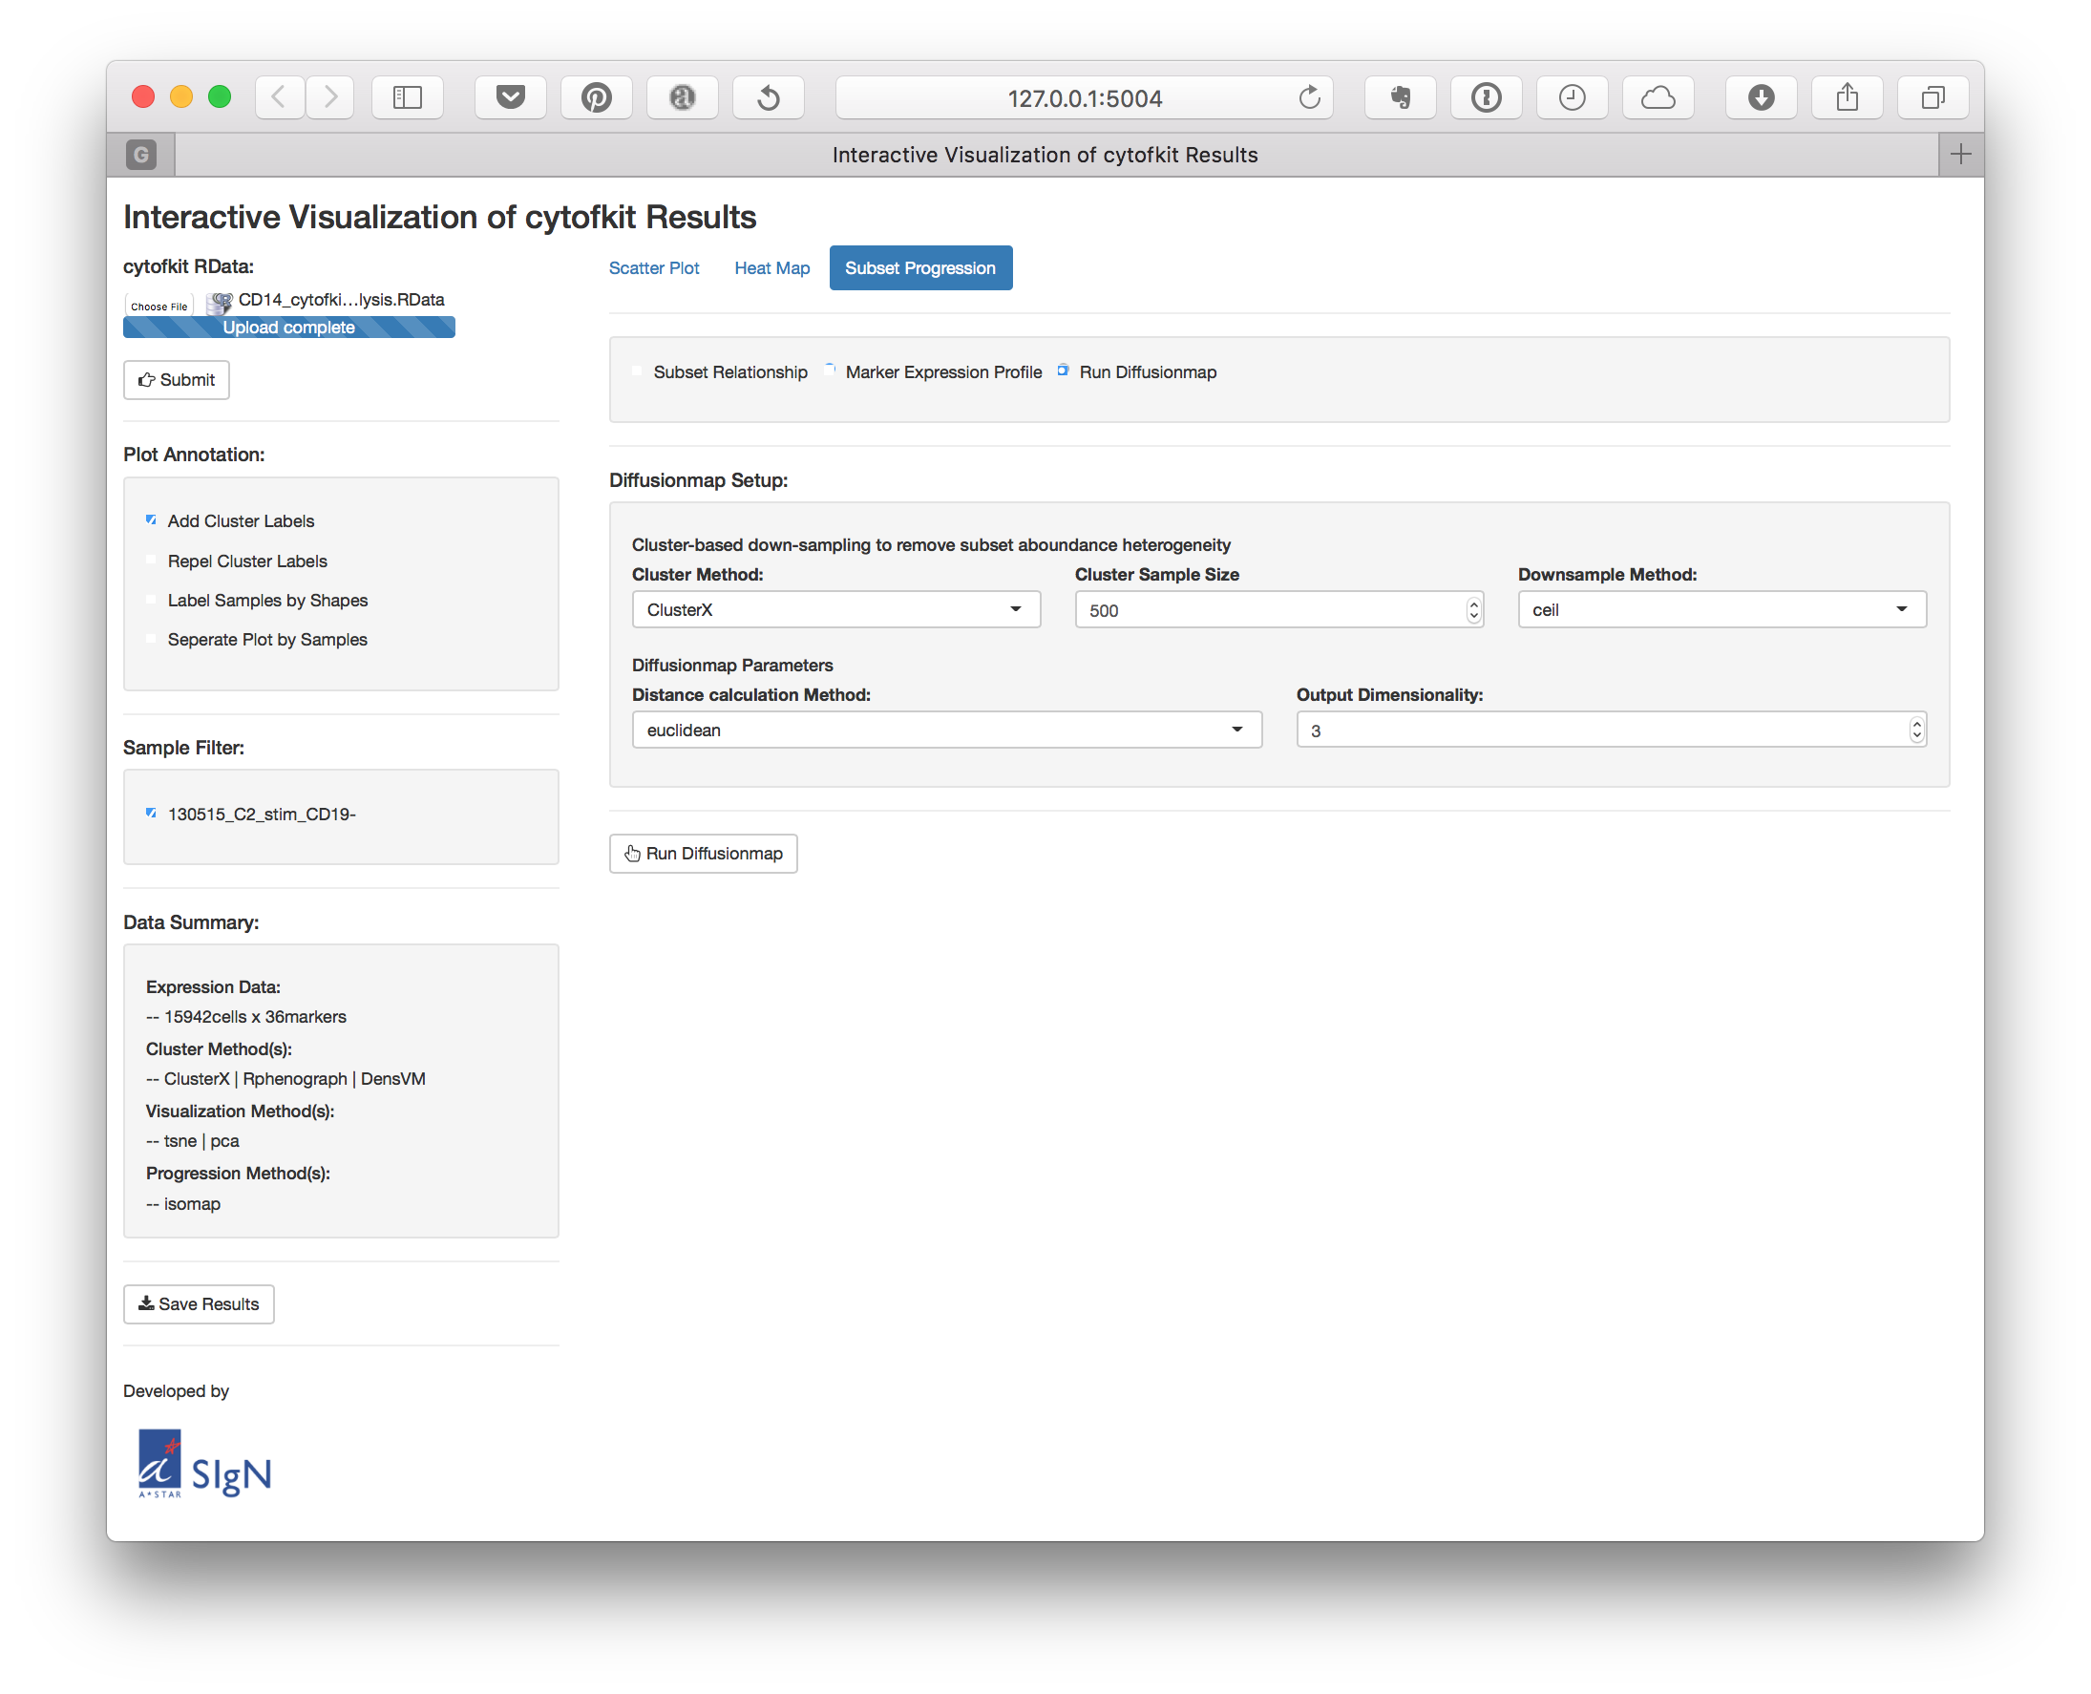
Here we combine the diffusion map with the clustering results to infer inter-subset relatedness, which is expected to help detection of cell differentiation trajectories. Firstly, we down-sampled the number of cells in each cluster to an equal size, thus reducing the cell subsets density heterogeneities and removing the dominance effect of large populations in the data. Then we ran diffusion map on the down-sampled dataset and overlay the clusters onto the transformed dimensions.
On the setup page:
- Choose a clustering results from Cluster Method.
- Set the down-sampling size from Cluster Sample Size.
- There are four different down-sampling methods, including ceil, all, min and fixed.
  - ceil (the default option): up to a fixed number (Cluster Sample Size) of cells are sampled without replacement from each cluster
  - all: all cells from each cluster are used.
  - min: The minimum number of cells among all the clusters are sampled from each cluster
  - fixed: a fixed num (Cluster Sample Size) of cells are sampled (with replacement when the total number of cell in that cluster is less than the fixe num) from each cluster.
- Select a distance calculation method for Diffusionmap.
- Select the output dimensionality for Diffusionmap.

