Supporting information Text S6.

Novel non-invasive algorithm to identify the origins of re-entry and ectopic foci in the atria from 64-lead ECGs. A computational study.

Erick A. Perez Alday¹, Michael A. Colman², Philip Langley ³, Henggui Zhang^{1*}
¹ Biological Physics Group, Department of Physics and Astronomy, University of Manchester, Manchester, United Kingdom,
²Theoretical Physics Division, Department of Physics and Astronomy, University of Manchester, Manchester, United Kingdom
³School of Engineering, University of Hull, Hull, United Kingdom,
*Correspondence: henggui.zhang@manchester.ac.uk

Fast Fourier Transformation analysis (FFT) MATLAB function was applied to different experimental lead V1 signals (Fig A - A). The sample rate was 500Hz. The sample time was 500 ms. The analysis was made over the first 50Hz of the power spectrum density (PSD) signals. PSD signals were normalized for comparison proposes. AFFTr_{2DF} values were obtained for four different experimental data were F-waves were presented (Fig A- B). The PSD signals. It can be observed how the AFFTr_{2DF} values decreased with more fragmented ECG signals (Fig A – B i-iv).
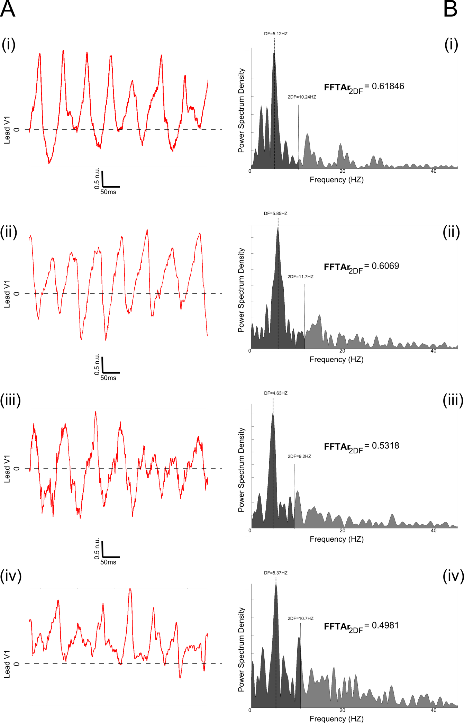

Fig A. Illustration of AFFTr_{2DF} obtained for different experimental Lead v1 signals with F-waves. (A): Lead V1 signals with F-waves presented. (B) Power spectral density of each ECG signal. The darker shadow corresponds to the area between 0 – 2 x Dominant frequency (DF). AFFTr_{2DF} is the ratio of the area under the power spectrum density in the ranges 0 – (2 x DF) Hz and (2 x DF) – 50 Hz: AFFTr_{2DF} = Area_{0-2DF}/Area_{0-50Hz}.

