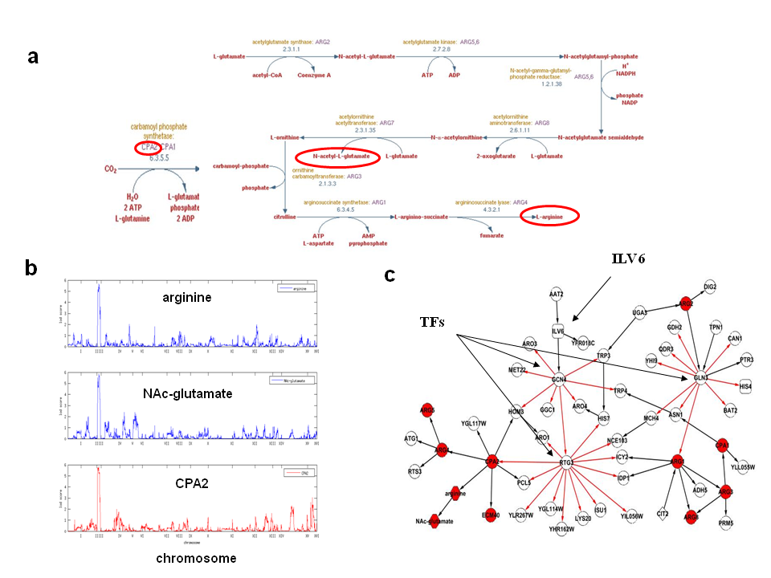
C
B
A

Figure S4. Relationship between arginine, NAc-glutamate and genes linked to the eQTL hot spot on chromosome III. a) The Arginine biosynthesis pathway; b) QTL plots for metabolites and genes in the arginine biosynthesis pathway (red circles); c) Arginine, NAc-glutamate and genes involved in arginine biosynthesis pathway (red nodes) are under regulation of ILV6 and multiple transcription factors GCN4, RTG3 and GLN3.

