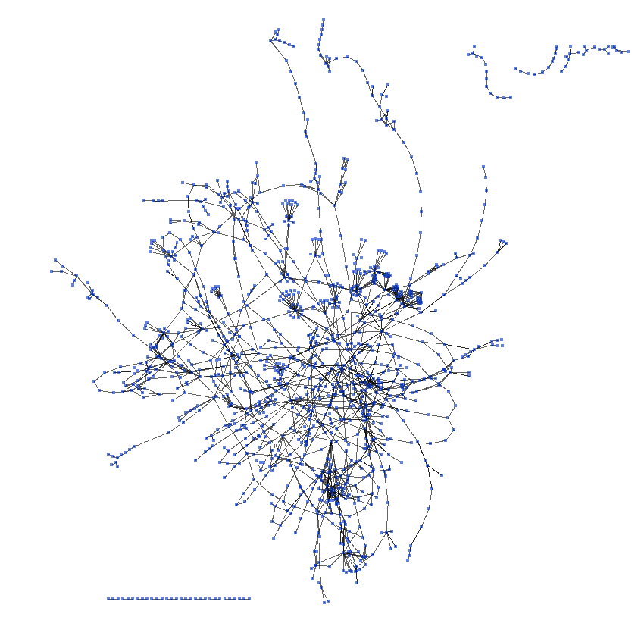
Figure S7. A global view of pairwise relationships of metabolites and catalyzing enzymes parsed from the KEGG biochemical pathway database.

