Table S2: Assessment of RNA quality obtained by laser microdissection
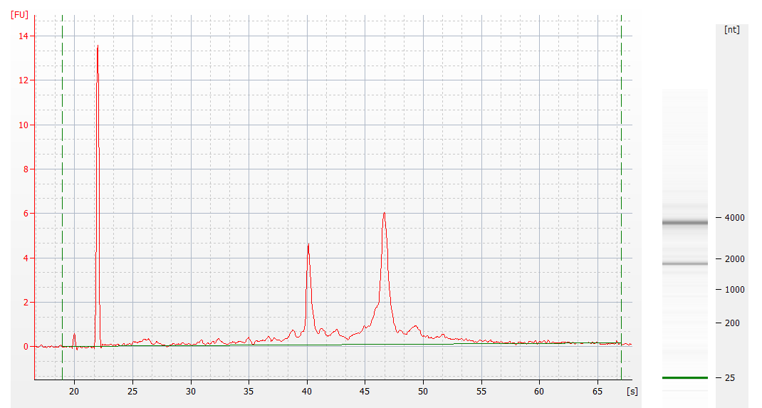
(18S:28S ration RIN: 8.2-8.8)
Detection of target genes with SYBRGreen (PC – Purkinje cells, GCL – granule cell layer)
mRNA | Official full name (NCBI) | Primer (5' -> 3') | Size  (bp) | PC  (Cp) | GCL  (Cp)
Gapdh | glyceraldehyde-3-phosphate dehydrogenase | FP:ACAATGAATACGGCTACAG  RP:GGTCCAGGGTTTCTTACT | 78 | 30.07 | 28.82
Actb | actin, beta | FP:GAAGATCAAGATCATTGCTCCT  RP:TGGAAGGTGGACAGTGAG | 84 | 30.71 | 29.23
Pgk1 | phosphoglycerate kinase 1 | FP:GTGATGAGGGTGGACTT  RP:TGGAACAGCAGCCTTGAT | 79 | 31.07 | 31.11
Ppia | peptidylprolyl isomerase A | FP:AAGACTGAATGGCTGGAT  RP:ATGGCTTCCACAATGTTCA | 75 | 32.44 | 30.10
Calb2 | calbindin 2 | FP:AGTTCAATGCCATCTTCA  RP:TTCATCTCCTTCTTGTTCTT | 112 | > 35 | 31.09
Rbfox3 | RNA binding protein, fox-1 homolog (C. elegans) 3 | FP:TGAGATTTATGGAGGCTAT  RP:ATAACTGTCACTGTAGGC | 79 | > 35 | 29.52
Gfap | glial fibrillary acidic protein | FP:AACCTGGCTGCGTATAGA  RP:CGAACTTCCTCCTCATAGAT | 125 | > 35 | > 35
Cspg4 | chondroitin sulfate proteoglycan 4 | FP:AGTTTACGCTCACCACTC  RP:AAATATGTCCACGTAGATAAAGTT | 89 | > 35 | > 35
Eno2 | enolase 2, gamma neuronal | FP:AAGATGGTGATCGGTATG  RP:TGATGTATCGGGAAGGAT | 100 | 32.55 | 30.93
Gap43 | growth associated protein 43 | FP:AGGAGAAAGACGCTGTAG  RP:AGTTCAGGCATGTTCTTG | 98 | > 35 | 31.79

Detection of target genes with TaqMan Gene Expression Assays
mRNA | Official full name (NCBI) | TaqMan (ABI) | Size  (bp) | Cp  (PC) | Cp  (GCL)
Gapdh | glyceraldehyde-3-phosphate dehydrogenase | Mm99999915 | 107 | 34.09 | 32.16
Pcp2 | Purkinje cell protein 2 (L7) | Mm00435514_m1 | 59 | 32.60 | > 35

