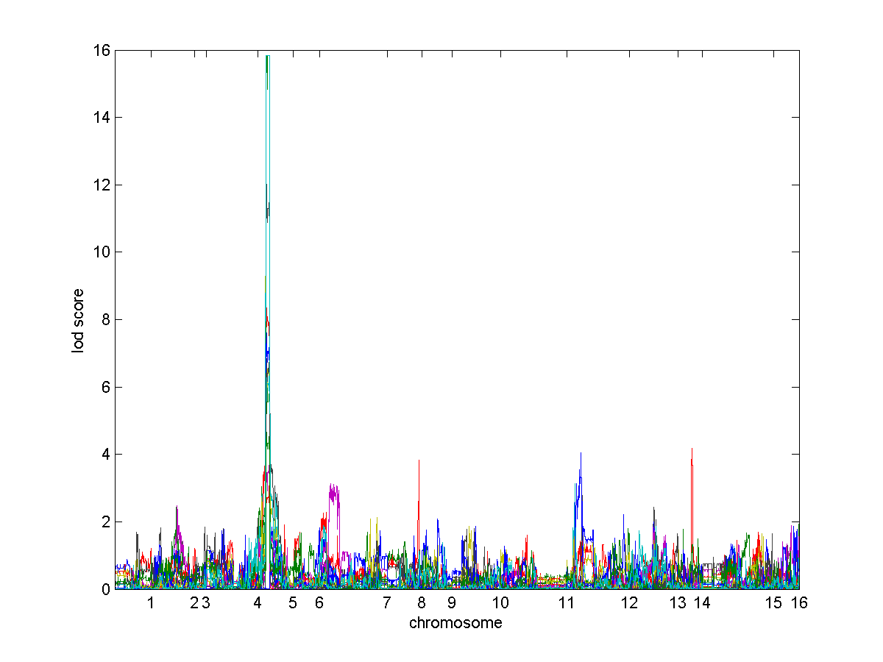

Figure S9. Trait values of nodes compared with genotype data for the URA3 subnetwork. eQTLs and metQTLs are located on Chromsome V.

