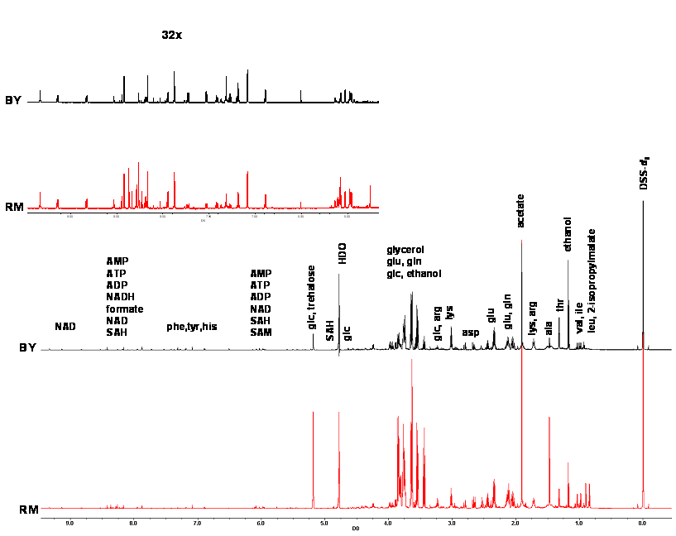
Figure S2. 1D proton NMR spectra of BY and RM yeast strains. The insert of the upper 2 traces are a 32× expansion of the down field region (i.e. left side of the bottom spectra).

